Press release

Sims Crane & Equipment takes delivery of LR 1250.1 Unplugged

⸺
LR 1250.1 unplugged adds a modern solution to Sims large fleet.
The battery-powered unplugged crane offers the same optimum performance as the conventional version.
No emissions and little noise are emitted.
Premier crane rental and rigging service, Sims Crane & Equipment purchases a Liebherr LR 1250.1 unplugged to add to their growing fleet. The battery-powered LR 1250.1 unplugged is the first model of Liebherr’s Unplugged series to be sold on the US East Coast. The crawler crane with an alternative drive system offers the same performance as the conventional version, while putting off zero emissions.
Newport News, VA (USA), Liebherr USA, Co., Crawler Cranes and Deep Foundation Machines, February 23, 2023 – For more than 60 years, Sims Crane & Equipment has been a leader in the crane and rigging industry with an emphasis in cutting edge technology. Offering 13 locations throughout Florida, the company continues to grow their large fleet with the purchase of a Liebherr LR 1250.1 unplugged crawler crane. This battery-powered machine will join Sims cranes fleet of all terrain, mobile, crawler, and rough terrain cranes including Liebherr’s LR 1250.1 and LR 1300 SX.
The LR 1250.1 unplugged is the first unplugged crawler crane model to be sold on the US East Coast. The models of the Unplugged series can perform either via battery (unplugged) or plugged in offering identical performance to the conventional version. The battery can last up to approximately eight hours based on individual workload. The machine also comes with an app that provides the status of the batteries power. The unplugged series offers zero emissions and very little noise pollution, making this the ideal crane for Sims to work in more populated areas including amusement parks, hospitals, and residential areas.
Sims Cranes’ new 1250.1 unplugged will be delivered with a 242 ft main boom and 311 ft luffing jib + aux tip. This addition will further aid their mission of providing turn-key crane and rigging solutions, completing each job safely and smoothly.
Jackson Sims, Owner / VP sales / Market Development at Sims Crane noted, “We are honored to partner with Liebherr and be on the forefront to serve a vastly growing need for alternative energy to Sims' ever-growing customer base.”
About Liebherr USA, Co.
Liebherr USA, Co. based in Newport News, VA provides sales and service on behalf of ten different Liebherr product segments: earthmoving, material handling, mining, mobile and crawler cranes, tower cranes, concrete technology, deep foundation machines, maritime cranes; components, and refrigeration and freezing.
About the Liebherr Group
The Liebherr Group is a family-run technology company with a highly diversified product portfolio. The company is one of the largest construction equipment manufacturers in the world. It also provides high-quality and user-oriented products and services in a wide range of other areas. The Liebherr Group includes over 140 companies across all continents. In 2021, it employed more than 49,000 staff and achieved combined revenues of over 11.6 billion euros. Liebherr was founded in Kirchdorf an der Iller in Southern Germany in 1949. Since then, the employees have been pursuing the goal of achieving continuous technological innovation, and bringing industry-leading solutions to its customers.
Images
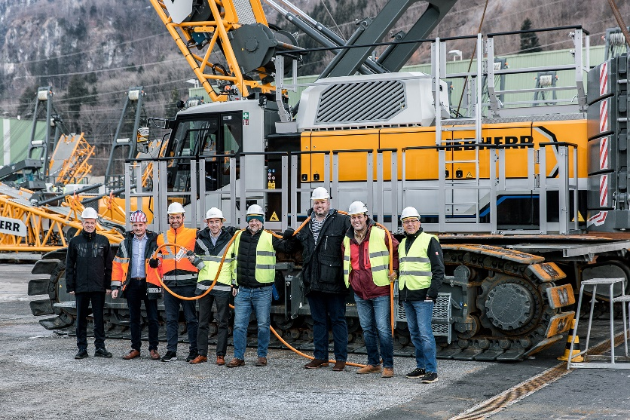
liebherr-Sims-Crane-handover-1.jpg
Sims Crane takes delivery of a Liebherr LR 1250.1 unplugged.
Pictured left to right: Dietmar Haemmerle, Michael Neyer, Lukas Burtscher, Michael Flecker, Timothy McDaniel, Michael Kuffermann, Jared Lester, Wolfgang Herzog

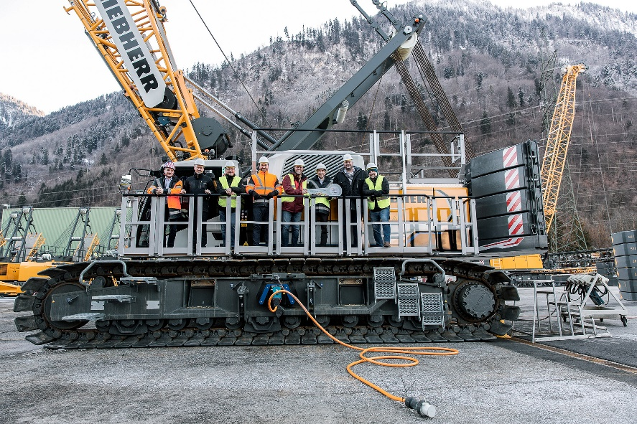
liebherr-Sims-Crane-handover-2.jpg
Sims Crane joins Liebherr in Austria for handover.
Pictured left to right: Michael Neyer, Dietmar Haemmerle, Wolfgang Herzog, Lukas Burtscher, Jared Lester, Michael Flecker, Michael Kuffermann, Timothy McDaniel

Contact
Ana Cabiedes
Head of Marketing
Liebherr USA, Co
E-Mail: ana.cabiedes@liebherr.com
Published by
Liebherr USA, Co.
Newport News / USA
www.liebherr.com

