Press release

Karunia invests in four Liebherr R 9300 mining excavators

⸺
Karunia have purchased four units of the new Liebherr R 9300 mining excavator
This purchase is based on the exceptional performance of the R 9300 pre-series unit Karunia received in September 2022
The R 9300 is still in its validation phase and will enter serial production in 2024
In January 2023, Karunia – a Liebherr Indonesia customer – signed an agreement for the purchase of four additional units of the R 9300 mining excavator for Tabang mine, located in the Kutai Kartanegara Regency of East Kalimantan, Indonesia. These four excavators will be delivered from late 2023 to early 2024 and will join the R 9300 pre-series unit that has been on site since September 2022.
Jakarta (Indonesia), 8 February 2023 – PT Karunia Armada Indonesia (Karunia) has agreed to increase its existing mining fleet with four of Liebherr Mining’s latest 250-tonne class excavator: the R 9300 G8. Karunia received a pre-series unit of the R 9300 in September 2022 as part of the development and validation process for the mining excavator.
During the development and validation process, Karunia provided direct and transparent feedback about its Liebherr fleet. This helped Liebherr to better understand the role that its technology played in supporting customers’ daily activities. After a few months in operation, the figures provided to Liebherr by Karunia have proven that the R 9300 G8 perfectly matches Karunia’s requirements during its operations.
Karunia has observed the high performance of the R 9300 since its arrival on site in September 2022, further solidifying its decision to expand its R 9300 fleet. The company has expressed that the performance of the R 9300 G8 has been staggering and surpassed all expectations. The excavator has helped Karunia to achieve its ever-increasing production targets. Karunia has also articulated that the best things about the pre-series unit they received were the comprehensive services and the quick response times from Liebherr Indonesia.
A blossoming business relationship
Liebherr Mining and Karunia established their partnership in 2021, with the delivery of an R 9100 mining excavator to the Tabang mine. Since that time, Karunia’s fleet of Liebherr machines has increased and now includes an R 9200, the pre-series R 9300, and two PR 776 mining dozers. The steady growth of Karunia’s fleet of Liebherr equipment, including their purchase of four more R 9300 units, represents Karunia’s faith in Liebherr’s ability to deliver products that provide exceptional results.
Karunia originally chose Liebherr Mining products for their competitive availability and terms, offered during a time of uncertainty. Further, Liebherr’s product support – directly backed by the OEM (original equipment manufacturer) – is a unique structure in Indonesia. Karunia chooses to continue to work with Liebherr Indonesia due to the encompassing measures the company takes to support Karunia’s growth after the sale of the equipment.
The latest in site efficiency
Karunia is a mining contractor headquartered in Balikpapan, East Kalimantan. In 2011, Karunia expanded into surface mining when the company was offered a contract by PT Bayan Resources Tbk (Bayan) to haul coal and overburden within the Tabang mine site. Since this contract was established, it has been Karunia’s goal to increase coal production on site to meet Bayan’s requirements. Liebherr’s R 9300 will play a crucial role in increasing the efficiency of Karunia’s operation.
The R 9300 G8 – unveiled at the Bauma exhibition in Germany last year – is the latest mining excavator to join Liebherr Mining’s portfolio. The new R 9300 is the second Generation 8 excavator launched within the portfolio and is fitted with the most advanced Liebherr Mining technologies, building on Liebherr’s decades of expertise designing excavators for the mining industry.
The R 9300 will replace the R 9250 within Liebherr’s portfolio once the new model enters serial production in 2024.
About the Liebherr Group
The Liebherr Group is a family-run technology company with a highly diversified product portfolio. The company is one of the world's largest manufacturers of construction machinery. It also offers high-quality, user-oriented products and services in multiple other areas. Today, the group consists of more than 140 companies across all continents. In 2021, it employed more than 49,000 people and achieved combined revenues of over 11.6 billion euros. Liebherr was founded in 1949, in Kirchdorf an der Iller in southern Germany. Ever since then, the company’s employees have been committed to satisfying customers with advanced solutions and to helping drive technological progress.
Images
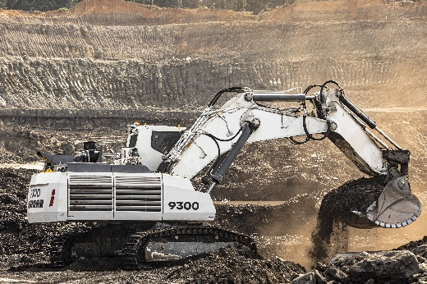
liebherr-r9300-karunia.jpg
The R 9300 G8 working hard at Tabang mine for PT Karunia.

Contact
Swann Blaise
Divisional General Manager: Marketing & Business Intelligence
Telephone: +1 757 928 2239
Email: swann.blaise@liebherr.com

Published by
Liebherr-Mining Equipment Colmar SAS
Colmar / France
www.liebherr.com

