Press information

Assembly via helicopter:
Liebherr flat-top crane at work on Mont Blanc

⸺
A 150 EC-B 8 is helping build a cable car station and a new educational centre in the aim to increase climate awareness
The crane needs to be compatible with the helicopter's load capacity
Careful planning and a well-coordinated team ensure smooth assembly with as few flights as possible
A new educational centre focused on climate change, complete with cable car, is currently being built on France’s largest glacier, the “Mer de Glace”. The transformation of the Montenvers station is intended to make students, tourists and residents even more aware of the effects of climate change. Access to the high mountain area will also be made easier with the new cable car moving closer to the glacier. A Liebherr 150 EC-B 8, whose assembly required the use of a helicopter, is an integral part of the project.
Chamonix (France), 7 February 2023 – The flat-top crane's tower is in place. A helicopter delivered one tower section after another to the Montenvers mountain station up at an altitude of 1,913 metres, after the foundation anchor was secured to the massif. Four assembly engineers from Liebherr's partner FT Montage and six flight assistants from Heliswiss International took delivery of the parts from overhead, connected them and worked their way up to a tower height of over 40 metres. A spectacular panorama presents itself: rock faces, trees and ice fields sparkle in the sunshine. But the engineers have little time to appreciate the views from the foot of Mont Blanc, the highest mountain in the Alps and the European Union. The helicopter is on its approach with the crane’s slewing platform.
“Assembly has been a true team effort that wouldn't have been possible without mutual trust,” says Guillaume Riband, Operations Manager France Centre East at Vinci Construction France. “Everyone has pulled together and risen to the challenge as a result.” FT Montage won the "Trophée des Grues á Tour" in the category "Assembly of the Year" due to the complexity and difficulty of the operation. The award is presented annually by the CPMDG (Professional commission for tower crane professions and equipment) from the DLR Federation.
EC-B series with flexible jib length
A job like this one with a 150 EC-B 8 in the middle of the Alps isn't something that happens every day. The crane, with a 45-metre jib and a hook height of 42 metres, will support the construction of the new cable car station and the International Glacier and Climate Interpretation Centre until June 2023. The new “Glaciorium” is to become the flagship attraction at Montenvers and will help visitors to understand the phenomena associated with global warming. The Montenvers redevelopment will cost more than 50 million euros and is due to be completed in December 2024. The project was designed to be of high ecological and architectural quality in order to minimise the impact on nature. In terms of energy consumption, waste disposal and visitor awareness, the project fulfils high standards.
One of the biggest challenges the construction company faced was selecting the right crane. Originally, the site required a crane in the 250 metric tonnes range due to the loads that needed to be moved. This value is based on radius (m) and lifting capacity (t) and serves to classify the size of the crane. As such a crane is too heavy for helicopter assembly, Liebherr worked with customers Solumat GAT ( Materials Division, Vinci Group) and CBCE Grenoble (a local construction company that is part of the Vinci Group) to find economic alternatives. Depending on temperature and altitude, the helicopter can move a maximum of 3,800 kilograms.
Fast assembly thanks to clever design concept
In the end, Liebherr suggested the use of a 150 EC-B, as its counter jib, which weighs in at 3,600 kilograms, is light enough for the helicopter to manage. Plus, the flat-top crane can be easily dismantled into several individual parts thanks to its flexible design concept. Elements such as the crane’s compact head, slewing platform, cabin and control cabinet can all be quickly reconnected. The site's architects and the construction company also adapted the planning so that the loads to be moved wouldn’t exceed the crane's maximum lifting capacity of eight tonnes. This was in part achieved through the use of lighter concrete elements.
For safety reasons, the Montenvers train, which dates back to 1910, was temporarily suspended due to the proximity of its power lines. The retro-style electric rack railway connects Chamonix-Mont-Blanc and Montenvers. It climbs steeply upwards for more than five kilometres and visitors reach the terminus at an altitude of 1,913 metres after approx. 20 minutes.
Robust cranes for unusual tasks
Thanks to the right choice of crane, good preparation and a well-coordinated team, the assembly on Mont Blanc has gone smoothly. The unusual assembly of the 150 EC-B took around eight hours. During this time, a powerful Kamov KA 32 A11 BC heavy-lift helicopter from Heliswiss International flew back and forth 30 times to deliver all the crane parts and tower system elements.
The delivery site needed to be easily accessible for trucks and offer sufficient space. The location chosen was an area in Chamonix on the Arveyron River, about 3.5 kilometres from the Montenvers mountain station. This relatively short distance helped to keep flight times, and therefore refuelling, to a minimum. “Precision planning has been key to this all-round successful assembly,” Guillaume Riband concludes.
This is the second successful helicopter assembly for Heliswiss International and Liebherr. In 2015, they used a helicopter to transport a 150 EC-B 6 flat-top crane onto the Zugspitze to work on the construction of the new Eibsee cable car station. Up at an altitude of 2,975 metres, the crane marked Germany's highest construction site back then. The 150 EC-B 8 won't quite reach such heights in France, but sub-zero temperatures are expected here in the winter months as well. This isn't a problem for Liebherr tower cranes, which are designed for such conditions.
About the Liebherr Tower Cranes Division
More than seven decades of experience have made Liebherr a recognised specialist for lifting technology on all types of construction sites. The range of Liebherr Tower Cranes encompasses an extensive selection of high-quality tower cranes that are used worldwide. This includes fast-erecting, top-slewing, luffing jib and special-purpose cranes as well as mobile construction cranes. In addition to these products, Liebherr also offers a wide range of services that complete the company’s portfolio: Tower Crane Solutions, the Tower Crane Center and Tower Crane Customer Service.
About the Liebherr Group
The Liebherr Group is a family-run technology company with a highly diversified product portfolio. The company is one of the world's largest manufacturers of construction machinery. It also offers high-quality, user-oriented products and services in multiple other areas. Today, the group consists of more than 140 companies across all continents. In 2021, it employed more than 49,000 people and achieved combined revenues of over 11.6 billion euros. Liebherr was founded in 1949, in Kirchdorf an der Iller in southern Germany. Ever since then, the company’s employees have been committed to satisfying customers with advanced solutions and to helping drive technological progress.
Images
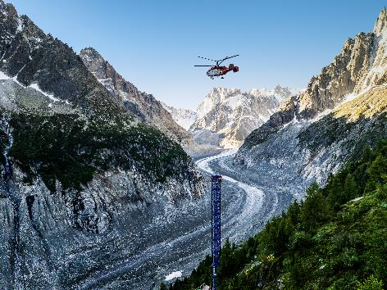
liebherr-150-ecb-mont-blanc-2023-01.jpg
Assembly of the Liebherr 150 EC-B was carried out using a powerful heavy-lift helicopter from Heliswiss International.

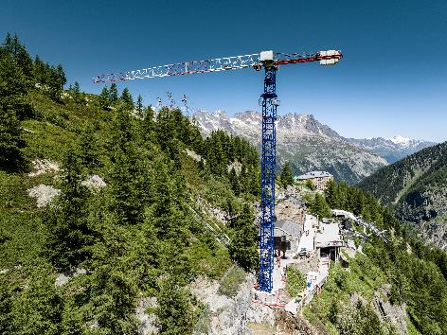
liebherr-150-ecb-mont-blanc-2023-02.jpg
Liebherr’s 150 EC-B 8 is helping to build a new cable car station”.
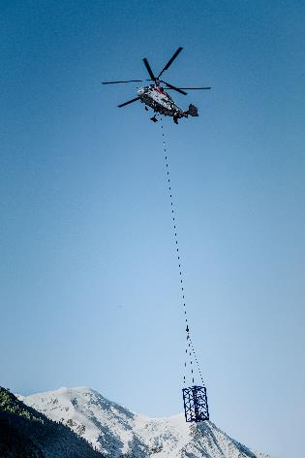
liebherr-150-ecb-mont-blanc-2023-03.jpg
The helicopter transported components from their delivery location to the site on Mont Blanc.
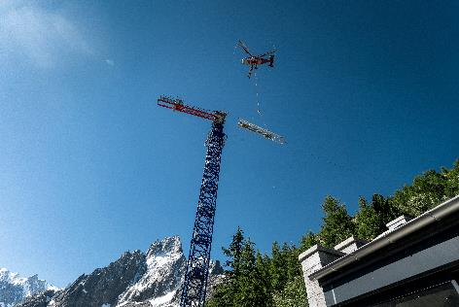
liebherr-150-ecb-mont-blanc-2023-04.jpg
Thanks to precision planning and a strong team effort, assembly was completed within a day.
Contact
Daniel Haefele
Global Communication
Phone: +49 7351 / 41 - 2330
Email: daniel.haefele@liebherr.com
Published by
Liebherr-Werk Biberach GmbH
Biberach / Germany
www.liebherr.com

