Press release

Liebherr crawler cranes from Grúas Aguilar erect retractable stadium roof

⸺⸺
- An LR 1700-1.0 and an LR 1600/2 erected twelve steel girders for the retractable roof of the new Estadio Santiago Bernabéu
- The two cranes performed tandem lifts of the 72-tonne steel girders, with radii between 70 and 118 metres
- These were challenging tasks for the team and its cranes
The construction of a retractable roof is one of the highlights of the renovation and reconstruction work at Real Madrid CF's stadium, the Estadio Santiago Bernabéu. The break in matchday operations caused by the World Cup in Qatar provided an opportunity to assemble the steel girders for the hydraulically adjustable roof structure. Two Liebherr crawler cranes from Grúas Aguilar, an LR 1700-1.0 and an LR 1600/2, played together as a team.
Ehingen (Donau) (Germany), 3 February 2023 – The legendary football stadium Estadio Santiago Bernabéu, home of the record champion Real Madrid CF, has been repeatedly rebuilt and enlarged since it was first constructed in 1947. Currently, the largest reconstruction project in its history is underway. The redesigned ultra-modern stadium with its hydraulically adjustable roof structure, retractable hybrid turf, LED-lit façade and new shopping, business and leisure facilities is scheduled for completion in the middle of this year.
Liebherr mobile and crawler cranes from Grúas Aguilar are playing a key role in the modernisation measures. During the break in play caused by the World Cup in Qatar, the Madrid-based crane and transport company used two Liebherr crawler cranes to assemble the girders for the retractable roof. An LR 1700-1.0 and an LR 1600/2 lifted twelve 72-metre-long and 72-tonne cross beams to a height of 70 metres in tandem lifts. The two crawler cranes were positioned outside the stadium and had to cope with radii of 70 to 118 metres.
The Grúas Aguilar team and its cranes also had to overcome several major challenges when carrying out this exceptional operation. In particular, the limited space around the stadium made it extremely difficult to erect large lattice boom cranes. Therefore, the boom of the LR 1600/2 had to be mounted in a car park near the stadium.
Another difficulty was that the crane operators could not always see the cross beams when lifting them into the stadium. To ensure the success of the assembly, Grúas Aguilar's design department meticulously planned the movements of each girder in advance, taking into account the respective angles of the main boom and luffing jib of the two cranes in each phase.
Originally, the assembly of the roof cross beams was to be carried out using a single, larger crane. After extensive testing, this plan had to be discarded due to, among other things, space problems in the vicinity of the construction site and the large assembly radii. Instead, Grúas Aguilar opted for tandem lifts using the LR 1700-1.0 and LR 1600/2 crawler cranes.
"Having assembled the entire roof of the Estadio Santiago Bernabéu, the completion of this job means the end of an exciting project for the Grúas Aguilar team," says company owner Luis Aguilar. "The best feedback we can ask for is the fact that our customers have placed their trust in us day in and day out ever since we first started this special project four years ago. We also get great support from the Liebherr Ibérica team in terms of customer service and advice."
About Grúas Aguilar
Grúas Aguilar was founded in 1968 and has since worked on thousands of projects throughout Spain, Portugal, France and Morocco. Its crane fleet, which consists of more than 60 machines (of which more than 40 are from Liebherr), is being continuously upgraded in order to procure the most modern, reliable and safe models on the market. Grúas Aguilar provides services in a wide range of sectors, including public works, civil engineering, energy, cement, iron and steel, chemicals and environmental engineering. For years, the company has relied on Liebherr cranes due to their high quality and Liebherr's efficient customer service.
About Liebherr Ibérica, S.L.
Liebherr Ibérica is the Liebherr Group’s Spanish sales and service company and was founded in 1988. Today, Liebherr Ibérica is responsible for sales and customer service for the Mobile and Crawler Cranes, Earthmoving Machines, Mining, Maritime Cranes and Concrete Technology Business Units.
About Liebherr-Werk Ehingen GmbH
Liebherr-Werk Ehingen GmbH is a leading manufacturer of mobile and crawler cranes. Its range of mobile cranes extends from 2-axle 35 tonne cranes to heavy duty cranes with a lifting capacity of 1200 tonnes and a 9-axle chassis. Its lattice boom cranes on mobile or crawler crane chassis deliver lifting capacities of up to 3000 tonnes. With universal boom systems and extensive additional equipment, they can be seen in action on construction sites throughout the world. The Ehingen site has a workforce of 3,800. Extensive, global service guarantees the high availability of Liebherr mobile and crawler cranes. In 2021, the Liebherr plant in Ehingen recorded a turnover of 2.33 billion euros.
About the Liebherr Group
The Liebherr Group is a family-run technology company with a highly diversified product portfolio. The company is one of the largest construction equipment manufacturers in the world. It also provides high-quality and user-oriented products and services in a wide range of other areas. The Liebherr Group includes over 140 companies across all continents. In 2021, it employed more than 49,000 staff and achieved combined revenues of over 11.6 billion euros. Liebherr was founded in Kirchdorf an der Iller in Southern Germany in 1949. Since then, the employees have been pursuing the goal of achieving continuous technological innovation, and bringing industry-leading solutions to its customers.

Images

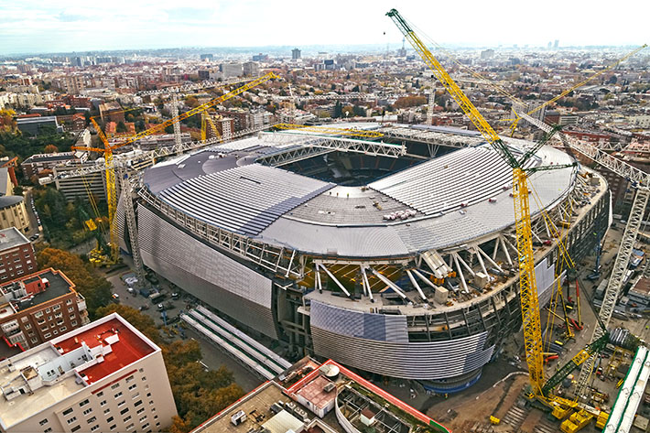
liebherr-lr1600-lr1700-gruas-aguilar-01.jpg
Grúas Aguilar's Liebherr LR 1700-1.0 and LR 1600/2 crawler cranes assemble the retractable roof of the new Santiago Bernabéu stadium.

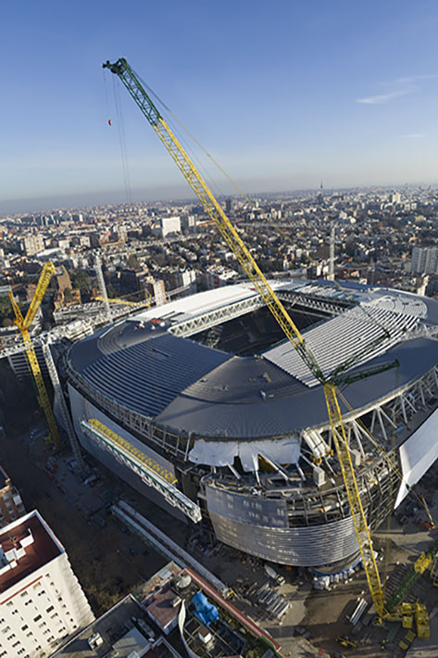
liebherr-lr1600-lr1700-gruas-aguilar-02.jpg
Liebherr crawler cranes assemble twelve steel girders at a height of 70 metres and at maximum working radii of between 70 and 118 metres.
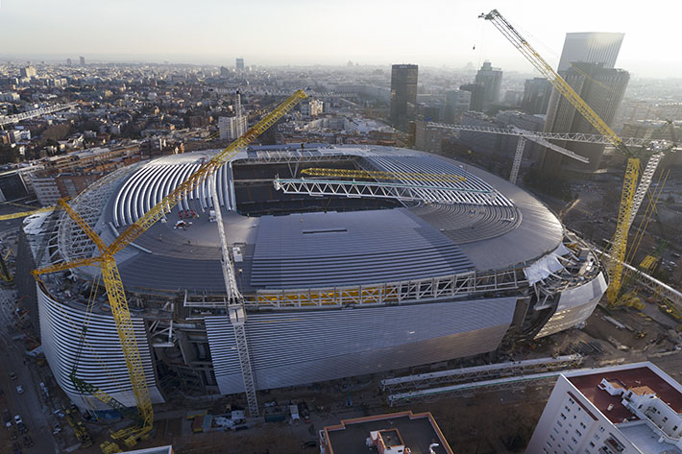
liebherr-lr1600-lr1700-gruas-aguilar-03.jpg
Tight space conditions, large working radii and the positioning of the cross beams without a direct line of sight to the crane operators posed enormous challenges for the team and the cranes.

Contact
Wolfgang Beringer
Marketing and Communication
Phone: +49 7391/502 - 3663
Email: wolfgang.beringer@liebherr.com
Published by
Liebherr-Werk Ehingen GmbH
Ehingen (Donau), Germany
www.liebherr.com

