Press release

Eurogate CTW to purchase two automated dual trolley STS cranes

⸺
Automated cranes supplied with Remote Operator Stations (ROS)
Dual trolley decouples the land and sea side
Will play a key role in the expansion and modernisation of CTW
In what is the first order of its type for Liebherr Container Cranes Ltd., Eurogate Container Terminal Wilhelmshaven (CTW) have placed an order for two dual trolley ship to shore container cranes (STS). The automated cranes decouple the land and sea side cycles of vessel handling, allowing for increased productivity.
Killarney (Ireland), January 2023 – Eurogate Container Terminals Wilhelmshaven have placed an order with Liebherr Container Cranes Ltd. for two dual trolley ship to shore container cranes. The cabinless, automated cranes have a primary outreach of 73 m, a lift height of 54.5 m, a span of 30.48 m and operational back reach with secondary trolley of 26 m. The cranes are supplied with Liebherr Remote Operator Stations. Designed for tandem operation, the primary trolley delivers containers automatically to the pinning platform. The containers rest on frames whilst the twist locks are removed. Once the pinning personnel leave the platform, they activate the secondary trolley, which automatically delivers the container to the landside AGVs.
The order is the latest project where Eurogate has relied on Liebherr for its container handling needs. Recent years have seen Liebherr supply over twenty STS cranes to Eurogate Terminals in Germany as well as eight STS to Tanger Alliance in Morocco, where Eurogate are a shareholder. The cranes will be the first double trolley container cranes at CTW and will handle the world’s largest container vessels. Container Terminal Wilhelmshaven is Germany’s only deep-water port allowing ultra large container vessel access at all tides and its strategic location makes it a key component of Germanys transport infrastructure. Significant growth in throughput is expected at Wilhelmshaven and Eurogate are expanding and modernising the terminal into an automated terminal geared for the future.
Speaking about the order, Liebherr’s Managing Director – Sales, Gerry Bunyan commented: “It is an honour for us at Liebherr to continue our partnership with Eurogate and to supply these important cranes to CTW. Eurogate have first-hand experience with Liebherr’s ship to shore container cranes and have come to know, and rely on the high-quality cranes and service that Liebherr provide. Our technical ability is well recognised and we look forward to delivering state-of-the-art industry leading STS cranes to CTW and to seeing them playing a key role in the terminal’s future.”
About Liebherr Container Cranes
Liebherr Container Cranes Ltd. Is one of the world’s leading manufacturers of ship to shore container cranes, rail mounted gantry cranes and rubber tyre gantry cranes. From a base in Killarney, Ireland, Liebherr Container Cranes Ltd designs, builds and exports container cranes worldwide. Founded in 1958 as the first Liebherr factory outside of Germany, today, container cranes manufactured by Liebherr in Ireland are renowned for their quality, longevity and productivity
About the Liebherr Group
The Liebherr Group is a family-run technology company with a highly diversified product portfolio. The company is one of the largest construction equipment manufacturers in the world. It also provides high-quality and user-oriented products and services in a wide range of other areas. The Liebherr Group includes over 140 companies across all continents. In 2021, it employed more than 49,000 staff and achieved combined revenues of over 11.6 billion euros. Liebherr was founded in Kirchdorf an der Iller in Southern Germany in 1949. Since then, the employees have been pursuing the goal of achieving continuous technological innovation, and bringing industry-leading solutions to its customers.

Images
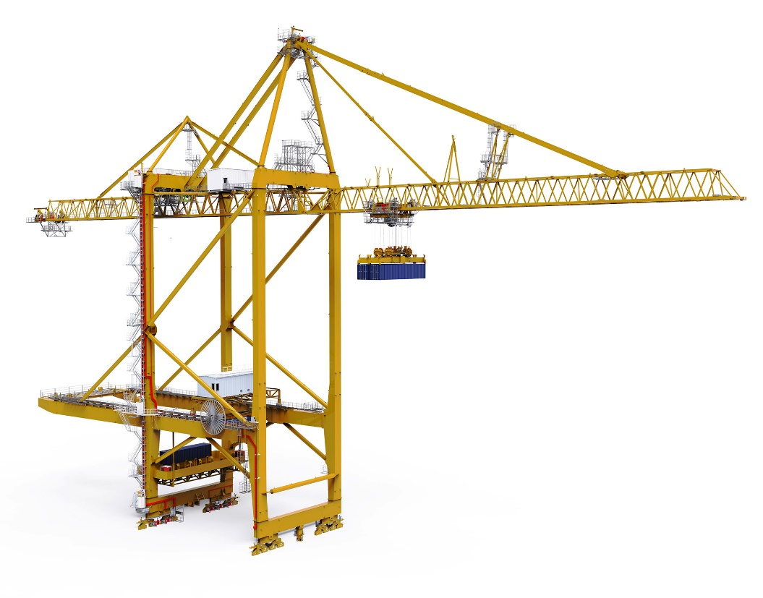

dualtrolleySTS.jpg
Eurogate have placed an order with Liebherr Container Cranes ltd. for dual trolley ship to shore container cranes

Contact
Trevor O’Donoghue
Marketing Manager
Telephone: +353 64 6680459
E-Mail: trevor.odonghue@liebherr.com
Published by
Liebherr Container Cranes Ltd.
Killarney / Ireland
www.liebherr.com

