Press release

Liebherr works together: LRT 1100-2.1 crane helps assemble Liebherr T 264 mining truck

⸺
Liebherr’s first LRT 1100-2.1 rough terrain crane with counterweight upgrade used in the USA
Assembly of the T 264 mining truck made easier with LRT’s high safety standards
Liebherr’s LRT 1100-2.1 rough terrain crane with counterweight upgrade was brought to Liebherr Mining Equipment Newport News Co. site to assemble a T 264 Liebherr mining truck. The LRT’s high safety standards, along with additional lifting capacity with the upgraded counterweight made it an easy choice for the job.
Newport News, VA (USA), Liebherr USA, Co., January 23, 2022 – Liebherr’s LRT 1100-2.1 rough terrain crane was upgraded in 2022. The upgraded steel counterweight is increased by 1 metric ton resulting in an increased lifting capacity, allowing the LRT to hoist loads beyond what’s capable for the rest of its class. The counterweight is also more compact providing a better rear view in the cab, minimizing blind spots. This upgrade also allows for increased load charts as well as inclination charts, aiding in operation up to 2 degrees from level.
The upgraded LRT was taken to Virginia to assist in quick assembly of an on-site mining truck. The rough terrain crane allowed for a smooth and rapid assembly of the T 264 mining truck and fulfilled any lifts needed at the site. Due to its top of the line safety features and high lifting capacity, the rough terrain crane was the top choice for this job. With no down time, the LRT crane also allowed the job to be finished four days ahead of schedule, saving both time and money.
“It can be very hard to schedule cranes for builds like this,“ noted Thomas Coenen, Liebherr Mining Equipment Product Support Representative. “Auxiliary cranes are often shared and used for maintenance of heavy mining equipment and other lifting needs around mining sites. In this instance, I was able to use the upgraded LRT from Prillaman’s crane rental. Using one crane that can lift the truck makes the project easier, and we can complete the build faster. This also meant no downtime or crane changes for different components to be lifted.“

Safety comes standard
A wide array of safety features come standard with the LRT, including the variable outrigger system, Variobase®, allowing safe operation of the crane with asymmetric outrigger positions integrated into the LMI (load moment indicator). The crane also offers LICCON controlled load moment limiter that minimizes accidents and human error as well as a monitored 2 hook operation which allows for safe rotation of loads.
“At any mine site safety is the biggest concern,” noted Beau Pocock, RT Business Development Manager for Liebherr USA, Co. Mobile and Crawler Cranes. “Any operation like this is planned out to use the safest methods possible. That is why the Liebherr LRT is the right machine for the job.”
The LRT also provides safe ascent to the crane with numerous handholds, a flat deck minimizing tripping hazards, as well as a larger cabin that tilts for better vision and ease-of-use on rough terrain.
About Liebherr USA, Co.
Liebherr USA, Co. based in Newport News, VA provides sales and service on behalf of ten different Liebherr product segments: earthmoving, material handling, mining, mobile and crawler cranes, tower cranes, concrete technology, deep foundation machines, maritime cranes; components, and refrigeration and freezing.
About the Liebherr Group
The Liebherr Group is a family-run technology company with a highly diversified product portfolio. The company is one of the largest construction equipment manufacturers in the world. It also provides high-quality and user-oriented products and services in a wide range of other areas. The Liebherr Group includes over 140 companies across all continents. In 2021, it employed more than 49,000 staff and achieved combined revenues of over 11.6 billion euros. Liebherr was founded in Kirchdorf an der Iller in Southern Germany in 1949. Since then, the employees have been pursuing the goal of achieving continuous technological innovation, and bringing industry-leading solutions to its customers.

Images
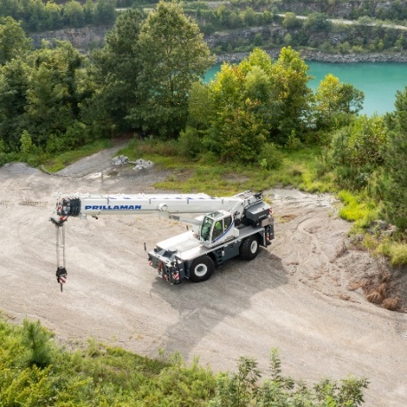
liebherr-LRT-1100-2-1.jpg
The upgraded LRT 1100-2.1 at Virginia testing site.
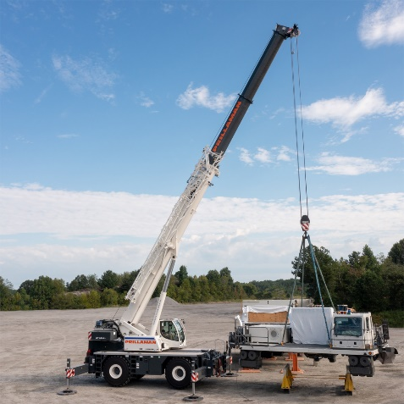
liebherr-Aerial-LRT-1100-2-1.jpg
The rough terrain crane lifts pieces of equipment at the quarry.
Contact
Ana Cabiedes
Head of Marketing
Liebherr USA, Co
E-Mail: ana.cabiedes@liebherr.com
Published by
Liebherr USA, Co.
Newport News / USA
www.liebherr.com

