Press information

Last crane finishes work on the Spin Tower in Frankfurt

⸺
Two 230 HC-L 8/16 and two EC-B cranes from Liebherr have been helping build the 128 metre-high hotel and office tower
Liebherr Tower Crane Solutions developed a cost-effective concept for external climbing
Multiple load hooks in a small area required precise planning of crane positioning
After three and a half years, the 230 HC-L 8/16 has carried out its last lift. With a final hook height of approx. 180 metres, the Liebherr luffing jib crane was the tallest crane on "The Spin" project in Frankfurt – and also the last remaining crane on site. It was dismantled in mid-November. Another 230 HC-L 8/16 and two flat-top cranes, a 150 EC-B 8 and a 110 EC-B 6, had already been taken down at an earlier date.
Frankfurt (Germany), 19 January 2023 – When Liebherr's Tower Crane Solutions project department started planning crane operations almost five years ago, the dismantling of the 230 HC-L 8/16 was already on the agenda. To ensure a smooth climb down, the crane, with its radius of 55 metres, had to be able to negotiate the new hotel and office tower without colliding with it. And it needed to do so along a façade with multiple projections. The upper storeys are each at a slightly rotated angle compared to the lower ones so that the 128 metre-high tower doesn’t have a uniform, smooth-running exterior. On top of that, there was little leeway in the choice of crane location due to the confines of the construction site and the busy Mainzer Landstraße road.
Minimal guying made interior outfitting easier
Tower Crane Solutions solved this challenge with just as much precision as the anchoring needed for the HC-L. The luffing jib crane was climbed on the outside of the building. “The guying required for this needed to affect as few hotel rooms as possible,” explains Julia Wiebeck, project manager at Tower Crane Solutions. Interior work on the hotel started while construction was still underway on the upper part of the tower.
“If the guying had blocked too many of the hotel rooms, it would have been difficult to keep to the interior work schedule,” says Julia Wiebeck. Liebherr and the project developer Groß & Partner came up with a solution for this together. The 230 HC-L 8/16 was anchored to the building with three guy lines, two in the hotel area and one at office floor level. The crane climbed on a 24 HC 630 tower system measuring 2.4 x 2.4 metres. Positioned on a 6 x 6 metre gauge undercarriage, the 230 HC-L 8/16 was the only crane to climb on this project.

High freestanding hook height achieved
Another 230 HC-L 8/16 was assembled in a freestanding position at a tower height of 84.3 metres. It wasn’t possible to erect the crane directly at the tower, which meant that there wasn't a way to attach it to the building for external climbing. This exceptionally high freestanding hook height could only be achieved by using strong foundation anchors together with a tower combination of 24 HC 630 and 24 HC 1250 tower systems. Foundation anchors were also chosen for securing the 150 EC-B 8 and 110 EC-B 6 cranes.
“Given the inner-city conditions, all assembly steps for the two 230 HC-L tower cranes and the two flat-top cranes required precise planning, preparation and handling by our customer GP Con and Nagel Baumaschinen Frankfurt GmbH as sales and service partner. Working together with Liebherr Tower Crane Solutions, we always found the right technical and economically feasible solution,” says sales manager Jürgen Schmitt from Nagel Baumaschinen Frankfurt GmbH.
“Work with Liebherr and Nagel has been all about competence, professionalism and customer orientation throughout, right from the initial crane concept through to dismantling the cranes. It meant that inner-city requirements could be met and complex construction conditions overcome,” says Dennis Ferdinand, senior construction manager at GP Con GmbH. “Planning the use of the two high-rise cranes allowed the climbing stages to be compensated for and an economical solution was achieved while still meeting performance requirements.”
The cranes assisted in the construction of the tower and development of its surroundings. Featuring intelligent assistance systems, such as the Micromove fine positioning mode, the Liebherr cranes mainly helped with concreting, formwork and façade-related tasks. The luffing jib cranes were operated in 1-line mode for high and fast performance and were therefore able to carry out lifts with a weight of up to eight tonnes.
A distinctive tower design
And so, a new tower has been rising on the Frankfurt skyline since spring 2019. “The Spin” is one of three high-rise buildings that have now been erected on Güterplatz. A new place to live and work has been created between the trade fair centre and the main railway station on what had been derelict land for decades. The 32-storey Spin Tower, designed by top architect Hadi Teherani, offers space for a premium hotel, offices and a roof terrace with spectacular views.
According to project developer Groß & Partner, the tower impresses with an accomplished visual separation of its two uses: Whereas the ascendant, smooth lower section will house the hotel, the upper section opens up with an angular floor design. It is this feature which gives the tower its distinctive character and name. The Spin Tower is easily accessible by public transport and the hotel is scheduled to open in spring 2023.

Custom construction site solution
The invaluable expertise of Tower Crane Solutions was crucial to the success of an inner-city construction project like this one. Projecting edges from adjacent buildings and tight construction site conditions required careful crane selection and precise crane concept planning before the start of construction. This meant that the limited available space on the 2,600 m² site was used effectively and efficiently for crane operations.
About the Liebherr Tower Cranes Division
More than seven decades of experience have made Liebherr a recognised specialist for lifting technology on all types of construction sites. The range of Liebherr Tower Cranes encompasses an extensive selection of high-quality tower cranes that are used worldwide. This includes fast-erecting, top-slewing, luffing jib and special-purpose cranes as well as mobile construction cranes. In addition to these products, Liebherr also offers a wide range of services that complete the company’s portfolio: Tower Crane Solutions, the Tower Crane Center and Tower Crane Customer Service.
About the Liebherr Group
The Liebherr Group is a family-run technology company with a highly diversified product portfolio. The company is one of the world's largest manufacturers of construction machinery. It also offers high-quality, user-oriented products and services in multiple other areas. Today, the group consists of more than 140 companies across all continents. In 2021, it employed more than 49,000 people and achieved combined revenues of over 11.6 billion euros. Liebherr was founded in 1949, in Kirchdorf an der Iller in southern Germany. Ever since then, the company’s employees have been committed to satisfying customers with advanced solutions and to helping drive technological progress.

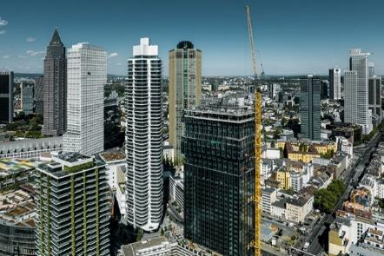
Images

liebherr-hcl-spin-tower-frankfurt-01.jpg
A Liebherr 230 HC-L 8/16 tower crane with a final hook height of approx. 180 metres was used for the construction of the Spin Tower in Frankfurt.

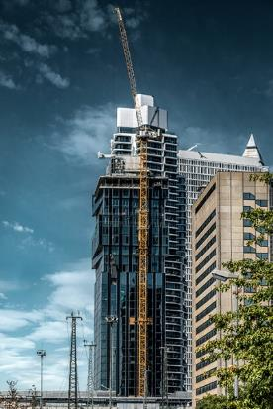
liebherr-hcl-spin-tower-frankfurt-02.jpg
Liebherr's 230 HC-L 8/16 luffing jib crane climbed the outside of the building.
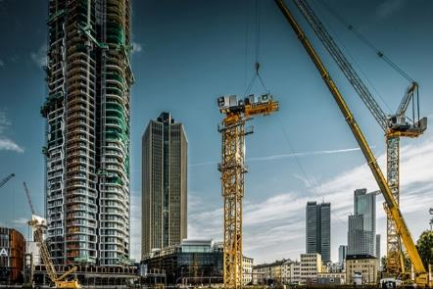
liebherr-hcl-spin-tower-frankfurt-03.jpg
Looking back: the two Liebherr luffing jib cranes were assembled in spring 2019.

Contact
Daniel Haefele
Global Communication
Phone: +49 7351 / 41 - 2330
Email: daniel.haefele@liebherr.com
Published by
Liebherr-Werk Biberach GmbH
Biberach / Germany
www.liebherr.com

