Press release

Liebherr breaks ground for new hydraulic cylinder plant in Oberopfingen

⸺
- The components product segment expands its site in Oberopfingen (Germany)
- Relocation of mechanical production for hydraulic cylinders to the existing main plant in Oberopfingen planned by 2025
Liebherr’s components product segment is expanding hydraulic cylinder production with a new building at the Oberopfingen site. With the new plant, the mechanical production for hydraulic cylinders will join the existing main plant starting from 2024.
Kirchdorf an der Iller (Germany), 15 December 2022 – With a ground-breaking ceremony on 13 December, Liebherr-Components Kirchdorf GmbH has officially commenced construction work for a new plant in Oberopfingen (Germany). The new building will be available from 2024 and will be housing the mechanical production of hydraulic cylinders, which is currently located in Kirchdorf an der Iller. Also, the production-related administrative areas will be moved to Oberopfingen, where the main plant for the production of hydraulic cylinders and other hydraulic components, as well as administration, assembly, painting and logistics have already been located since 2018. The new plant will have a ground area of approximately 46,000 m². "The consolidation of the entire hydraulic cylinder production into one location is the basis for Liebherr to continue to grow and further drive the economic efficiency of our site," says Christian Zenner, Managing Director of Liebherr-Components Kirchdorf GmbH.
With the expansion of the components location, a total of three new halls will be built. One hall houses a logistics area, including a high-bay warehouse, the quality control, the customer service, as well as a modern production for fibre composite components. The other two halls will house a modernised mechanical production. In addition to this, two adjoining administrative buildings will complement the halls. Construction is planned to span 1.5 years, aiming for overall conclusion, including all relocation work, by spring of 2025.
Combined component power
Thanks to the local bundling of production, internal processes and production sequences will be optimised, on the one hand. On the other, opportunities are being created to improve and fully redesign production conditions: "For example, we are expanding the capacity of fibre composite production and investing in new machinery and equipment. In order to implement the overall processes in the best way possible in the future, areas from the older plant in Oberopfingen will also be moved into the new building," explains project manager Thomas Angielsky from Liebherr-Components Kirchdorf GmbH.
"We will not only join forces again as one team in one place, but also exploit potentials for the future – as an attractive employer and a reliable partner,'' explains Christian Zenner. "The construction project is an essential step towards fulfilling our customers' needs, as well as towards positioning ourselves as one of the leading hydraulic cylinder manufacturers worldwide," he adds.
About Liebherr-Components
In this segment, the Liebherr Group specialises in the development, design, manufacturing of high-performance components in the field of mechanical, hydraulic and electric drive and control technology. Liebherr-Component Technologies AG, based in Bulle (Switzerland), coordinates all activities in the components product segment. The extensive product range includes combustion engines, injection systems, engine control units, axial piston pumps and motors, hydraulic cylinders, slewing bearings, gearboxes and winches, switchgear, electronic and power electronics components, and software. The high-quality components are used in cranes and earthmoving machinery, in the mining industry, maritime applications, wind turbines, automotive engineering or in aviation and transport technology. Synergy effects in s other product segments of the Liebherr Group are used to drive continuous technological development.
About the Liebherr Group
The Liebherr Group is a family-run technology company with a highly diversified product portfolio. The company is one of the largest construction equipment manufacturers in the world. It also provides high-quality and user-oriented products and services in a wide range of other areas. The Liebherr Group includes over 140 companies across all continents. In 2021, it employed more than 49,000 staff and achieved combined revenues of over 11.6 billion euros. Liebherr was founded in Kirchdorf an der Iller in Southern Germany in 1949. Since then, the employees have been pursuing the goal of achieving continuous technological innovation, and bringing industry-leading solutions to its customers.

Images
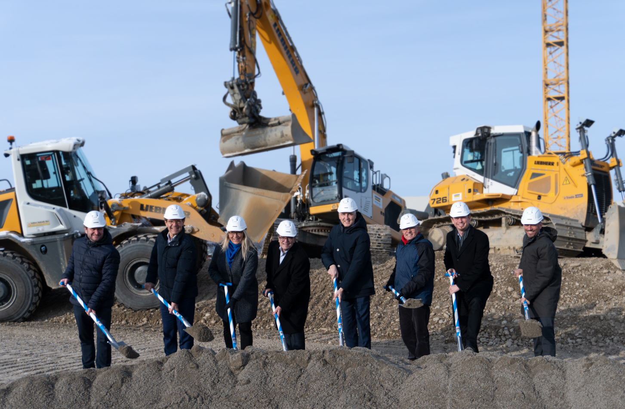
liebherr-oberopfingen-spatenstich.jpg
Ready to rumble: On 13 December 2022, construction work started with a ground-breaking ceremony.

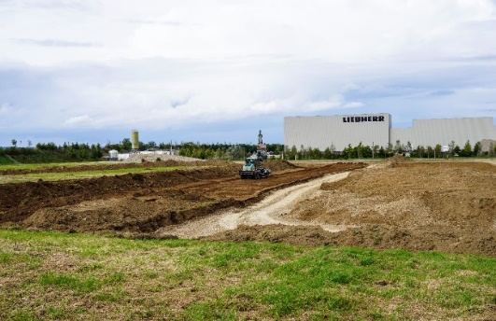
liebherr-Oberopfingen-Bauarbeiten.jpg
Preparations for the construction of a new building at the Liebherr-Components site in Oberopfingen are in full swing.

Contact
Alexandra Nolde
Senior Communication & Media Specialist
Phone: +41 56 295 / 4326
Email: alexandra.nolde@liebherr.com

Published by
Liebherr-Components AG
Nussbaumen/ Switzerland
www.liebherr.com

