Press release

Liebherr large order: WASEL invests 60 million euros

⸺⸺
- As a new subsidiary of the Hagedorn Group, WASEL expands its close cooperation with Liebherr and places major order
- Included in the crane package: LTM 1750-9.1, LR 1700-1.0, LR 11000, LTC 1050-3.1E, LRT 1130-2.1
- Sustainability, trouble-free and efficient use as well as homogeneity in operator application were crucial in the decision to buy the new Liebherr cranes
As a new subsidiary of the Hagedorn Group, WASEL GmbH is continuing and expanding its close cooperation with Liebherr. In a new major order worth 60 million euros, WASEL has bought an LTC 1050-3.1E, an LRT 1130-2.1, an LTM 1750-9.1, an LR 1700-1.0 and an LR 11000, in addition to other Liebherr machines. The new cranes are intended to serve the ongoing modernisation of the equipment fleet, taking sustainability aspects into account. In doing so, it is important to WASEL to ensure trouble-free and efficient use at the customer's site.
Ehingen (Donau) (Germany), 9 December 2022 – As a new subsidiary of the Hagedorn Group, WASEL GmbH is continuing and expanding its close cooperation with Liebherr across all product groups. In addition to a large order for Liebherr tower cranes and, on the part of Hagedorn, construction machinery, WASEL has invested in several new Liebherr mobile cranes – including the two new cranes LTC 1050-3.1E and LRT 1130-2.1 recently unveiled at Bauma. The largest cranes in the package include the Liebherr LTM 1750-9.1 mobile crane and the Liebherr LR 1700-1.0 and LR 11000 crawler cranes.
The two crawler cranes are already the second of their type in WASEL's fleet. "Homogeneity in operator application and workshop operation, as well as ensuring trouble-free and efficient use by the customer, are really important to us," states Managing Director Matthias Wasel, explaining the investment in the Liebherr cranes. "With the replacement and expansion investments, we want to contribute to the ongoing modernisation of the equipment fleet, taking into account sustainability aspects with regard to the emissions standard," Matthias Wasel continues. Together with his brother Thomas Wasel, he still manages the company's business.
Zero emissions: LTC 1050-3.1E with electric drive
The LTC 1050-3.1E with electric drive of the superstructure purchased by WASEL also plays an important role in sustainability and CO₂ reduction. With this compact crane, which has both a conventional drive and an electric motor, crane movements can optionally be carried out with electricity. The new variant of the compact 50-tonner reduces CO₂ emissions and meets the requirements for operation on "zero emission" construction sites. The compact crane retains all its familiar properties regardless of whether it is powered by the electric motor or the internal combustion engine.
Another new crane in the large order is the Liebherr LRT 1130-2.1 rough terrain crane. The powerful telescopic crane offers the highest lifting capacity of 130 tonnes and the longest telescopic boom of all 2-axle rough terrain cranes in the world – and also scores with economical transport and safety.
Strong cranes for the climate revolution
"Wind energy is a crucial component of Germany's energy transition strategy. Thousands of new high-capacity wind turbines must be erected and disused, smaller turbines must be dismantled," Thomas Wasel is certain. In the upper load range, WASEL strengthens its position with an LTM 1750-9.1, an LR 1700-1.0 and an LR 11000. These cranes are specially designed to meet the ever-increasing requirements of wind turbine assembly.
"Overall, German industry is facing immense investments in plants and facilities in order to be able to produce in a climate-neutral way by 2045. Remodelling requires the right equipment, perfectly prepared surfaces and the highest environmental and occupational safety standards. WASEL cranes have long been a reliable partner for the maintenance and repair of industrial plants. Hagedorn complements the portfolio with competences in deconstruction and disposal", explains Thomas Hagedorn, managing partner of the Hagedorn Group of Companies. "No matter whether it's the phasing out of coal, the modernisation of industry, roads and bridges or the expansion of wind power, hydrogen and power lines or the digitalisation of the construction industry – there's a lot for Hagedorn and WASEL to do together," Thomas Hagedorn is convinced. It is important to the two family businesses now and for the future that the economy, people and the environment are equally in focus. That is why all those involved are committed to the responsible use of resources, the clever closing of loops and climate protection.
About WASEL GmbH
WASEL GmbH, with its headquarters in Bergheim in the Rhineland and ten other locations in North Rhine-Westphalia and Berlin, offers complete services for heavy load logistics. WASEL GmbH is also a Liebherr factory dealer for tower cranes. For over seven decades, the name WASEL has been associated with sophisticated project planning, innovative technology and consistent safety thinking.
Today, the company has an equipment and vehicle fleet of over 700 units: Mobile, lattice and crawler cranes of the latest design, heavy-duty vehicles and tower cranes. With more than 400 specialists, WASEL GmbH solves the demanding tasks for customers from industry, petrochemistry and many other areas of the economy.
About the Hagedorn Group of Companies
The Hagedorn Group is Germany's most efficient all-round service provider in the fields of demolition, waste disposal, civil engineering and land revitalisation. The Group's process chain also includes the remediation of contaminated sites, recycling and material flow management, the creation of industrial outdoor facilities and the development of new utilisation concepts. Since the merger with WASEL GmbH in July 2021, heavy load logistics and crane services have supplemented the portfolio. The family business headed by Barbara and Thomas Hagedorn achieved a turnover of over 328 million euros in the 2021 financial year. This makes the company – founded in 1997 by Thomas Hagedorn – one of the top 4 largest and most successful demolition companies in the world with over 1500 employees. In addition to the headquarters in Gütersloh, Hagedorn is now active throughout Germany with additional locations.

About Liebherr-Werk Ehingen GmbH
Liebherr-Werk Ehingen GmbH is a leading manufacturer of mobile and crawler cranes. Its range of mobile cranes extends from 2-axle 35 tonne cranes to heavy duty cranes with a lifting capacity of 1200 tonnes and a 9-axle chassis. Its lattice boom cranes on mobile or crawler crane chassis deliver lifting capacities of up to 3000 tonnes. With universal boom systems and extensive additional equipment, they can be seen in action on construction sites throughout the world. The Ehingen site has a workforce of 3,800. Extensive, global service guarantees the high availability of Liebherr mobile and crawler cranes. In 2021, the Liebherr plant in Ehingen recorded a turnover of 2.33 billion euros.
About the Liebherr Group
The Liebherr Group is a family-run technology company with a highly diversified product portfolio. The company is one of the largest construction equipment manufacturers in the world. It also provides high-quality and user-oriented products and services in a wide range of other areas. The Liebherr Group includes over 140 companies across all continents. In 2021, it employed more than 49,000 staff and achieved combined revenues of over 11.6 billion euros. Liebherr was founded in Kirchdorf an der Iller in Southern Germany in 1949. Since then, the employees have been pursuing the goal of achieving continuous technological innovation, and bringing industry-leading solutions to its customers.

Image
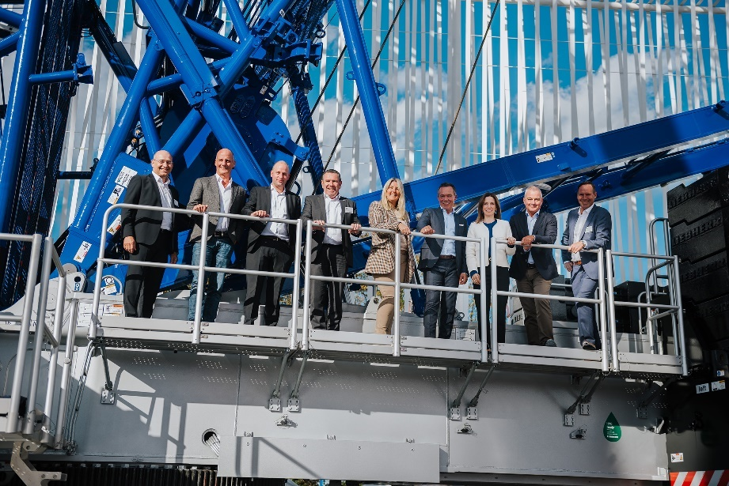
lwe-wasel-bauma-2022.jpg
Here's to continued good cooperation: Wasel, Hagedorn and Liebherr together at Bauma in Munich: (from left to right) Erich Schneider (Liebherr-Werk Ehingen GmbH), Matthias Wasel (Wasel GmbH), Christian Hülsewig (Hagedorn Group of Companies), Christoph Kleiner (Liebherr-Werk Ehingen GmbH), Barbara Hagedorn (Hagedorn Group of Companies), Thomas Hagedorn (Hagedorn Group of Companies), Sophie Albrecht (Member of the Board of Liebherr-International AG), Thomas Wasel (Wasel GmbH), Dieter Walz (Liebherr-Werk Ehingen GmbH).

Contact
Wolfgang Beringer
Marketing and Communication
Phone: +49 7391 / 502 - 3663
Email: wolfgang.beringer@liebherr.com
Published by
Liebherr-Werk Ehingen GmbH
Ehingen (Donau), Germany
www.liebherr.com

