Press release

LiMain remote maintenance showcased live

⸺
Platform operators in the offshore wind industry experienced remote maintenance of offshore cranes in action
From Nenzing, Austria, LiMain module 4 was used for remote maintenance of a RL 2600 offshore crane stationed in Rostock, Germany
Offshore crane maintenance controlled from onshore will reduce manned service calls significantly

Well-known representatives from the offshore wind industry were convinced live of the benefits of remotely maintaining cranes with the help of LiMain – Liebherr Intelligent Maintenance. LiMain is a fully digital, remote, and semiautomatic maintenance system that saves platform operators significant investments and resources. Thanks to remote maintenance, platform operators can remotely maintain the crane on manned or unmanned platform.

Rostock (Germany), December 2022 – As the energy transition develops, wind farms are increasingly being built in offshore locations, making maintenance of all the necessary equipment a challenge. Automated intelligence is therefore becoming an effective solution to make offshore crane maintenance work more resource efficient. Liebherr recognised this trend early on and developed its LiMain intelligent maintenance concept in response.
A new level of independence for manned and unmanned platform operators is provided by this maintenance system. Liebherr Intelligent Maintenance will enable anyone to maintain a crane on a platform without being on site. It allows operators to act whenever and wherever they are. Ideally, owners or operators would have to visit their platform for service only once during an entire year, which is an outstanding business advantage. Visits could be even less frequent depending on platform type and usage. This way, LiMain embodies the future workplace in a digitalised world: Maintenance work independent of time and space.
Live showcase in Rostock
In autumn 2022, the new system was presented to well-known representatives of the offshore wind industry in a live show. An offshore crane of type RL 2600, located in Rostock, Germany, was controlled from Nenzing, Austria. LiMain was convincing throughout. "Maintenance costs are a decisive factor in the offshore sector. Today's presentation has exceeded our expectations," comments Caspar Stein from Siemens Energy in Hamburg, Germany.
Afterwards, all participants were able to pick up the joysticks themselves. The offshore crane RL 2600 could be controlled from the office building via a remote-control station. The participants were impressed by the precise control, which was made possible by the very low latency.
Modular system
The foundation of LiMain is its modular system architecture consisting of four modules: Automatic Greasing, Condition Monitoring, Predictive Maintenance and Remote Maintenance Cycle. The modular package enables operators to determine the scope of intelligent maintenance that meets their needs.
Automatic Greasing will continuously check critical components and automatically lubricate them when needed, even in complexly installed positions. Condition Monitoring benefits from sensor technology, detailed data about the crane as well as its components, and is monitored in real-time to deliver an unprecedented level of insight. Predictive Maintenance puts ad-hoc data into context, building on decades of experience from the construction of over a thousand offshore cranes. The module serves as the foundation for an optimised product and component lifecycle. Remote Maintenance Cycle represents the combination and interconnection of all the previously mentioned modules – the crane is remotely moved, and semiautomatic maintenance and self-diagnosis is enabled.
With LiMain up to 75 % less mobilisation and up to 50 fewer man-days on platforms are possible. As a result, platform owners will save immensely on resources, whether on personnel, material, or transport.

About Liebherr-MCCtec Rostock GmbH
Liebherr-MCCtec Rostock GmbH is one of the leading European manufacturers of maritime handling solutions. The product range includes ship, mobile harbour and offshore cranes. Reach stackers and components for container cranes are also included in the product portfolio.
About the Liebherr Group
The Liebherr Group is a family-run technology company with a broadly diversified product range. The company is one of the largest construction machinery manufacturers in the world. However, it also offers high-quality, user-oriented products and services in many other areas. Today, the group comprises more than 140 companies on all continents. In 2021, it employed more than 49,000 people and generated a total consolidated turnover of over 11.6 billion euros. Liebherr was founded in 1949 in Kirchdorf an der Iller in southern Germany. Since then, the employees have pursued the goal of convincing their customers with sophisticated solutions and contributing to technological progress.

Images
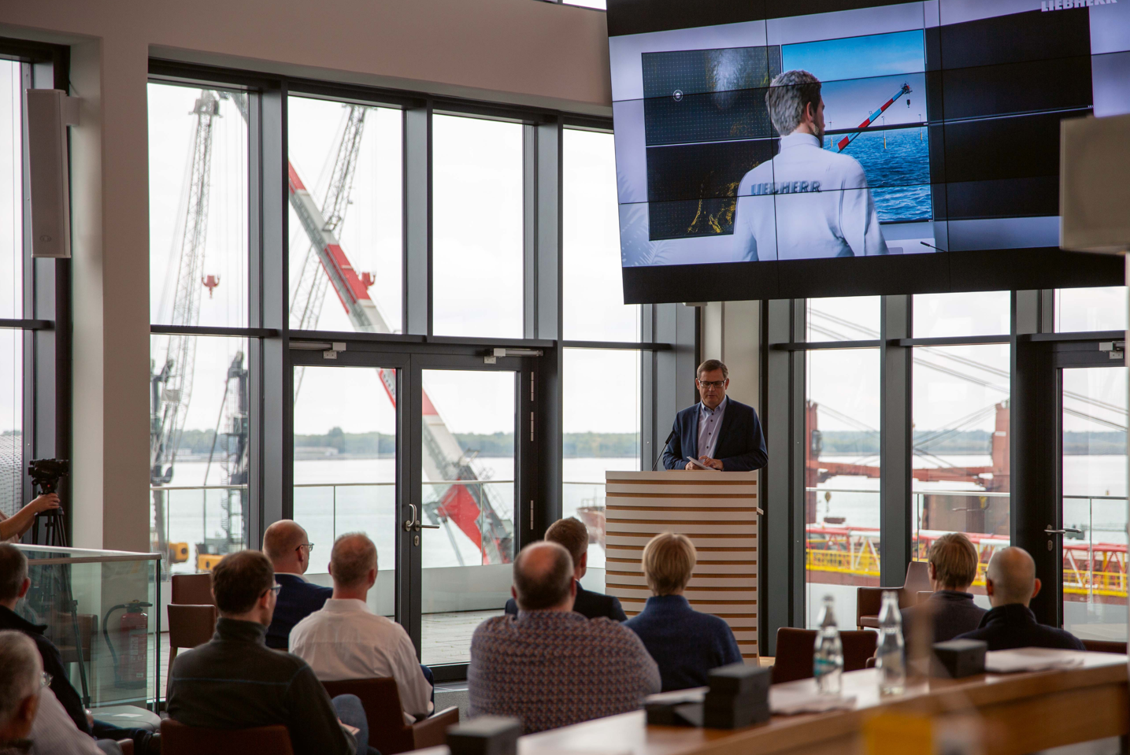
liebherr-remote-maintenance-limain-showcase-rostock-germany-1
From Nenzing, Austria, LiMain module 4 was used for remote maintenance and control of an RL 2600 offshore crane stationed in Rostock, Germany.

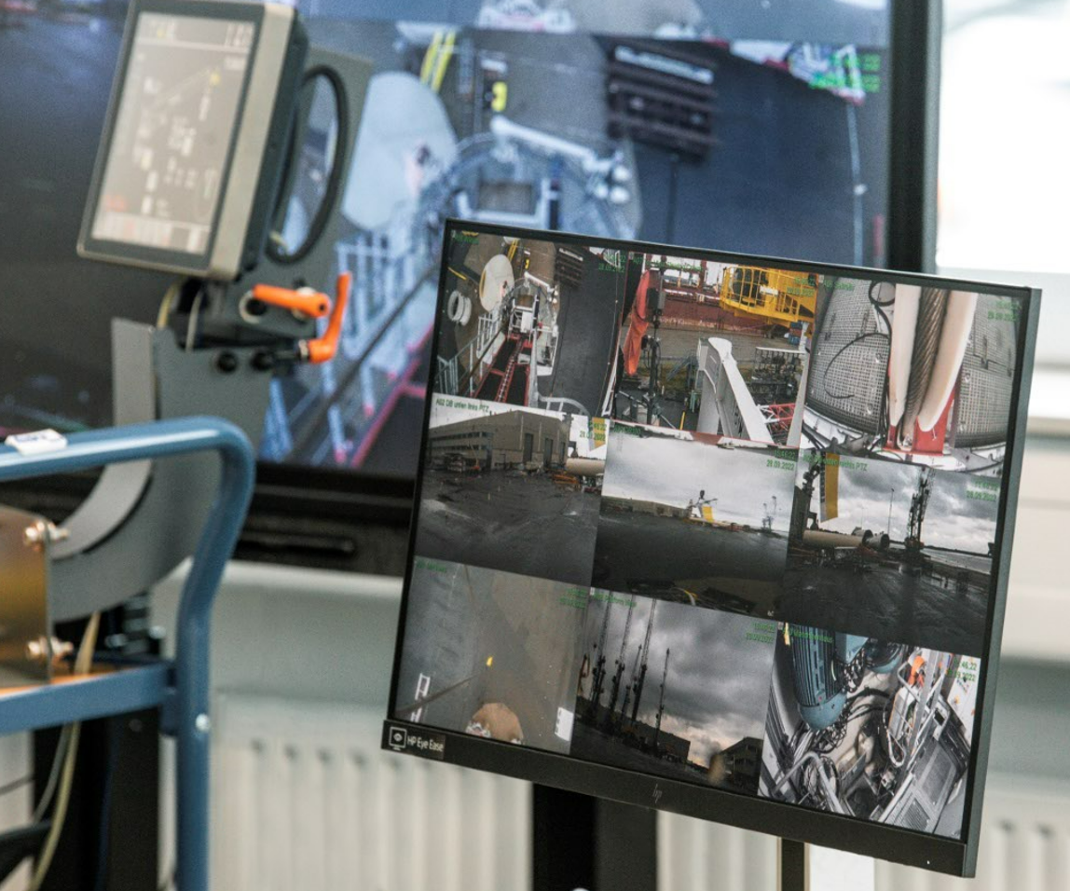
liebherr-remote-maintenance-limain-showcase-rostock-germany-2
Offshore crane maintenance controlled from onshore will reduce manned service calls significantly.

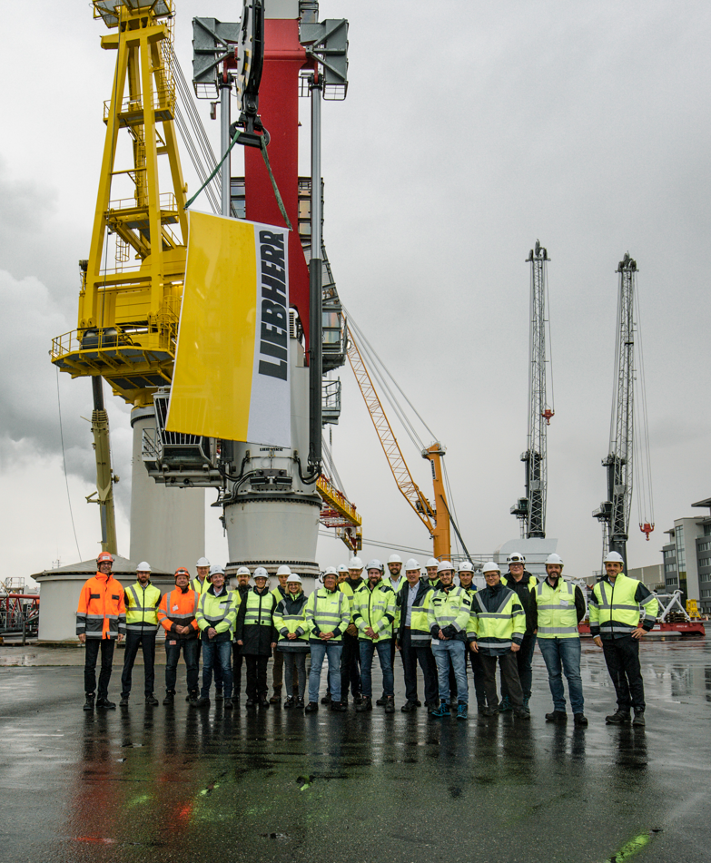
liebherr-remote-maintenance-limain-showcase-rostock-germany-3
Platform operators in the offshore industry experienced remote maintenance of offshore cranes in action.

Contact
Philipp Helberg
Phone: +49 381 6006 5024
E-mail: Philipp.helberg@liebherr.com

Published by
Liebherr-MCCtec Rostock GmbH
Rostock / Germany
www.liebherr.com

