Press release

Successful business deal at Bauma 2022: LEONHARD WEISS orders ten Liebherr railroad excavators

⸺
LEONHARD WEISS construction company placed an order for ten Liebherr railroad excavators
The Bauma construction machinery and mining trade fair from 24 to 30 October 2022 in Munich provided the ideal setting for this
The A 922 Rail Litronic is predestined for versatile applications in track construction
LEONHARD WEISS GmbH & Co KG, one of the leading construction companies in Europe, is expanding its machine portfolio and once again relying on Liebherr. The order for ten new A 922 Rail Litronic was concluded at Bauma 2022. The machines are to be used primarily in the areas of track and switch conversion, platform construction and the erection of level crossings, noise barriers and overhead lines.
Munich (Germany), 25 October 2022 - Infrastructure projects, especially in the rail sector, play an important role in shaping the future. Both the new construction and the expansion as well as the maintenance of rail infrastructures are the basis for this. With the ten new Liebherr railroad excavators, LEONHARD WEISS construction company will continue to contribute to this in the future.
Liebherr and LEONHARD WEISS have a long-standing and trusting relationship. Over the last eight years, the construction company with its two main sites in Göppingen and Satteldorf has taken delivery of around 65 Liebherr A 922 Rail machines, which are now used throughout Germany on a wide range of projects. Now the machine portfolio is being supplemented by ten more railroad excavators. "We are delighted to be adding further powerful and versatile Liebherr excavators to our existing machine fleet. We were able to take advantage of Bauma to conclude the contract directly with Liebherr and the Liebherr sales and service partner Nagel Baumaschinen in Ulm. We really appreciate the personal exchange and the fast, uncomplicated communication channels," emphasises Ralf Schmidt, shareholderand managing director of the technology department at LEONHARD WEISS.
Overall concept of Liebherr machines convinced again: Solid, powerful and adaptable
"We are convinced by the overall concept of the Liebherr railroad excavators. The machines have numerous advantages that had a decisive influence on our purchase decision. These include, among other things, the extraordinarily good stability when working with high payloads or the enormous performance of the machines in operation with hydraulic attachments," emphasises Ralf Schmidt.
The construction company is also enthusiastic about the generously designed double cab of the machines. It not only offers a high level of user-friendliness and comfort for the machine operators in their daily work. Thanks to the large glazing in combination with the standard rear and side camera, it also ensures optimum visibility and thus better safety conditions in the working and slewing area.
Another decisive purchase criterion was the high machine availability and Liebherr's excellent service network, especially with regard to the new EU regulation ECM (Entity in Charge of Maintenance). This is a mandatory certification system for the institutions and bodies involved in the maintenance of railway vehicles. Ralf Schmidt notes: "Like LEONHARD WEISS, Liebherr-Hydraulikbagger GmbH and Nagel Baumaschinen Ulm GmbH are officially certified according to ECM and will thus continue to be available to us in the future for competent advice thanks to holistic, ECM-compliant processes."
The Liebherr railroad excavator: Top quality for versatile applications since 1967
Since 1967, Liebherr has been developing and producing railroad excavators to high quality standards, which can be used for both road and rail applications. With an operating weight of between 20,400 and 23,400 kg, the A 922 Rail Litronic is the smaller representative of Liebherr's railroad excavator portfolio. A rail undercarriage is mounted on both sides of the undercarriage. This brings the tyres to rail level during rerailing, with the inner wheels of the twin tyres taking over the travel drive on the rail.
Equipped with the fully hydraulic quick-coupling system LIKUFIX® from Liebherr, which has also been in use at LEONHARD WEISS for many years, the excavator can work with a wide variety of mechanical and hydraulic attachments, which can be changed safely and conveniently directly from the driver's cab. The machines are thus very adaptable to their respective working environment and a wide variety of work applications.

About the Liebherr Group
The Liebherr Group is a family-run technology company with a highly diversified product portfolio. The company is one of the largest construction equipment manufacturers in the world. It also provides high-quality and user-oriented products and services in a wide range of other areas. The Liebherr Group includes over 140 companies across all continents. In 2021, it employed more than 49,000 staff and achieved combined revenues of over 11.6 billion euros. Liebherr was founded in Kirchdorf an der Iller in Southern Germany in 1949. Since then, the employees have been pursuing the goal of achieving continuous technological innovation, and bringing industry-leading solutions to its customers.
Image
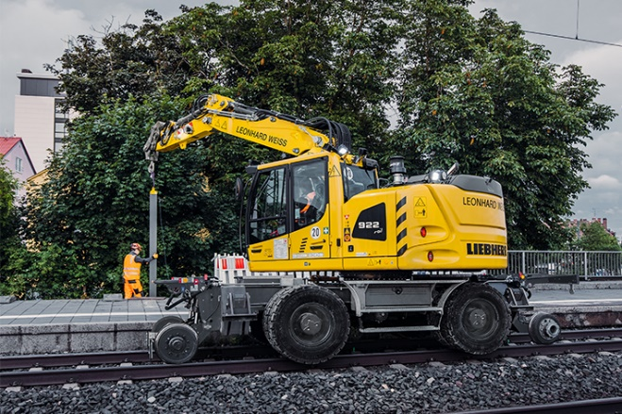
liebherr-leonhard-weiss-a922rail.jpg
LEONHARD WEISS GmbH & Co KG, one of the leading construction companies in Europe, ordered ten Liebherr railroad excavators A 922 Rail Litronic at Bauma 2022.
Contact
Nadine Willburger
Marketing
Phone: +49 7354 / 80 - 7332
E-mail: nadine. willburger@liebherr.com
Published by
Liebherr-Hydraulikbagger GmbH
Kirchdorf a.d. Iller / Germany
www.liebherr.com

