Press release

Port Canaveral acquiring second LHM 600

⸺
The new LHM 600 is part of Liebherr’s latest mobile harbour crane generation, and is expected to arrive at Port Canaveral in December 2023
Canaveral Port Authority officials visited Liebherr Rostock in September 2022 for a signing ceremony
Port Canaveral entered their first LHM 600 into service in February 2019

Port Canaveral has agreed to purchase another mobile harbour crane from the Liebherr Group to serve the Port’s growing cargo operations. The LHM 600 will be based on the updated generation of Liebherr mobile harbour cranes. Digital enhancements, a modernised cabin, and improved lifting height are among the crane’s benefits welcomed by Port Canaveral.

Rostock (Germany), November 15, 2022 – The second LHM 600 purchased by Port Canaveral is built for the future. It boasts a contemporary exterior design and is more digitally advanced and efficient. Assistance and partial automation systems are made possible by a sophisticated crane control system, evolved sensor integration, and digital information transfer. It will be Port Canaveral’s second mobile harbour crane to be deployed. In early 2019, the Port put into service its first Liebherr mobile harbour crane of type LHM 600.
The forthcoming crane will have a lift capability up to 154 tons and a jib length of 61 meters. Its 20-container reach will accommodate containers stacked nine high on deck – an upgraded handling capability from the first crane.
Pioneering crane will support growing cargo business, offer more features
Port Canaveral is already familiar with Liebherr mobile harbour cranes. The LHM 600 that started its work in early 2019 has been instrumental in heavy-lifting operations for the Port. In Fiscal Year 2020, the current LHM 600 already lifted a record number of boosters for space projects. With the upcoming LHM 600, the outreach ability has been upgraded from 58 to 61 meters.
“We’re pleased to add this major acquisition to our port to better meet the demands of an expanding portfolio of diverse cargo,” notes Port CEO Captain John Murray. “We’re projecting the pace of growth in cargo handling to be very significant over the coming year. This crane will provide greater lift capability that will also meet the needs of the developing commercial space enterprise in our region.”
Modern cabin and other amenities distinguish the next LHM 600
Driver comfort and safety were carefully considered in the crane update, with the redesign of the LHM operator’s cab offering many practical advantages. An innovative coupling of joystick and armrest helps ensure that the control of the crane becomes more precise and safer, while at the same time increasing operator comfort. A variety of project cargo, whether for space projects or other clients of the port, can thus be handled more effectively. To also enable a more simplified operation of the crane, a newly integrated touch panel interface allows for all crane functions to be selected clearly and intuitively.
Relevant to Florida’s often hot and humid climate, a revised air-conditioning concept increases the well-being of the operator, whether for cooling or heating. It also ensures that fogged windows are quickly dehumidified, thus providing a clear view and more safety.
With these and other improvements, the upcoming LHM 600 will be the optimal mobile harbour crane with which Port Canaveral can handle a variety of logistical projects in the future.

About Liebherr-MCCtec Rostock GmbH
Liebherr-MCCtec Rostock GmbH is one of the leading European manufacturers of maritime handling solutions. The product range includes ship, mobile harbour and offshore cranes. Reach stackers and components for container cranes are also included in the product portfolio.
About the Liebherr Group
The Liebherr Group is a family-run technology company with a broadly diversified product range. The company is one of the largest construction machinery manufacturers in the world. However, it also offers high-quality, user-oriented products and services in many other areas. Today, the group comprises more than 140 companies on all continents. In 2021, it employed more than 49,000 people and generated a total consolidated turnover of over 11.6 billion euros. Liebherr was founded in 1949 in Kirchdorf an der Iller in southern Germany. Since then, the employees have pursued the goal of convincing their customers with sophisticated solutions and contributing to technological progress.
Images
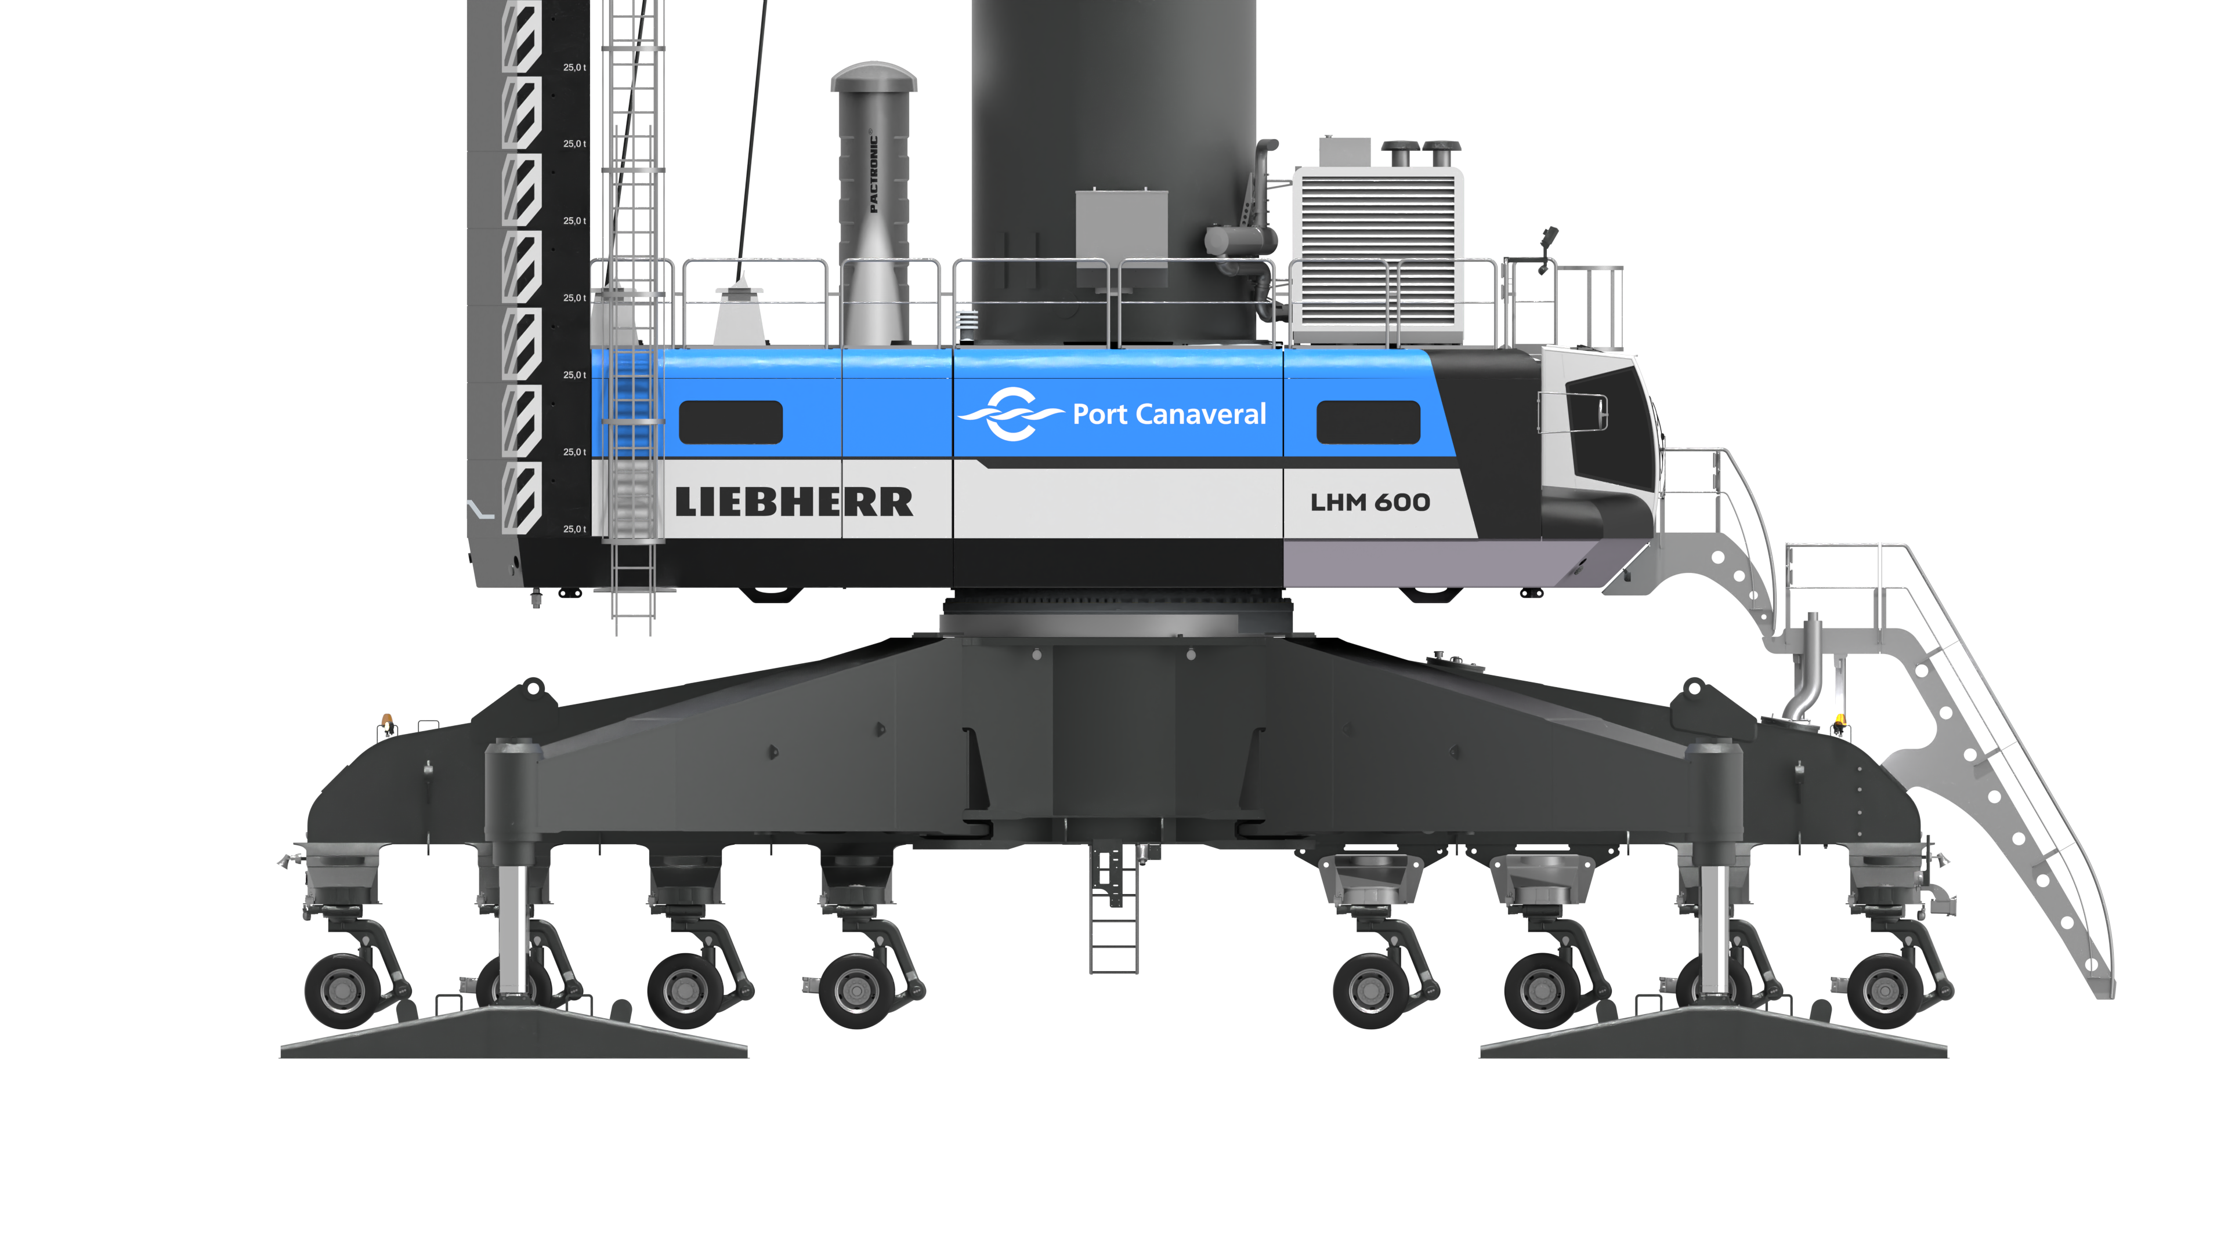
liebherr-lhm-600-mobile-harbour-crane-port-canaveral-north-america-1.jpg
The redesigned Liebherr LHM 600 offers an updated cabin and many innovations for increased comfort, efficiency, and safety.

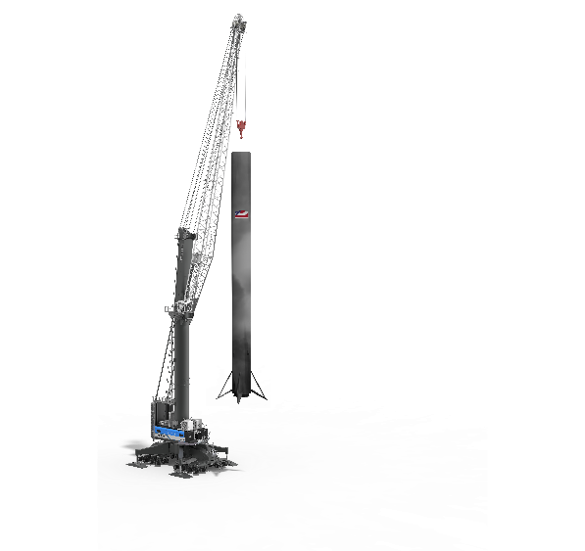
liebherr-lhm-600-mobile-harbour-crane-port-canaveral-north-america-2.jpg
With a variety of technical upgrades, the next iteration of the LHM 600 will offer better performance for a range of cargo for Port Canaveral, including for a growing space industry.

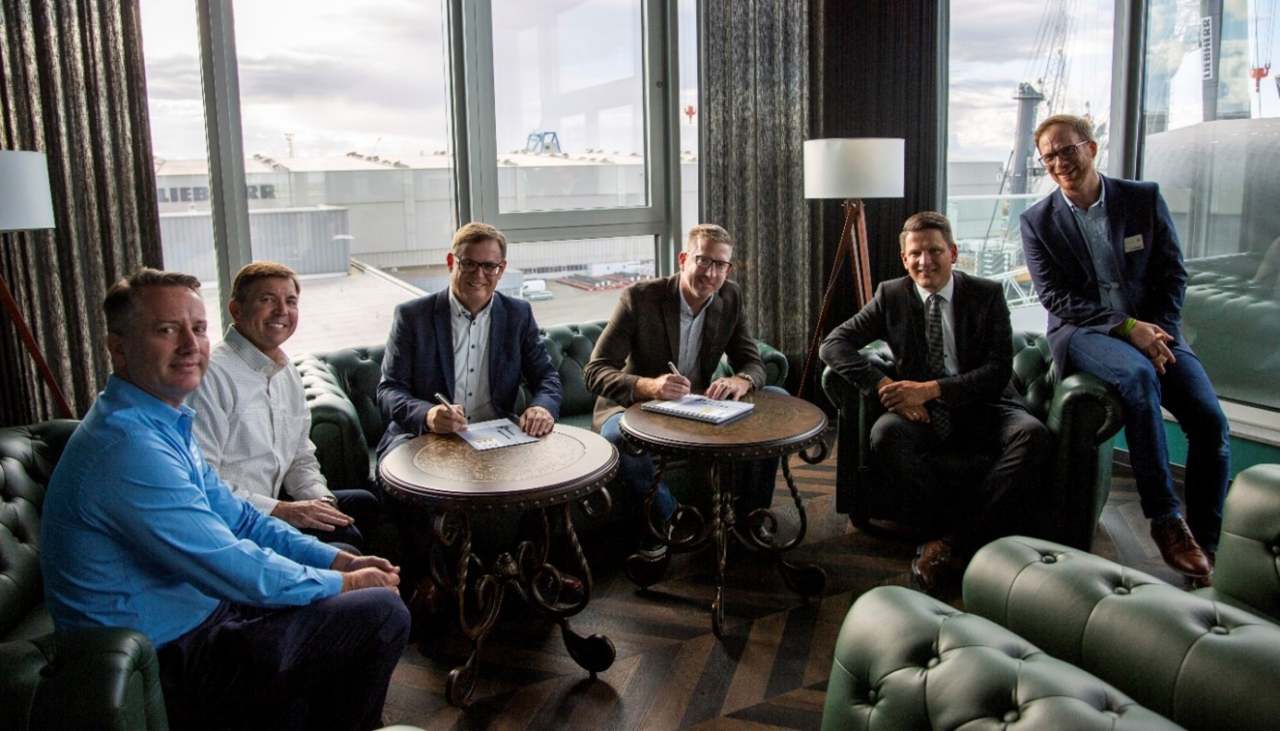
liebherr-lhm-600-mobile-harbour-crane-port-canaveral-rostock-signing-ceremony.jpg
In September 2022, Canaveral Port Authority officials met in Liebherr’s corporate headquarters in Rostock, Germany, for a signing ceremony (f.l.t.r. William Crowe, Vice President, Engineering, Construction and Facilities at Canaveral Port Authority; Michael B. Poole, CFO at Canaveral Port Authority; Leopold Berthold, Managing Director at Liebherr Rostock; Micah Loyd, Port Commissioner at Port Canaveral; Andreas Müller, LHM Sales Director at Liebherr Rostock; Winston Ziegler, Head of Sales at Liebherr U.S.).

Contact
Mathias Haugner
Phone: +49 381 6006 5036
E-Mail: mathias.haugner@liebherr.com

Published by
Liebherr-MCCtec Rostock GmbH
Rostock / Germany
www.liebherr.com

