Press release

Bigge’s Perfect Fleet is growing bigger with new Liebherr models!

⸺

- LR 1400 SX: Liebherr’s biggest multipurpose crawler crane
- LR 1700-1.0: combines the benefits of economical transport with high performance

For Liebherr’s long-standing customer, Bigge Crane and Rigging Co., it is crucial to provide the right crane for the right market at the right cost. On the first day of Bauma 2022, Liebherr has handed over new crawler cranes to the company - an LR 1400 SX and an LR 1700-1.0. These new models are on top of Bigge’s Perfect Fleet®, including over a hundred crawler and mobile cranes from Liebherr.
Munich (Germany), October 24, 2022 – Based in California and Texas, Bigge is one of the biggest crane rental companies in the USA. “Big” is also the keyword for the machine that was the first to be handed over at the Liebherr booth at this year’s Bauma. The LR 1400 SX is the largest multipurpose crawler crane that Liebherr has ever built. It was developed because Liebherr listened to its customers. “Just build a bigger LR 1300,” said one customer. The LR 1300 SX is the best-selling crawler crane to date. Over fifteen years ago, Bigge started to use their first 300-tonne crawler cranes for lifting activities. To date, they have purchased more than 130 models of the LR 1300 SX.
But the loads that need to be moved are getting heavier and heavier, and this changes the demands on the cranes. The new LR 1400 SX results from the customers’ needs – powerful, fast, and easy to operate. The crawler crane has a load capacity of 400 tonnes.
Bigge emphasized at the handover that the LR 1400 SX on display at the Bauma is one of many more models they are planning to add to their fleet. The company has already ordered three more units. This purchase represents Bigge’s significant commitment to offering a Perfect Fleet to customers and partners everywhere, providing the right crane for the right market at the right cost.
Despite its size, the LR 1400 SX is easy to transport and assemble. The heaviest part of transport is the uppercarriage. It includes the carbody center section and the A-frame – parts that never need to be disassembled. Even the walkways and railings can easily be folded up and remain on the crane for transport.
Thanks to the crane’s self-assembly system, it is easy to assemble and disassemble the hoist winches, crawlers, carbody counterweight, and boom sections – all of this without a service crane. The crane can even lift, lower, and secure the 150-tonne rear counterweight hydraulically. The rear counterweight itself is modular and can be equipped with five or 10-tonne counterweight slabs, depending on the requirements.
The LR 1400 SX is equipped with a powerful 450 kW Liebherr diesel engine – the most powerful engine in its class! The crawlers are now equipped with four drive motors, making it easier to manoeuvre on construction sites with difficult ground conditions.
Third LR 1700-1.0 on order
Bigge already operates two LR 1700-1.0 crawler cranes in its fleet and has ordered a third crane for delivery in 2023. It is intended for use in industry and wind power. Bigge will then operate the largest fleet of this type of crane in the USA.
The LR 1700-1.0 combines the benefits of economical transport of 600 tonne (660 US-ton) class crawler cranes with the performance of 750 tonne (825 US-ton) class lattice boom cranes. Also, it features all the innovations of Liebherr’s crawler crane developments from the last few years.
The LR 1700-1.0 is actually the benchmark in this crane class for lattice boom cranes both for classic industry work and also for wind power. The boom can be raised to a height of up to 198 metres, comprising the main boom at 102 metres and a luffing jib at 96 metres. These lattice sections enable the crane to be used in purely main boom mode with a length of up to 162 metres.
Minimal wear is becoming more and more important for moving the crawler travel gear, particularly during jobs at wind farms. The Liebherr engineers have therefore made the structural steelwork for the crawler carriers particularly robust and increased the size of the rollers. The 4-fold drive for the travel gear is standard.
Bigge also operates the largest fleet of LR 1500s in the US. Two more LR 1500s are on order for delivery in 2023. For the first of these, Bigge has ordered equipment for wind power and industrial applications.
Bigge has also ordered two LTM 1230-5.1s from Liebherr.
The Liebherr staff are delighted with the orders from its long-standing customer – also because many industry insiders consider an order from Bigge as a seal of quality. The crane rental company advertises to offer its customers the Perfect Fleet with the best cranes in their class.

The animation shows the LR 1400 SX from its transportation to the jobsite to the execution of lifting work: Liebherr - Crawler Crane LR 1400 SX - YouTube

Images
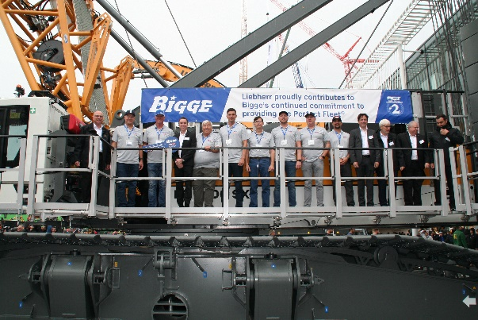
liebherr-handover-lr-1400-sx.jpg
Liebherr handed over the new LR 1400 SX crawler crane to Bigge.

Contact
Philipp Hirth
Head of Public Relations
Phone: +49 7351 41-4445
eMail: philipp.hirth@liebherr.com
Published by:
Liebherr-International Deutschland GmbH
Biberach/ Germany
www.liebherr.com

