Press release

Workout with 100 tonnes: the new LR 1100.1 from Liebherr

⸺
- Most powerful engine in its class
- High flexibility thanks to radio remote control
- Gradient Travel Aid for safe negotiation of slopes and inclines
The quick availability of crawler cranes is a decisive factor in the 100-tonne class. A requirement that the new LR 1100.1 fulfils perfectly making it the ideal multi-purpose crane on any construction site.
Munich (Germany), 24 October 2022 - The new crawler crane LR 1100.1 is optimised for all typical lifting applications in the 100-tonne class. It can be configured either with a main boom up to 62 metres, or with a main boom up to 44 metres in combination with a fixed jib up to 20 metres.
The LR 1100.1 is fitted with the most powerful engine in its class - 230 kW provide the necessary performance for the lifting operations. Thanks to the Eco-Silent Mode, the engine speed can be reduced to a predefined level. This means that diesel consumption and noise emission are reduced but performance level remains the same. The Automatic Engine Stop Control offers a further economic and environmentally friendly solution. After checking certain system functions, the engine is switched off during longer work interruptions.
Everything in focus: compact transport, self-assembly system, and radio remote control
The crawler crane is optimised for quick transfer between construction sites. The transport width is 2,983 or 3,500 millimetres, depending on whether the crane is transported with or without crawlers. At the construction site, the assembly of the LR 1100.1 is simplified through the self-assembly system and radio remote control.
Radio remote control allows the crane operator a high degree of flexibility and additional safety also during operation. The crane can be operated from outside the cabin and so allow for a better overview of the construction site. So-called blind spots can thus be avoided. Depending on the application, a second person is often no longer required to assist with hand signals during lifting operations. Furthermore, the cabin of the new crawler crane can be elevated by 2.8 metres, thus allowing for a good all-round view.

Safety on the slopes
For the safe negotiation of slopes and inclines, the new crane is fitted with Gradient Travel Aid. The control system automatically calculates the centre of gravity and warns the operator before the crane leaves the safe area. While travelling, the operator constantly receives information about the permissible and actual gradient and the crane's overall centre of gravity. If necessary, the boom angle can be altered so that the machine remains in the safe area.
Further insights of the Gradient Travel Aid: Liebherr - Gradient Travel Aid - YouTube
About the Liebherr Group
The Liebherr Group is a family-run technology company with a highly diversified product portfolio. The company is one of the largest construction equipment manufacturers in the world. It also provides high-quality and user-oriented products and services in a wide range of other areas. The Liebherr Group includes over 140 companies across all continents. In 2021, it employed more than 49,000 staff and achieved combined revenues of over 11.6 billion euros. Liebherr was founded in Kirchdorf an der Iller in Southern Germany in 1949. Since then, the employees have been pursuing the goal of achieving continuous technological innovation, and bringing industry-leading solutions to its customers.
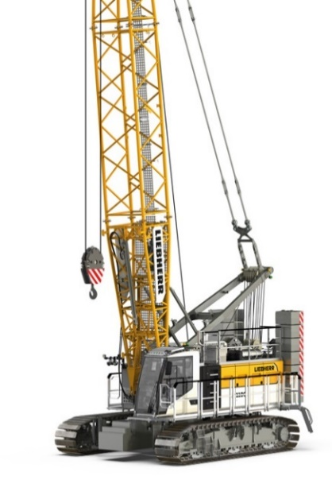
Images
liebherr-lr-1100.1.jpg
The multi-purpose crane from Liebherr for all jobsites: the LR 1100.01
Contact
Gregor Griesser
Strategic Marketing and Communications
Email: gregor.griesser@liebherr.com
Wolfgang Pfister
Head of Strategic Marketing & Communications
Tel.: +43 50809 41444
Email: wolfgang.pfister@liebherr.com
Published by
Liebherr-Werk Nenzing GmbH
Nenzing/Austria
www.liebherr.com

