Press release

Liebherr crawler concrete pump for special civil engineering at Bauma

⸺
Liebherr is showing a 110 D-K crawler concrete pump for special civil engineering together with a Liebherr LRB 23 piling and drilling rig at Bauma in Munich. Both units often work in tandem on construction sites. Due to its high flexibility, the mobile Liebherr crawler concrete pump is particularly suitable for use on construction sites with frequent changes of location within the construction site. The concrete pump mounted on a crawler chassis can be conveniently controlled via a radio remote control.
Munich (Germany), 24 October 2022 – The Liebherr crawler concrete pump is normally used in bored pile foundations to supply concrete to a drilling rig. This work involves deep drilling holes to prepare the ground for construction. When the drill is pulled out, these holes are filled with concrete. In the process, the concrete is conveyed down via a tube in the middle of the drill. The crawler concrete pump travels in parallel with the drilling rig to the various application positions, with the concrete hose remaining connected to the drilling rig. The Liebherr crawler concrete pump is also suitable for various other types of pumping applications.
Data exchange via radio optimises workflows on the construction site
The crawler concrete pump and the drilling rig are connected by radio and can thus communicate and exchange information on the construction site. The recurring processes of drilling, pulling and pumping can thus be optimised: the driver of the drilling rig can start and stop the pumping process from his cabin, accurate to the second. This contributes to both simpler and more efficient workflows taking less time.
Two high-quality models: robust, powerful and easy to maintain
The robust crawler concrete pump is available in two performance classes, the THS 110 D-K and the THS 140 D-K. The more powerful version manages up to 135 m³ per hour. Both types are equipped with powerful six-cylinder engines. The powerful pump units run very quietly and have very good suction performance. The hydraulic system is particularly easy to maintain thanks to the open hydraulic circuit. The design also facilitates the replacement of wearing parts, which greatly simplifies servicing. The shape of the feed hopper without edges or protrusions also reduces concrete residues and dirt. The machine's extensive equipment also includes a capacious 500-litre water tank with water pump and a lockable tool box. The high-quality design, characterised by smooth and easy-care surfaces, rounds off the overall concept of the two machines.
Further insights into the exciting teamwork of the crawler concrete pump with the piling and drilling rig can also be found here: https://www.liebherr.com/dreamteam
About Liebherr-Mischtechnik GmbH
Liebherr-Mischtechnik GmbH is a global manufacturer and supplier of high-quality concrete mixing plants, concrete pumps and ready-mixed concrete truck mixers. The company is part of the Liebherr group and is headquartered in Bad Schussenried, Germany.
About the Liebherr Group
The Liebherr Group is a family-run technology company with a highly diversified product portfolio. The company is one of the largest construction equipment manufacturers in the world. It also provides high-quality and user-oriented products and services in a wide range of other areas. The Liebherr Group includes over 140 companies across all continents. In 2021, it employed more than 49,000 staff and achieved combined revenues of over 11.6 billion euros. Liebherr was founded in Kirchdorf an der Iller in Southern Germany in 1949. Since then, the employees have been pursuing the goal of achieving continuous technological innovation, and bringing industry-leading solutions to its customers.
Images
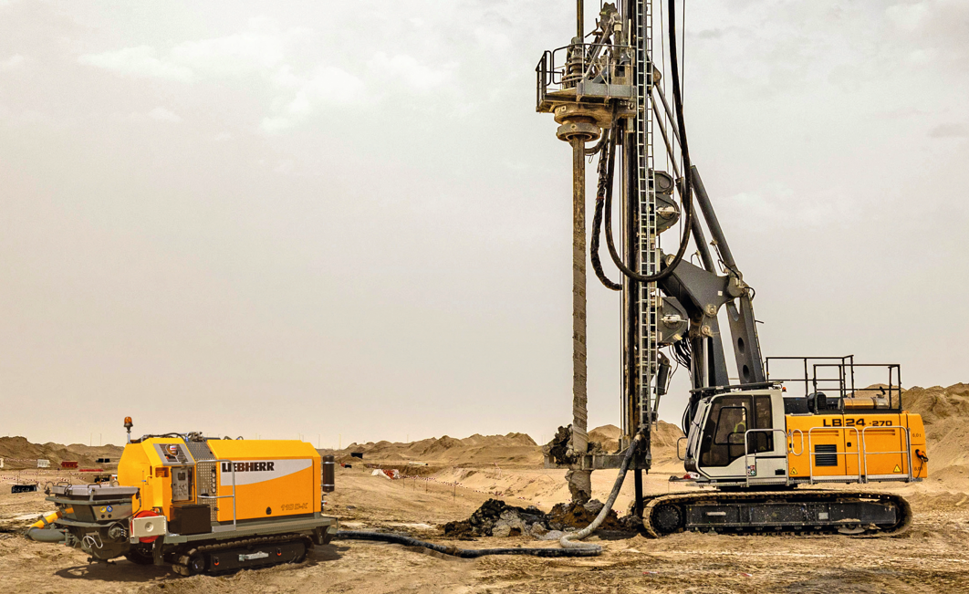
liebherr-crawler-concrete-pump.jpg
Liebherr THS 110 D-K crawler concrete pump with Liebherr drilling rig.
Contact
Klaus Eckert
Head of marketing
Telephone: +49 7583 949-328
E-Mail: klaus.eckert@liebherr.com
Published by
Liebherr-Mischtechnik GmbH
Bad Schussenried / Germany
www.liebherr.com

