Press release

The Liebherr R 950 Tunnel-E: an electric crawler excavator with cable and battery-powered mobility kit

⸺
The R 950 Tunnel crawler excavator now comes in a electric drive version: the R 950 Tunnel-E
With the aid of a 100% electric engine, the R 950 Tunnel-E solution offers a response to the powerful environmental arguments for low-emission construction sites in the future
This crawler excavator is supplied with a battery-powered mobility kit
A model suited to underground sites
The Bauma construction technology fair is the showcase Liebherr-France SAS has picked for its new R 950 Tunnel-E electric crawler excavator. As part of its research into alternative drive concepts embracing a variety of technologies, the Liebherr Group is developing more and more solutions for all its construction machines. The R 950 Tunnel-E, a new iteration of the R 950 Tunnel launched in a diesel version in 2015, takes centre stage at a dynamic presentation of some key alternative solutions offered by the Liebherr Group.
Munich (Germany), 24 October 2022 – the R 950 Tunnel-E crawler excavator features an electric power system that can be connected to the power supply directly with its own cable or via an optional cable reel. For greater flexibility, a battery-powered travel kit is available as an option, to ensure improved temporary mobility without a cable connection to the mains. This newest innovation from Liebherr-France SAS in Colmar is a model perfectly tailored to underground sites.
Zero on-site emissions
Using this new crawler excavator leads to cleaner sites, as there are no on-site emissions. Environmental impact is reduced because there is less risk of the soil pollution that used to be caused by engine oil or fuel. In addition, using this machine guarantees zero CO, CO2, NOX and particulate emissions. The air exhaust system has also been simplified.
Another goal of the R 950 Tunnel-E is making customers’ sites easier to manage, by increasing excavator availability while at the same time reducing energy costs.
To provide a pleasant working environment and comfortable conditions, the R 950 Tunnel-E has also been designed to produce less noise and heat.
A robust electric excavator
The machine’s hydraulic and structural components have already been tried and tested in the diesel version of the R 950 Tunnel. For optimal tunnelling performance, the equipment, undercarriage, crawler tracks, cab and bodywork have been reinforced.
This excavator comes equipped with a 100% electric, water-cooled synchronous engine. The power supply is three-phase 400 V, frequency 50 Hz, while the engine provides 150 to 190 kW power output, with a cutting option. A water-cooled battery pack with NMC technology, similar to a car battery, is available as an option. It has 64 kWh energy capacity provided by two 32 kWh batteries allowing 30 minutes’ travel at 2 km/h. With the machine operating in cable mode, a battery pack at 20% charge takes just 2.5 hours to reach 100% charge.
An ideal model for underground sites
Inside a tunnel, extreme working conditions prevail. Narrow and confined spaces, large amounts of equipment, and dust are factors that make work difficult.
The R 950 Tunnel-E crawler excavator is ideally suited for underground use.
The lift height limitation automatically restricts machine movements in order to reduce the risk of collision to a minimum. This minimises impacts on the equipment, hoses and piping. The small swivel radius and the side and rear cameras also reduce the risk of collision with walls, equipment or site personnel.
About Liebherr-France SAS
Liebherr-France SAS, based in Colmar, has been responsible for development and production of Liebherr Group earth-moving crawler excavators since 1961. The current range features about 30 crawler excavator models, from the R 914 Compact to the R 980 SME, which are designed for earth-moving and quarrying applications. The company also produces a host of special attachments for specific tasks such as demolition, material handling, and dredging or tunnelling applications, in addition to electric excavators. Crawler excavators with 14 to 100 tonne operating weights are supplied with Liebherr engines offering 90 to 420 kW power output. With more than 1,400 employees, Liebherr-France SAS achieved sales of 692 million euros in 2021.
About the Liebherr Group
The Liebherr Group is a family-run technology company with a highly diversified product portfolio. The company is one of the largest construction equipment manufacturers in the world. It also provides high-quality and user-oriented products and services in a wide range of other areas. The Liebherr Group includes over 140 companies across all continents. In 2021, it employed more than 49,000 staff and achieved combined revenues of over 11.6 billion euros. Liebherr was founded in Kirchdorf an der Iller in Southern Germany in 1949. Since then, the employees have been pursuing the goal of achieving continuous technological innovation, and bringing industry-leading solutions to its customers.

Images
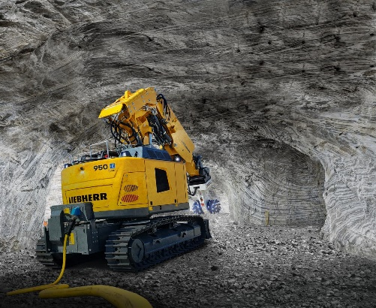
liebherr-r-950-tunnel-e-1.jpg
The R 950 Tunnel-E crawler excavator features an electric power system that can be connected to the power supply directly with its own cable or via an optional cable reel.

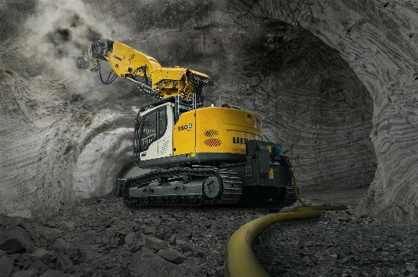
liebherr-r-950-tunnel-e-2.jpg
Using this new crawler excavator leads to cleaner sites, as there are no on-site emissions.
Contact
Alban Villaumé
Marketing Manager
Telephone: +00 333 89 21 36 09
Email: alban.villaume@liebherr.com
Published by
Liebherr-France SAS
Colmar, France
www.liebherr.com

