Press release

Liebherr and AMETEK MRO AEM cooperate on E-Jet E1 landing gear overhaul

⸺
Liebherr-Aerospace and AEM have publicly announced during MRO Europe 2022 that they have signed a Memorandum of Understanding for cooperation on state-of-the-art landing gear maintenance, repair and overhaul (MRO) services to Embraer E-Jet E1 operators in the EUMEA region.
London (UK), October 2022 – Riding on the stable high market demand for MRO landing gear services in the EUMEA region, the partnership enables Liebherr-Aerospace to off-load contracted landing gear work to AEM, a highly qualified and well established MRO landing gear provider based in Ramsgate (UK). This agreement will increase the number of available overhaul slots for E-Jet E1 aircraft, while the reliability of the service offer will be backed through the partnership between Liebherr-Aerospace and AEM.
Christian Franz, Director Customer Service of Liebherr-Aerospace Lindenberg (Germany), explained: "For our customers, this partnership generates more flexibility and availability in planning and selecting overhaul slots, which will optimize the fleet operation of our E-Jet E1 customers."
Andy Wheeler, DVP and Managing Director of AEM, commented, “AEM is delighted to partner with Liebherr-Aerospace to supply E-Jet landing gear overhaul services. Our Ramsgate team has many years of experience in providing the quality of service that Liebherr-Aerospace’s customers demand. This partnership further cements AEM as a leading landing gear maintenance provider and complements wider landing systems capabilities offered by AMETEK MRO.”
About Liebherr-Aerospace & Transportation
Liebherr-Aerospace & Transportation SAS, Toulouse (France), is one of eleven divisional control companies within the Liebherr Group and coordinates all activities in the aerospace and transportation systems sectors.
Liebherr-Aerospace is a leading supplier of systems for the aviation industry and has more than six decades of experience in this field. The range of aviation equipment produced by Liebherr for the civil and defense sectors includes flight control and actuation systems, gears and gearboxes, landing gear and air management systems as well as electronics. These systems are deployed in wide-bodied aircraft, single aisle and regional aircraft, business jets, defense aircraft, defense transporters, defense training aircraft and civil and defense helicopters.
Liebherr’s aerospace and transportation systems division employs around 6,000 people. It has four aviation equipment production plants at Lindenberg (Germany), Toulouse (France), Guaratinguetá (Brazil) and Nizhny Novgorod (Russia). These production sites offer a worldwide service with additional customer service centers in Saline (Michigan/USA), Seattle (Washington/USA), Montreal (Canada), Hamburg (Germany), Dubai (UAE), Bangalore (India), Singapore and Shanghai (People’s Republic of China).

About the Liebherr Group
The Liebherr Group is a family-run technology company with a highly diversified product portfolio. The company is one of the largest construction equipment manufacturers in the world. It also provides high-quality and user-oriented products and services in a wide range of other areas. The Liebherr Group includes over 140 companies across all continents. In 2021, it employed more than 49,000 staff and achieved combined revenues of over 11.6 billion euros. Liebherr was founded in Kirchdorf an der Iller in Southern Germany in 1949. Since then, the employees have been pursuing the goal of achieving continuous technological innovation, and bringing industry-leading solutions to its customers.
About AEM
AEM has been Europe's leading independent overhaul and repair facility for more than 60 years and has a solid reputation in the aerospace industry for providing a broad range of services to international and regional airlines, helicopter operators and airframe manufacturers. Conducting business from three sites in the United Kingdom, AEM’s capabilities cover aircraft windings, electrical power, hydraulic components, landing gear and safety equipment.
About AMETEK MRO
AMETEK MRO, a division of AMETEK Inc, is a well-respected global provider of MRO services to the commercial, regional, and general aviation aftermarkets. With 13 strategically placed locations around the world, AMETEK MRO is capable of servicing more than 40,000 aircraft components across its brands: AEM, Aeromedic, Ameron, AMETEK Singapore, Antavia, Avtech Avionics and Instruments, B&S Aircraft, Drake Air, Muirhead Avionics, and Southern Aeroparts.
AMETEK, Inc. (NYSE: AME) is a leading global manufacturer of electronic instruments and electromechanical devices with annualized sales of approximately $5.5 billion. The common stock of AMETEK is a component of the S&P 500.
Images
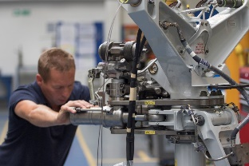
Landing Gear-copyright-AEM-AMETEK-MRO.jpg
Landing gear in overhaul shop AMETEK MRO – © AEM AMETEK MRO

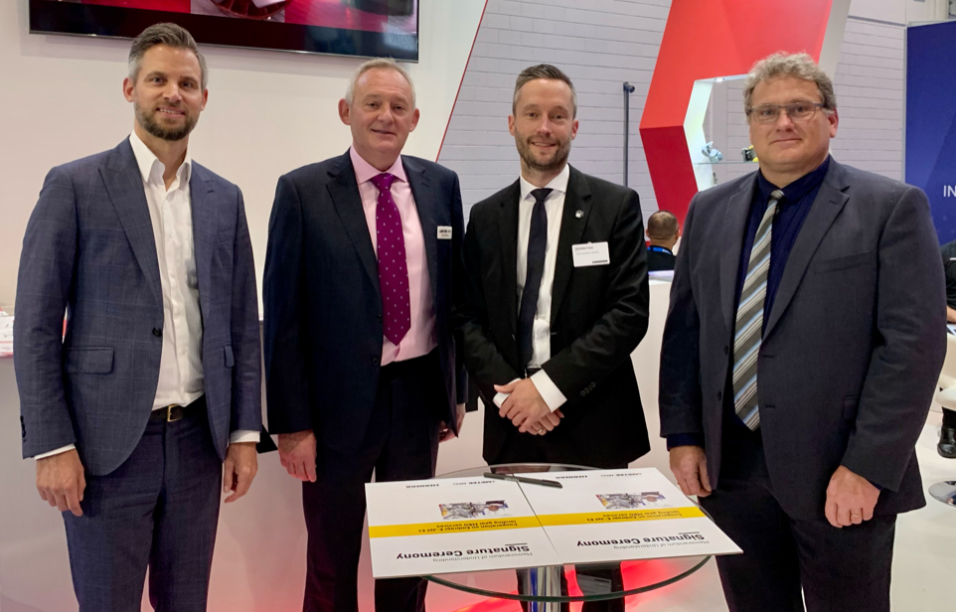
liebherr-ametek-mro-landing-gear-mou-picture-copyright-liebherr.jpg
At the signature ceremony from left to right: Sven Dicke, VP MRO Operation & Strategic Investment, Customer Support & Services of Liebherr-Aerospace & Transportation SAS, Andy Wheeler, DVP and Managing Director of AEM, Christian Franz, Director Customer Service of Liebherr-Aerospace Lindenberg GmbH and Markus Fritsch, Team Leader MRO Purchasing of Liebherr-Aerospace Lindenberg GmbH – © Liebherr

Contact person
Ute Braam
Corporate Communications
Phone: +49 8381 / 46 - 4403
E-mail: ute.braam@liebherr.com
Published by
Liebherr-Aerospace & Transportation SAS
Toulouse / France
www.liebherr.com

