Press release

Liebherr further expands its axial piston portfolio and introduces a concept study

⸺
- The Liebherr components product segment is expanding its axial piston portfolio by two hydraulic pumps with nine nominal sizes
- As part of a concept study, Liebherr introduces a system solution of a parallel pump with an innovative control system

At this year's Bauma, Liebherr is presenting two new product developments in the field of axial piston hydraulics, along with a concept study of a parallel pump with an innovative control system.

Bulle (Switzerland), 17. October 2022 - Upon development of new hydraulic solutions, Liebherr focuses primarily on solution orientation and digitalisation, as well as the ever-growing challenges therein. The product portfolio of open circuit pumps will, therefore, be broadened by the nominal size of 550 and as a double pump by the nominal size of 1100 cm³, respectively. The LH30VO family will also be expanded by the nominal size of 100.

DPVO 550i – on the pulse of current affairs with new nominal sizes of open circuit pumps

The mining and industrial sectors, as well as maritime applications place increasing demands on the availability and longevity of machines and technology. In order to keep up, the components product segment at the site in Bulle (Switzerland) is expanding its product portfolio of open circuit pumps by the nominal size of 550, which can also be used as a double pump of 1100 cm³. "Like all pumps in this product family, the DPVO 550i is characterised by a particular robustness. In the view of digitalisation, this product is ready to incorporate various sensor technologies", explains Guillaume Bonnetot, General Manager Systems at Liebherr-Mining Equipment Colmar SAS. "We are looking forward to see Liebherr components in use on our own machines".
LH30VO100 – the newest member of the pump family
Modularity is the signature trait of the LH30VO family with nominal sizes of 28, 45 and 85. Liebherr is further pursuing this approach with the inclusion of the nominal size of 100 cm³. Among other things, the LH30VO100 consists of a modular system of eight controllers with a variety of combination options. The variable drive-through concept allows the selection and addition of further pumps, when installing them on the machine. In doing so, Liebherr-Components is fulfilling the growing demand for products with a high degree of flexibility. With all its nominal sizes, the entire LH30VO pump family offers a wide range of applications from mobile machinery and stationary hydraulics, for primary work functions to secondary applications, such as in fans, auxiliary drives or steering systems.
With a concept study on parallel pumps with innovative controls into the future
In the concept study of a compact parallel pump with an electro-hydraulic control (Electro Hydraulic Control (EHC)), Liebherr merges mechanical features with electronics. In addition to the possibility of different gear ratios, this parallel pump offers an ideal solution for machines with conceptually different drive speeds. With the flexibility of a software-based electro-hydraulic control, it is able to provide the oil volume flow in an optimised, efficient and highly dynamic fashion. "Accordingly, the concept creates a prerequisite for future application with condition monitoring of the component", explains Albert Bertschi, Sales Manager at Liebherr Machines Bulle SA.
With these additions to the product families and the presentation of the concept, Liebherr is up to par with current and future user requirements and takes an important step towards the digitalisation of its products. This will pave the way for new applications and industries.
About Liebherr-Components
In this segment, the Liebherr Group specialises in the development, design, manufacturing of high-performance components in the field of mechanical, hydraulic and electric drive and control technology. Liebherr-Component Technologies AG, based in Bulle (Switzerland), coordinates all activities in the omponents product segment.
The extensive product range includes combustion engines, injection systems, engine control units, axial piston pumps and motors, hydraulic cylinders, slewing bearings, gearboxes and winches, switchgear, electronic and power electronics components, and software. The high-quality components are used in cranes and earthmoving machinery, in the mining industry, maritime applications, wind turbines, automotive engineering or in aviation and transport technology. Synergy effects in s other product segments of the Liebherr Group are used to drive continuous technological development.
About the Liebherr Group
The Liebherr Group is a family-run technology company with a highly diversified product portfolio. The company is one of the largest construction equipment manufacturers in the world. It also provides high-quality and user-oriented products and services in a wide range of other areas. The Liebherr Group includes over 140 companies across all continents. In 2021, it employed more than 49,000 staff and achieved combined revenues of over 11.6 billion euros. Liebherr was founded in Kirchdorf an der Iller in Southern Germany in 1949. Since then, the employees have been pursuing the goal of achieving continuous technological innovation, and bringing industry-leading solutions to its customers.

Images
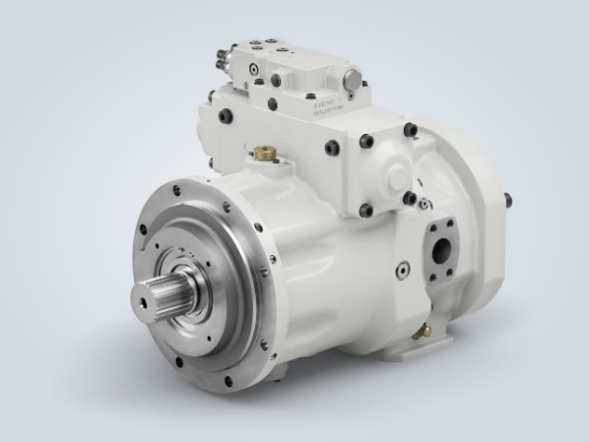
liebherr-hydraulic-pump-dpvo-550i.jpg
DPVO 550i – on the pulse of current affairs with new nominal sizes of open circuit pumps.

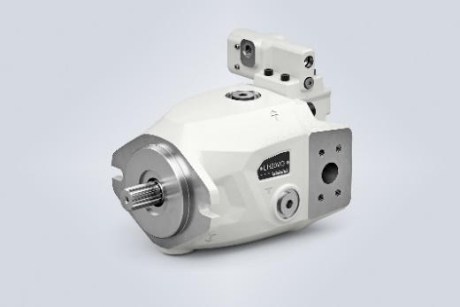
liebherr-hydraulic-pump-lh30vo100.jpg
LH30VO100 – the newest member of the pump family.
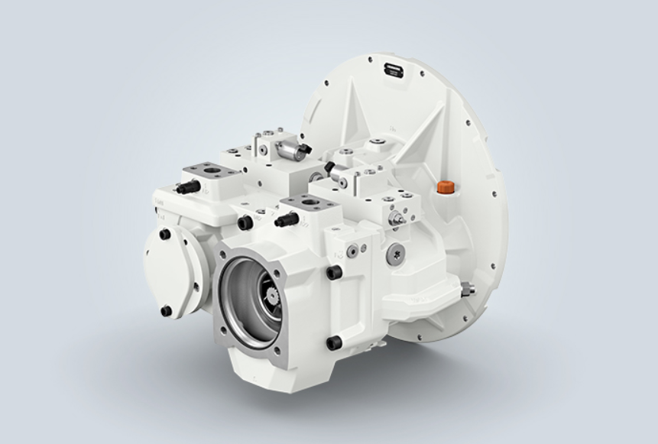
liebherr-concept-study.jpg
With a concept study on parallel pumps with innovative controls Liebherr-Components gets ready for the future.

Contact
Alexandra Nolde
Senior Communication & Media Specialist
Phone: +41 56 296 4326
E-mail: alexandra.nolde@liebherr.com

Published by
Liebherr-Components AG
Nussbaumen / Switzerland
www.liebherr.com

