Press release

First R 980 SME shovel in France

⸺
The R 980 SME excavator with bottom dump shovel has made its first appearance at Aizenay, in France's Vendée region
Excellent performance combined with lower consumption
Comfort and soundproofing greatly appreciated
A 104 tonne machine tailored to the customer’s needs
Through its local distributor, SOMTP Brittany, Liebherr delivered its first R 980 SME with bottom dump shovel in France in 2021. This is the largest member of the range developed and manufactured by Liebherr-France SAS in Colmar. Versatile and comfortable, this model has already won over Traineau, a long-standing Liebherr customer. It offers both high-level performance and efficiency, thanks to its special attachment.
Colmar (Haut-Rhin, France), 15 September 2022 – In use at our customer Traineau’s granite-quarrying operation at Aizenay in Vendée, the Liebherr R 980 SME excavator with bottom dump shovel was just what managing director Christophe Traineau needed.
The excavator’s origins, with design and production “made in France”, along with the Liebherr brand’s excellent reputation, were decisive factors for him. Vital to our activities, after-sales service managed jointly by Liebherr and SOMTP continues to play an essential role in maintaining good relationships between client, distributor and manufacturer.
Ideal for quarrying solid rock, this excavator provides an optimal view of the hopper thanks to its 1.20 m fixed cab elevation. Equipped with a bottom dump shovel, this excavator is a strong performer, with a different way of working from a classic backhoe bucket, explains excavator driver Cédric Di Gallo. The R 980 SME excavator enables very rapid operational cycles, thus increasing efficiency and productivity.
Putting the accent on comfort and safety
In addition to the cab elevation, access to the excavator is improved by a retractable ladder, widened access walkways and a hand rail all along the uppercarriage to assure safe and easy access for the operator and maintenance personnel. These access features were developed for Liebherr mining excavators.
Access points are also equipped with timed LED lighting which enables safer access at the start of a shift or at the end of the day.
This excavator offers a very high level of comfort: with electric joysticks, shovel flap opening via the joystick and semi-automatic flap closing, the seat suspension, and soundproofing inside and out, the R 980 SME can truly be said to provide the ultimate in flexibility and ergonomic design.
The bottom dump shovel that comes with the excavator was developed and manufactured by Liebherr-France SAS in Colmar. With 5.1 m³ capacity, this bottom dump shovel is supplied with a level 3 wear package kit (the highest level) to withstand the abrasiveness of the materials it handles. In this configuration, the bucket weighs in at 11,000 kg. The bucket’s delta blade guarantees optimum penetration into mined materials, even when they are tightly bound to each other.
An excavator tailored to the customer’s needs
Traineau opted for the Liebherr R 980 SME excavator because this model is especially well suited to our customer's granite quarrying operation. The 104 tonne excavator is used for the various operating phases: rock sorting, rock crushing with the drop-ball, and loading at the quarry face. The shovel attachment is especially effective and accurate in the sorting and crushing processes.
With a total production of around 800,000 tonnes of aggregate per year, our customer Traineau seems more than satisfied with the R 980 SME excavator and its low fuel consumption of 55 litres per hour. After reaching the 1,000 hour mark with the machine, the customer is well placed to confirm that the shovel attachment allows it to reduce cycle times and thus speed up dump truck loading.
About the Liebherr Group
The Liebherr Group is a family-run technology company with a highly diversified product portfolio. The company is one of the largest construction equipment manufacturers in the world. It also provides high-quality and user-oriented products and services in a wide range of other areas. The Liebherr Group includes over 140 companies across all continents. In 2021, it employed more than 49,000 staff and achieved combined revenues of over 11.6 billion euros. Liebherr was founded in Kirchdorf an der Iller in Southern Germany in 1949. Since then, the employees have been pursuing the goal of achieving continuous technological innovation, and bringing industry-leading solutions to its customers.

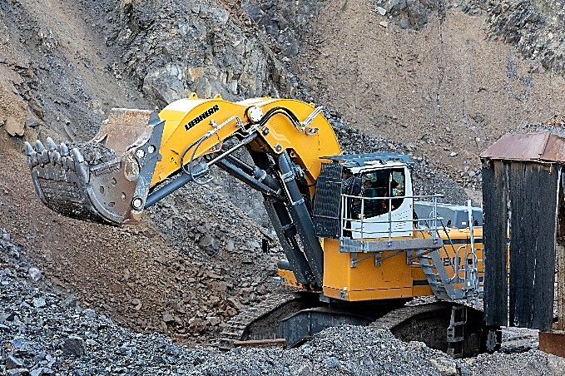
Images

liebherr-excavator-r980-sme-traineau-1.jpg
With a total production of around 800,000 tonnes of aggregate a year, Traineau seems more than satisfied with the R 980 SME excavator and its bottom dump shovel.

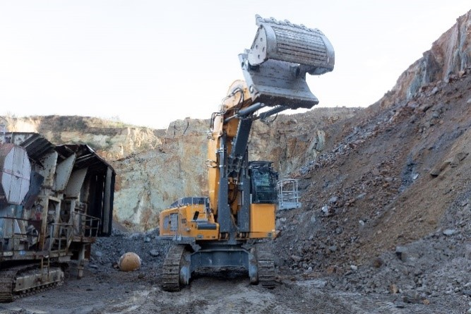
liebherr-excavator-r980-sme-traineau-2.jpg
Featuring a bottom dump shovel attachment, this R 980 SME excavator is the first of its type to be delivered in France.
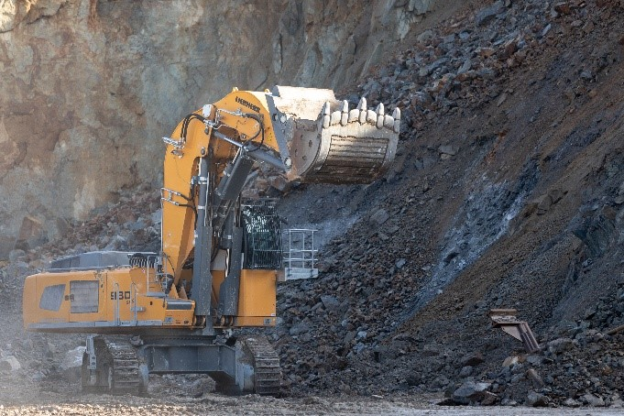

liebherr-excavator-r980-sme-traineau-3.jpg
In 455 working hours, the bottom dump shovel attachment made loading work easier and quicker for our customer Traineau.

Contact
Alban Villaumé
Marketing & Communication
Telephone: +3 33 89 21 36 09
Email: alban.villaume@liebherr.com
Published by
Liebherr-France SAS
Colmar, France
www.liebherr.com

