Press release

The beginning of a new era

⸺
Liebherr launches the first all-electric transshipment crane CBG 500 E
The CBG 500 E combines the market demands for a reliable crane with high handling capacity and the approach to make transshipment more sustainable
The crane is flexibly adaptable due to various configurations such as boom lengths, additional counterweights or a comfort ascent
Liebherr's portfolio of port and transshipment solutions has been expanded to include the
all-electric transshipment crane CBG 500 E. The crane combines state-of-the-art drive technologies with Liebherr's own crane control system "Master V". Another highlight is the energy recovery system LiCaTronic®, which makes optimum use of the energy available. The numerous configurations ensure that the crane is versatile and adaptable to different customer needs.
Rostock (Germany), August 2022 - The new all-electric crane CBG 500 E expands the transshipment solutions portfolio with a reliable machine that offers a handling performance of up to 2,000 tonnes per hour. The all-electric drives inside the crane in combination with the supercapacitors turn the rope luffing CBG 500 E into a unique handling solution in the market. The supercapacitors used as standard in Liebherr's own LiCaTronic® energy recovery system support the increasing requirements regarding energy efficiency. The combination of state-of-the-art inverter technology, power storage and application-specific power management leads in a powerful drive system with simultaneous reduction of the required energy. The CBG 500 E is a heavy-duty transshipment crane that operates emission-free and environmentally friendly.
New interior, new exterior
In addition to the powerful and efficient drives, the whole crane structure is optimised for an extraordinary performance. The boom of the CBG 500 E was designed as a lattice boom. This makes it particularly stiff and light, which further improves the turnover performance and at the same time reduces the energy need. The result is a lifting capacity of up to 105 tonnes in hook operation and a maximum grab capacity of up to 90 tonnes. The extension of the cabin and the high positioning ensure that the crane operator has an optimal viewing angle of all processes. The crane operator is supported operationally by the new, integrated "Master V" crane control system. Together with an even more efficient software architecture, it forms the basis for integrating future assistance and automation systems into the crane in the long term.
Flexibility as a core value
With the CBG 500 E, a crane has been developed that can be flexibly adapted to its subsequent purpose. An essential choice concerns the length of the boom, as the crane can be configured with 43 m and 50 m boom. The longer boom variant offers the decisive advantage of enabling direct transshipment between two vessels in sheltered and open water. The modes of operation range from bulk to container handling and are independent of the area of operation. For installation on a barge, the crane can be equipped with additional counterweights, enabling safe cargo handling in this application as well. Optional configuration options such as a comfort ascent or additional platforms and boom walkways for maintenance purposes complete the configuration possibilities.
A crane with recognition value
The CBG 500 E is designed in a colour combination of grey and white. The engine house with the all-electric drives is highlighted in yellow. The colour scheme is based on the Liebherr colours yellow, white and black in order to create recognition. For clear identification of the machine, a combination of logo and type designation of the crane is placed on both sides. In combination with the blue line and the addition "All-electric", it is clearly recognisable the CBG 500 E is characterised by advanced and
zero emission crane technology.

Video
https://youtu.be/6XIt-XHcdUc
Website
https://liebherr.com/en/int/products/maritime-cranes/transshipment-solutions/cbg-500-e/cbg-500-e.html

About Liebherr-MCCtec Rostock GmbH
Liebherr-MCCtec Rostock GmbH is one of the leading European manufacturers of maritime handling solutions. The product range includes ship, mobile harbour and offshore cranes. Reach stackers and components for container cranes are also included in the product portfolio.
About the Liebherr Group
The Liebherr Group is a family-run technology company with a highly diversified product portfolio. The company is one of the largest construction equipment manufacturers in the world. It also provides high-quality and user-oriented products and services in a wide range of other areas. The Liebherr Group includes over 140 companies across all continents. In 2021, it employed more than 49,000 staff and achieved combined revenues of over 11.6 billion euros. Liebherr was founded in Kirchdorf an der Iller in Southern Germany in 1949. Since then, the employees have been pursuing the goal of achieving continuous technological innovation, and bringing industry-leading solutions to its customers.
Images
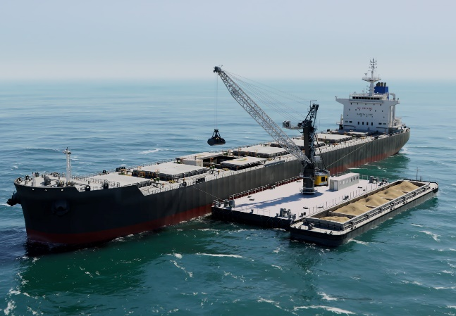
liebherr-transshipment-crane-CBG-500-E-keyvisual.jpg
The all-electric transshipment crane is designed for high-speed handling of bulk material on barges and transshippers in open and sheltered waters.

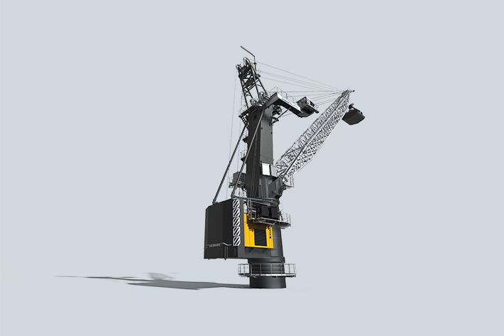
liebherr-transshipment-crane-CBG-500-E.jpg
The CBG 500 E has a boom length of up to 50 m and handles up to 2,000 tonnes per hour. In sheltered water, the maximum load capacity for grab operation is 90 tonnes and in open water 65 tonnes.

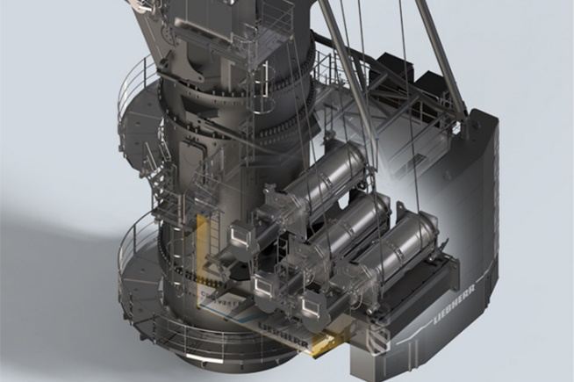
liebherr-transshipment-crane-CBG-500-E-electric-drives-winches.jpg
The all-electric drives and Liebherr's own energy recovery system ensure emission-free operation of the CBG 500 E.
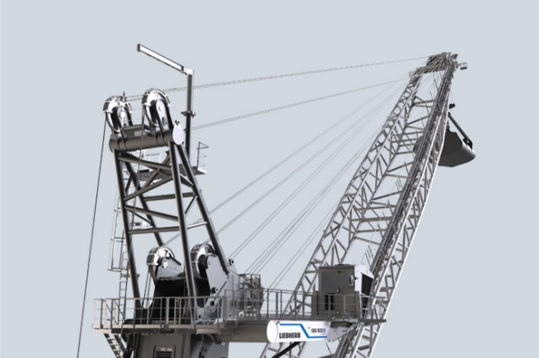
liebherr-transshipment-crane-CBG-500-E-Abock-boom-cabin.jpg
Innovations such as the lattice boom increase the load capacity and the cabin extension improve the visibility of the processes.

Contact
Vivien Bartz
Tel: +49 381 6006 5031
email: Vivien.bartz@liebherr.com
Published by
Liebherr-MCCtec Rostock GmbH
Rostock / Germany
www.liebherr.com

