Press release

Jandt expands crane fleet

with Liebherr LTM 1150-5.3 mobile crane

⸺⸺
- New 150-tonne crane complements crane fleet between 100 and 200 tonnes lifting capacity
- Long and strong telescopic boom and economic mobility were important decision criteria
- Long-standing partnership with Liebherr contributes to the company's success

Jandt Kranvermietung GmbH has taken delivery of a Liebherr LTM 1150-5.3 mobile crane. With the new 150-tonne crane, the company from Bielefeld complements its crane fleet in the range between 100 and 200 tonnes lifting capacity. Important criteria in the purchase decision were the very long telescopic boom (66 metres), the high lifting capacities and the economical transport concept of the Liebherr 5-axle crane.
Ehingen (Donau) (Germany), 19 August 2022 - Authorised signatory Jens Lübeck travelled to the Liebherr manufacturing plant in Ehingen to take delivery of the new LTM 1150-5.3. He reports: "In the range of our cranes between the 100 and 200 tonne class, we previously only had the LTM 1130-5.1. And since this was always very well utilised, we wanted to provide it with a reinforcement. The LTM 1150-5.3, which Liebherr has launched on the market as the successor to the 130-tonner, was therefore the logical choice for us."
Long and strong telescopic boom with simultaneous economic mobility
After building around 1,500 units, Liebherr presented the LTM 1150-5.3 in autumn 2020 as the successor to the successful LTM 1130-5.1. With a maximum lifting capacity of 150 tonnes and a 66-metre telescopic boom, it complements the Liebherr crane range below the 180-tonne LTM 1160-5.2. The telescopic boom, which is ten per cent longer than its predecessor, lifts loads that are on average 15 per cent higher, both with maximum and partial ballast. The achievement of the Liebherr engineers here was that the low overall weight of the predecessor could be maintained: With twelve tonnes of axle load, the crane carries nine tonnes of ballast on public roads.
This was also an important criterion for Jandt Kranvermietung GmbH when deciding on the purchase. "With nine tonnes of ballast, we can use the LTM 1150-3.1 excellently in the taxi crane business. If we need more power, we can get by with just one vehicle when transporting the counterweight. This allows us to offer our customers a very economical solution," says Lübeck.
Classic areas of application for the new 150-tonne crane at Jandt will be construction crane assembly and support work in wind power, as well as precast concrete assembly and activities on construction sites in the energy sector. In this context, Lübeck emphasises the high lifting capacity values with 45 tonnes maximum ballast and the 6-metre longer telescopic boom compared to the LTM 1130-5.1.
Long-standing partnership with Liebherr
20 telescopic mobile cranes in Jandt's fleet bear the Liebherr logo. Lübeck explains: "As a long-standing customer, we appreciate the partnership and the innovative strength of Liebherr. These factors have contributed significantly to the success and growth of our company. We are convinced of the cost-effectiveness of the products, for example the Liebherr single-engine concept, which has enabled us to further reduce the CO₂ emissions of our fleet. On the other hand, we benefit from the excellent service for our entire fleet."
Jandt is also consistently focusing on CO2 reduction with the procurement of the new LTM 1150-5.3. As with the latest developments in the Liebherr mobile crane series, the 150-tonner also features ECOmode in crane operation for fuel and CO2 savings and noise reduction. On the one hand, the complete pump drive can be automatically disengaged in engine idling mode and switched back on again in a matter of seconds via the intelligent control system when power is required. On the other hand, the crane control system automatically calculates the optimum engine speed for the working speed preselected via the control lever in order to avoid unnecessarily excessive engine speeds. When driving on the road, there is also a switchable eco mode that prescribes an optimised driving setting that saves fuel and CO2 and reduces noise.

About Jandt Kranvermietung GmbH
Jandt Kranvermietung GmbH was founded in 1950 by Friedrich Jandt and can look back on a long and successful company history. In the beginning, excavator and haulage work was carried out before the first crane vehicle was purchased in 1964. Since 1978, the company has been able to expand its fleet from six vehicles to around forty. Jandt operates branches in Bielefeld, Bad Salzuflen, Detmold, Gütersloh and Holzminden.
About Liebherr-Werk Ehingen GmbH
Liebherr-Werk Ehingen GmbH is a leading manufacturer of mobile and crawler cranes. Its range of mobile cranes extends from 2-axle 35 tonne cranes to heavy duty cranes with a lifting capacity of 1200 tonnes and a 9-axle chassis. Its lattice boom cranes on mobile or crawler crane chassis deliver lifting capacities of up to 3000 tonnes. With universal boom systems and extensive additional equipment, they can be seen in action on construction sites throughout the world. The Ehingen site has a workforce of 3,500. Extensive, global service guarantees the high availability of Liebherr mobile and crawler cranes. In 2020, the Liebherr plant in Ehingen recorded a turnover of 2.03 billion euros.

About the Liebherr Group

The Liebherr Group is a family-run technology company with a highly diversified product portfolio. The company is one of the largest construction equipment manufacturers in the world. It also provides high-quality and user-oriented products and services in a wide range of other areas. The Liebherr Group includes over 140 companies across all continents. In 2021, it employed around 48,000 staff and achieved combined revenues of over 10.3 billion euros. Liebherr was founded in Kirchdorf an der Iller in Southern Germany in 1949. Since then, the employees have been pursuing the goal of achieving continuous technological innovation, and bringing industry-leading solutions to its customers.
Image
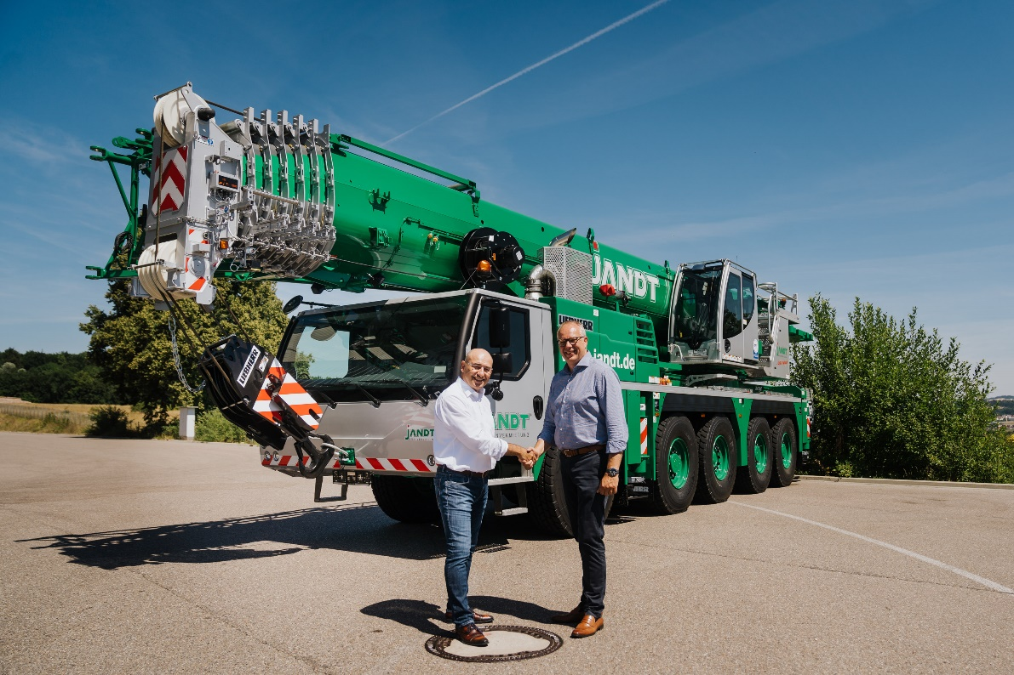
liebherr-ltm1150-5-3-jandt-handover.jpg
Crane handover in Ehingen (from left): Erich Schneider (Liebherr-Werk Ehingen GmbH), Jens Lübeck (Jandt Kranvermietung GmbH).

Contact
Wolfgang Beringer
Marketing and Communication
Phone: +49 7391/502 - 3663
Email: wolfgang.beringer@liebherr.com
Published by
Liebherr-Werk Ehingen GmbH
Ehingen (Donau), Germany
www.liebherr.com

