Press release

Liebherr Mining’s Perth facility expands for new technologies and zero emission progress

⸺
Liebherr-Australia has more than doubled the size of their mining facility in Perth with the acquisition of adjacent land and buildings
The expanded facility will accommodate the infrastructure, resources, and capability required for the development and delivery of Liebherr’s mining decarbonisation and technology projects
Liebherr-Australia has expanded their Perth mining facility, adding 47,000m² of workshop, office, and build space to the complex. This increased footprint will facilitate the company’s progress with their mining decarbonisation and technology projects. Perth is Liebherr-Australia’s second largest branch after the company’s Head Office Complex in Adelaide.
Adelaide (Australia), 5 August 2022 – Liebherr-Australia has announced the expansion of their Perth mining facility, which will strengthen the company’s ability to deliver accelerated zero emission solutions to the wider market. Liebherr-Australia’s growing involvement in the development and implementation of zero emission technology with Australian customers illustrates the necessity for this investment in infrastructure, and signifies Liebherr’s commitment to these industry-leading projects.
The Redcliffe-based branch purchased the land and buildings adjacent to the current location, increasing the Liebherr complex from 34,000m² to 81,000m². The new acquisition includes two workshops and a three-storey office building, adding to Liebherr’s existing 3,000m² service workshop, 5,000m² state-of-the-art parts warehouse, along with administration building and build area.
Liebherr-Australia Managing Director, Trent Wehr, commented on the importance of this facility expansion. “This is our largest investment in infrastructure here in Australia in many years, and this signifies how vital this facility is for our current and future business. Liebherr’s developments in zero emission technology, and the projects we are working on with industry partners and customers, are progressing every day and will deliver tangible solutions for the wider industry well before 2030,” Wehr said. “The team at Liebherr-Australia is making important contributions to the decarbonisation of the mining industry, and we’re committed to resourcing this momentous work for both our long term success and the benefit of the whole industry.”

Accelerated zero emission mining development
The newly acquired office and workshop buildings will form the central hub for Liebherr’s mining zero emission, autonomy, and other technology development and implementation projects in Australia.
The workshop and additional hardstand areas will facilitate these development projects, as well as new equipment builds for the growing number of machine orders in Western Australia. The additional office space will house the growing teams working on these industry-leading projects.
Liebherr-Australia’s Regional Manager WA, Paul Hyham, says the company’s decarbonisation and technology focus has ramped up quickly over the past year. “We’re building a really critical team here in Perth to support new technology development, which will employ everyone from engineers to on-site technicians,” said Hyham. “We’re excited to be bringing across some of our best international talent, as well as recruiting talent locally, and upskilling our own workforce over the next 12 months. We currently have around 200 permanent employees here in Perth and we forecast an increase steadily over the next few years.”
This expansion will have significant impact on the Liebherr Mining business both locally and globally, Hyham continued: “It’s exciting to have the forefront of this technology development and deployment right here in our backyard. Across the business there’s a feeling of excitement that we’re making real progress. Announcements like this facility expansion really show our employees, customers, and our wider network that we’re on the cusp of meaningful change.”
Alongside this expansion, the Perth complex will continue to be the main mining facility for all services in Western Australia, and support its satellite network of branches in the state’s regional mining hubs including Newman and the recently established branch in Kalgoorlie.
About Liebherr-Australia
Liebherr-Australia Pty Ltd was first incorporated as a company in 1981 and soon after, the new head office complex in Adelaide (South Australia) was built. Today, the company sells and supports a range of Liebherr products from seventeen branches across Australia and New Zealand, including mobile and crawler cranes, offshore cranes, tower cranes, deep foundation machines, earthmoving, and mining equipment.
About the Liebherr Group
The Liebherr Group is a family-run technology company with a highly diversified product portfolio. The company is one of the largest construction equipment manufacturers in the world. It also provides high-quality and user-oriented products and services in a wide range of other areas. The Liebherr Group includes over 140 companies across all continents. In 2021, it employed more than 49,000 staff and achieved combined revenues of over 11.6 billion euros. Liebherr was founded in Kirchdorf an der Iller in Southern Germany in 1949. Since then, the employees have been pursuing the goal of achieving continuous technological innovation, and bringing industry-leading solutions to its customers.

Images
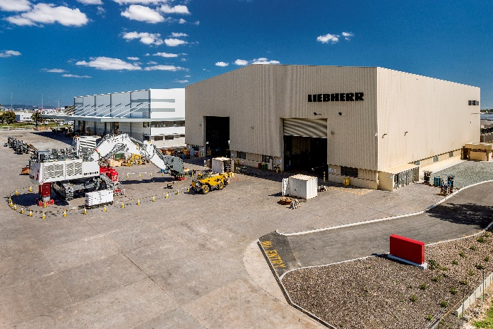
liebherr-australia-perth.jpg
Liebherr-Australia’s existing facility in Perth, now more than doubled in size with the acquisition of adjacent land and buildings.

Contact
Breanna Bennett
Communication and Brand Manager, Mining
Telephone: +61 7 3038 8803
E-Mail: Breanna.Bennett@liebherr.com
Published by
Liebherr-Australia Pty Ltd
Adelaide / Australia
www.liebherr.com.au

