Press information

182 metre-high skyscraper: New Liebherr crane at work in Canada

⸺
A new 280 HC-L impresses with reliability and high-handling performance during its first job in Burnaby
Smart assistance systems and level luffing make the crane operator’s job easier and increase safety on site
Liebherr's Project department Tower Crane Solutions provides support for an optimal climbing process
Fast working speed, simple operation and reliable service – these are the key factors that prompted Liebherr customer Cambie Forming Ltd. to opt for another 280 HC-L 12/24 Litronic. The new luffing jib crane is out on its first job in Burnaby, Canada. A 56-storey residential tower is being erected there as part of a development project. Experts from Tower Crane Solutions have provided climbing concept support.
Burnaby (Canada), August 3, 2022 – “The 280 HC-L is an extremely reliable and responsive crane. It’s by far the best crane I’ve worked with in my 25-year professional career,” says crane operator Richard Out. Two technologies impress him in particular: Micromove and level luffing at the push of a button. These functions have helped him, for example, to place concrete formwork panels with millimetre precision. Plus, he has an unrestricted view of loads from inside the modern LiCAB crane operator’s cab, which also features an ergonomic control stand.
The 280 HC-L in the version with its maximum 24-tonne load capacity is helping to build Hillside East Tower 1 to a final height of 182 metres. The skyscraper is part of a neighbourhood development project in the city Burnaby in the Canadian province of British Columbia. Several buildings are being constructed in the Brentwood district to accommodate residential and retail units as well as cafés and restaurants. At the same time, a Liebherr 355 HC-L 16/32 Litronic is working on Hillside East Tower 2. The building is to be 142 metres high. Two further skyscrapers, directly adjacent to the Hillside East Towers, have now been completed. These were also successfully erected with the help of two Liebherr 280 HC-Ls.
High-performance lifting and horizontal luffing
HC-L series cranes are optimally designed for use on tall buildings. They’re easy to assemble on tight construction sites and feature in-house manufactured high-performance drives. To ensure the appropriate handling capacity, the cranes also offer straightforward load hook re-reeving from one to two-line operation. The level luffing function makes work easier for the crane operator and ensures safe and efficient operation on site. When the jib moves, the control system automatically readjusts the hoist unit so that the load hook travels along a horizontal path.
An optimal climbing process is also important for safety and efficiency on the construction site. The 280 HC-L crane climbs up the building just like its 355 HC-L neighbour. The construction site’s layout proved a challenge in this respect. Both cranes could only be assembled in one place, as site operations would have been disrupted otherwise. Liebherr's Tower Crane Solutions project department, together with Cambie Forming Ltd, developed an optimal climbing process to minimise the loads on the building and the crane guy wires. Despite these challenges, only six guys were needed to safely climb the cranes to the great heights.
Collaboration you can count on
Customer Cambie Forming Ltd appreciates the package combination of high-performance equipment and comprehensive crane services. “We’ve owned Liebherr products for more than 15 years and have complete confidence in the reliability, quality of manufacturing and usability of these cranes as well as the provided customer service,” says managing director Peter Betz.
Purchasing the new 280 HC-L for the construction project in Burnaby has paid, “As far as we are concerned, 280 HC-L cranes have the best lifting and luffing speeds out there, they also offer impressive lifting capacities and are flexible when it comes to assembly.” The new 280 HC-L’s current job is expected to last until November this year. The 355 HC-L is scheduled to be disassembled in October.
The general contractor Cambie Forming Ltd is based in Vancouver and is a long-standing Liebherr customer. In addition to HC-L series cranes, the company also has top-slewing cranes from Liebherr’s HC, EC-B and EC-H series in its portfolio.
About the Liebherr Tower Cranes Division
More than seven decades of experience have made Liebherr a recognised specialist for lifting technology on all types of construction sites. The range of Liebherr Tower Cranes encompasses an extensive selection of high-quality tower cranes that are used worldwide. This includes fast-erecting, top-slewing, luffing jib and special-purpose cranes as well as mobile construction cranes. In addition to these products, Liebherr also offers a wide range of services that complete the company’s portfolio: Tower Crane Solutions, Tower Crane Customer Service and the Tower Crane Center.
About the Liebherr Group
The Liebherr Group is a family-run technology company with a highly diversified product portfolio. The company is one of the largest construction equipment manufacturers in the world. It also provides high-quality and user-oriented products and services in a wide range of other areas. The Liebherr Group includes over 140 companies across all continents. In 2021, it employed more than 49,000 staff and achieved combined revenues of over 11.6 billion euros. Liebherr was founded in Kirchdorf an der Iller in Southern Germany in 1949. Since then, the employees have been pursuing the goal of achieving continuous technological innovation, and bringing industry-leading solutions to its customers.
Images
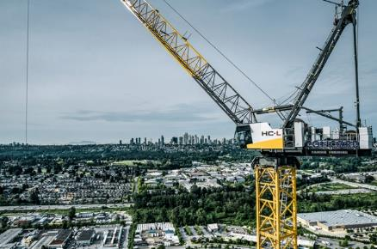
liebherr-hcl-cranes-canada-cambie-forming-01.jpg
A 280 HC-L and a 355 HC-L from Liebherr are helping to build two residential towers in Burnaby, Canada.
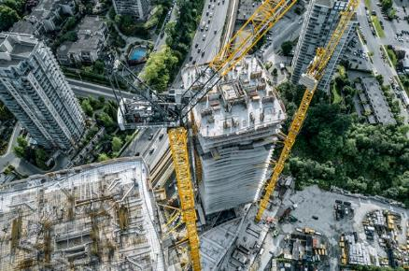
liebherr-hcl-cranes-canada-cambie-forming-02.jpg
The Liebherr 280 HC-L 12/24 Litronic crane offers an impressive maximum lifting capacity of up to 24 tons.
liebherr-hcl-cranes-canada-cambie-forming-03.jpg
The luffing jib cranes climb external to the building. Liebherr's Tower Crane Solutions project department assisted with the concept.
Contact person
Daniel Haefele
Global Communication
Telephone: +49 7351 / 41 - 2330
Email: daniel.haefele@liebherr.com
Published by
Liebherr-Werk Biberach GmbH
Biberach / Germany
www.liebherr.com

