Press release

Double pack: Henneberger Schwerlast takes delivery of two new Liebherr mobile cranes

⸺⸺
- Henneberger Schwerlast procures LTC 1050-3.1 and LTM 1160-5.2
- High product quality and comfort ease the burden on crane operators
- Henneberger relies one hundred percent on Liebherr for telescopic mobile cranes
The crane and logistics company Henneberger Schwerlast e.K. has taken delivery of two new Liebherr mobile cranes, an LTC 1050-3.1 and an LTM 1160-5.2. The LTC 1050-3.1 is already the third LTC compact crane that the company from Thema in southern Thuringia has taken over. The LTM 1160-5.2 complements the Henneberger fleet in the strong 5-axle class.
Ehingen (Donau) (Germany), 18 July 2022 – Henneberger Schwerlast remains true to its strategy of procuring only Liebherr mobile cranes in the telescopic crane sector. Mario Henneberger, owner of the second-generation family business, explains: "We have aligned ourselves with one manufacturer and thus achieved complete flexibility in personnel deployment. With Liebherr, we appreciate the uniform crane control, from small to large cranes. This allows us to make optimum use of our driving personnel in times of shortage of skilled workers and also to easily bridge downtimes due to vacation or illness. Liebherr's service is also exemplary, solving problems quickly and thus significantly reducing downtime."
Quality and comfort relieve crane drivers
The main catchment areas of Henneberger Schwerlast e.K. are central and southern Thuringia and northern Bavaria. The company attaches great importance to creating good working conditions for its personnel: "You have to do something for your people, because the job places high demands on the operator. That's why we provide material to take the strain off them in both driving and crane operation. High product quality also avoids downtime, reducing stress for operators and dispatch personnel alike."
Henneberger already has good experience with Liebherr LTC compact cranes. The new LTC 1050-3.1 is already the third unit the company has purchased in recent years. "The manoeuvrability and travel characteristics of the LTC are excellent. In addition, Liebherr has further improved the crane in many details, for example the assembly jip with roller set and hook traverse. Various cameras make the operator's work easier and more pleasant," says Mario Henneberger. He opted for the 36-meter TELEMATIK boom version, where the telescopic parts are bolted together. "We use the LTC 1050-3.1 as a universal machine. It doesn't just do indoor jobs for us."

Powerful crane for precast parts and heavy machinery
The LTM 1160-5.2 strengthens Henneberger's fleet in the upper 5-axle class. Complementing the LTM 1250-5.1, the company's largest crane, the new crane will be used in the assembly of precast concrete parts and heavy machinery, for example in the automotive industry. The Thuringia region also has a long tradition of glass production. So the LTM 1160-5.2 will also find jobs in this industry.
Mario Henneberger also cites the adjustable ballast radius VarioBallast® and the variable support base VarioBase® as important decision criteria. "VarioBase® is the most ingenious invention ever. We need it every day. It allows us to use our cranes much more flexibly and do jobs that would otherwise not be possible."
About Liebherr-Werk Ehingen GmbH
Liebherr-Werk Ehingen GmbH is a leading manufacturer of mobile and crawler cranes. Its range of mobile cranes extends from 2-axle 35 tonne cranes to heavy duty cranes with a lifting capacity of 1200 tonnes and a 9-axle chassis. Its lattice boom cranes on mobile or crawler crane chassis deliver lifting capacities of up to 3000 tonnes. With universal boom systems and extensive additional equipment, they can be seen in action on construction sites throughout the world. The Ehingen site has a workforce of 3,800. Extensive, global service guarantees the high availability of Liebherr mobile and crawler cranes. In 2021, the Liebherr plant in Ehingen recorded a turnover of 2.33 billion euros.
About the Liebherr Group
The Liebherr Group is a family-run technology company with a highly diversified product portfolio. The company is one of the largest construction equipment manufacturers in the world. It also provides high-quality and user-oriented products and services in a wide range of other areas. The Liebherr Group includes over 140 companies across all continents. In 2021, it employed more than 49,000 staff and achieved combined revenues of over 11.6 billion euros. Liebherr was founded in Kirchdorf an der Iller in Southern Germany in 1949. Since then, the employees have been pursuing the goal of achieving continuous technological innovation, and bringing industry-leading solutions to its customers.
Images
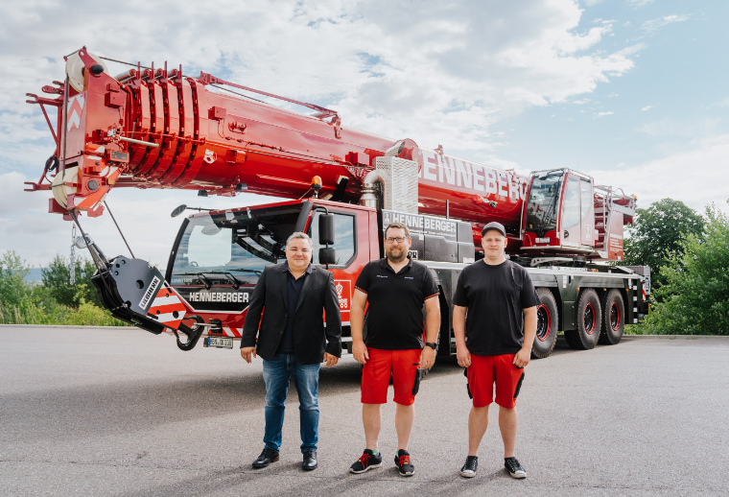
liebherr-ltm1160-5-2-handover-henneberger.jpg
Handover in Ehingen (f.l.t.r.): Mario Henneberger, Steffen Rauchmaul, Chris Schima (alle Henneberger Schwerlast e.K.).
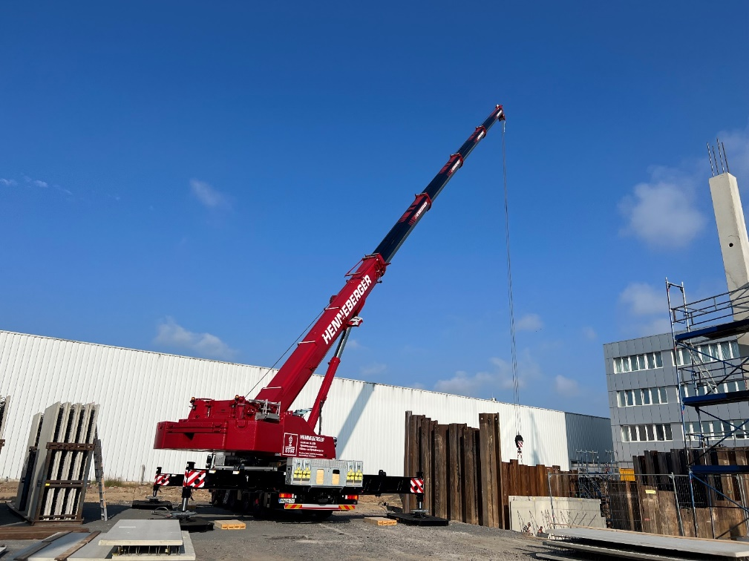
liebherr-ltm1160-5-2-handover-henneberger.jpg
The LTM 1160-5.2 on its first assignment in Sonneberg, Thuringia.
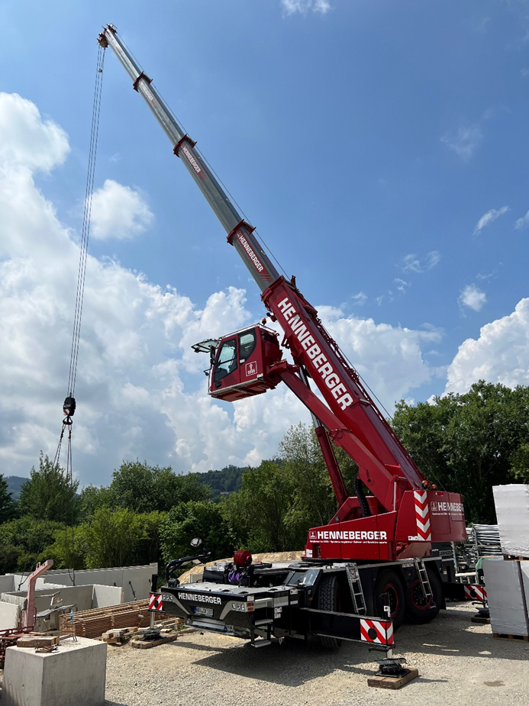
liebherr-ltc1050-3-1-henneberger-ilmenau.jpg
The LTC 1050-3.1 assembles wall elements in Ilmenau.
Contact
Wolfgang Beringer
Marketing and Communication
Phone: +49 7391/502 - 3663
Email: wolfgang.beringer@liebherr.com
Published by
Liebherr-Werk Ehingen GmbH
Ehingen (Donau), Germany
www.liebherr.com

