Press release

New 300 EC-B 12 Fibre and 270 EC-B 12: EC-B series from Liebherr continues to grow

⸺
The 300 EC-B 12 Fibre and 270 EC-B 12 deliver up to twelve tonnes of lifting capacity and a free-standing hook height of up to 91.7 metres
Simple transport and fast erection make the the cranes particularly economical
The new members of the “Tough Guys” group are available to order now all over the world
Liebherr is expanding its successful series of flat-top cranes with the new 300 EC-B 12 Fibre and 270 EC-B 12. Both machines are ideal for sites requiring heavy hoists and meet all the main requirements placed on a modern crane fleet. Erection, transport and operation – the new members of the “Tough Guys” group deliver outstanding features in every respect. The flat-top cranes are available to order now.
Biberach (Riss) (Germany), 15 July 2022 – The 300 EC-B 12 Fibre features the Liebherr fibre rope and therefore delivers significantly better performance values than similar cranes with a steel rope. The fibre rope also has a much longer service life which means that the rope has to be changed less frequently. That makes operation even more economical and increases the crane’s availability. The 300 EC-B 12 Fibre has a 70 metre jib and delivers a lifting capacity at the jib head of 3250 kilograms. The steel rope version of the 270 EC-B 12 with a 70 metre jib has a lifting capacity at the jib head of 2850 kilograms. Powerful hoist units and pure 2 line operation make both machines particularly efficient. The new cranes will replace the existing Liebherr 250 EC-B and 278 EC-B Fibre models.
Fast, safe erection
The “Tough Guys” have been designed for simple transport and erection, which also delivers major cost benefits for rental businesses. The counter-jib, slewing platform and jib segments can be carried to the site in just four transport units due to their smart stacking system. This also makes a major contribution to reducing greenhouse gases. The jib and counter-jib can be attached to the slewing platform easily, conveniently and safely. This is all made possible by Liebherr’s time-tested quick-release connectors. Depending on the requirements at the site, the jib can be extended or reduced in 2.5 metre sections.
Both machines have a 21 HC 290 tower connection. This tower system, which measures 2.1 x 2.1 metres, is the perfect choice in terms of performance and economy. It enables a maximum free-standing hook height of 71.5 metres. The 24 HC 630 (dimensions: 2.4 x 2.4 metres) enables a maximum free-standing hook height of 91.7 metres to be achieved.
Everything in clear sight – the crane cabin with TC-OS
To ensure safe crane operation, it is essential that the crane operator has a perfect view of the crane and site at all times. The LiCAB crane operator’s cabin features an ergonomic control stand and large glass windows which deliver perfect visibility. The cabin also includes the newly developed 12 inch display with its intuitive control concept. The Tower Crane Operating System (TC-OS) provides crane operators and erection engineers with special menus, a large selection of languages and readily understandable dimension units. Furthermore, smart assistance systems such as Load Plus (up to 20 percent increase in lifting capacity), Micromove (fine positioning of loans) and ABB (operating-range limiting system) support the crane operator and enable him to hoist loads safely.
The 300 EC-B 12 Fibre and 270 EC-B 12 fit seamlessly into the successful group of “Tough Guys” with their strong performance, flexibility and economy. From a small city crane to a large handling expert – EC-B cranes cover a wide range of operations. And due to their design, multiple flat-top cranes can operate on constricted sites without any problems.
Technical data for the 300 EC-B 12 Fibre and 270 EC-B 12:
Maximum jib length: | up to 73 metres
Maximum lifting capacity: | 12 tonnes
Lifting capacity at the jib head (70 metres): | 3250 kilograms (300 EC-B 12 Fibre)  2850 kilograms (270 EC-B 12)
Free-standing hook height: | up to 91.7 metres with the 24 HC 630 tower system  up to 71.5 metres with the 21 HC 290 tower system
About the Liebherr Tower Cranes Division
More than seven decades of experience make Liebherr an renowned specialist for hoisting technology on all kinds of construction sites. The Liebherr Tower Cranes portfolio includes an extensive range of high quality tower cranes suitable for use all over the world. They include fast-erecting, top-slewing, luffing jib and special cranes as well as mobile construction cranes. Alongside its products, Liebherr Tower Cranes has an extensive range of other services to round off its portfolio – Tower Crane Solutions, the Tower Crane Centre and Tower Crane Customer Service.

About the Liebherr Group

The Liebherr Group is a family-run technology company with a highly diversified product portfolio. The company is one of the largest construction equipment manufacturers in the world. It also provides high-quality and user-oriented products and services in a wide range of other areas. The Liebherr Group includes over 140 companies across all continents. In 2021, it employed more than 49,000 staff and achieved combined revenues of over 11.6 billion euros. Liebherr was founded in Kirchdorf an der Iller in Southern Germany in 1949. Since then, the employees have been pursuing the goal of achieving continuous technological innovation, and bringing industry-leading solutions to its customers.

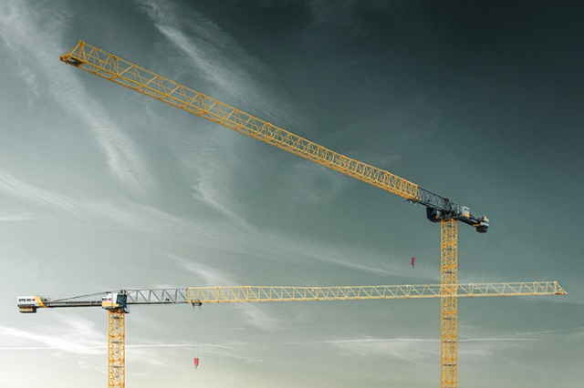
Images
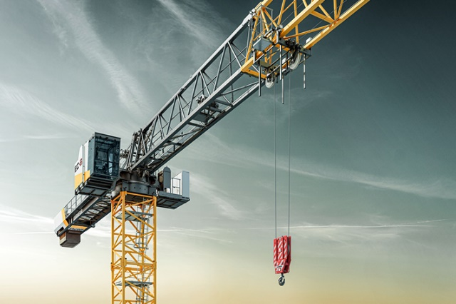
liebherr-300-ec-b-fibre-270-ec-b-01.jpg
The new 300 EC-B 12 Fibre from Liebherr delivers a lifting capacity at the jib head of 3250 kilograms with a 70 metre jib length. The new 270 EC-B 12 delivers a jib length of 70 metres with a lifting capacity of 2850 kilograms at the jib head.
liebherr-300-ec-b-fibre-270-ec-b-02.jpg
The 300 EC-B 12 Fibre features the Liebherr fibre rope and therefore delivers significantly better performance values than similar cranes with a steel rope.
Contact
Daniel Häfele
Global Communication
Phone: +49 7351 / 41 - 2330
Email: daniel.haefele@liebherr.com
Published by
Liebherr-Werk Biberach GmbH
Biberach / Germany
www.liebherr.com

