Press release

200 tonnes on the hook – MaxiKraft installs crane girder using LR 11000

⸺
Second job for MaxiKraft’s new LR 11000
Crane girder repurposed as a weather guard
LR 11000 crawler crane proves its worth in constricted conditions
Immediately after completing its first job erecting a wind turbine, a new Liebherr LR 11000 crawler crane owned by crane and heavy haulage contractor MaxiKraft had the opportunity to show its capabilities at a steel casting plant. The 1000 tonne crawler crane installed a 200 tonne crane girder, which had been completely repurposed, at ThyssenKrupp in Duisburg.
Ehingen (Donau) (Germany), 14 July 2022 – After its very first job erecting a wind turbine in southern Brandenburg, the Liebherr LR 11000 was transported around 600 kilometres to Duisburg by more than 30 heavy haulage vehicles. A 200 tonne crane girder for a former casting gantry crane measuring 40 metres in length had to be installed at a ThyssenKrupp steel casting plant. These girders are designed to transport hot liquid steel inside the plant.
In constricted space conditions, the LR 11000 had to be set up with 50 tonnes of central ballast, 170 tonnes of slewing platform ballast and 320 tonnes of derrick ballast within four days in its SL11DBV configuration with a 102 metre main boom and a 42 metre derrick boom. The hoist was completed on a Saturday so that the crane could then be dismantled again from the Monday and the steel plant could quickly restart operations.
LR 11000 – powerful and compact
Crane operator Marcel Kallwass is full of praise for both the crane and his team: “The delivery of the crane components was a logistical master class. Things were very tight, particularly when setting up the crane. But everything actually went very well. The LR 11000 is a fantastic crane. I’ve operated them all, from the LR 1600/2 to the LR 11350 and also large machines from other manufacturers.”
An SPMT module vehicle manoeuvred the colossal steel component from the preparation area to the crane where the LR 11000 picked it up on four giant shackles and then delicately placed the 200 tons at its assembly position at a lofty height. The 1000 tonne crane even had to move a few metres with the massive load on its hook. Thick excavator mats had been put in position specially to distribute the load.
The old crane girder has been modified for its new purpose as a weather guard. Over the next few months, a mobile safety wall will be attached to it to provide the open building which houses the extrusion casting system with better protection from wind and rain.
About Liebherr-Werk Ehingen GmbH
Liebherr-Werk Ehingen GmbH is a leading manufacturer of mobile and crawler cranes. Its range of mobile cranes extends from 2-axle 35 tonne cranes to heavy duty cranes with a lifting capacity of 1200 tonnes and a 9-axle chassis. Its lattice boom cranes on mobile or crawler crane chassis deliver lifting capacities of up to 3000 tonnes. With universal boom systems and extensive additional equipment, they can be seen in action on construction sites throughout the world. The Ehingen site has a workforce of 3,800. Extensive, global service guarantees the high availability of Liebherr mobile and crawler cranes. In 2021, the Liebherr plant in Ehingen recorded a turnover of 2.33 billion euros.

About the Liebherr Group

The Liebherr Group is a family-run technology company with a highly diversified product portfolio. The company is one of the largest construction equipment manufacturers in the world. It also provides high-quality and user-oriented products and services in a wide range of other areas. The Liebherr Group includes over 140 companies across all continents. In 2021, it employed more than 49,000 staff and achieved combined revenues of over 11.6 billion euros. Liebherr was founded in Kirchdorf an der Iller in Southern Germany in 1949. Since then, the employees have been pursuing the goal of achieving continuous technological innovation, and bringing industry-leading solutions to its customers.
Images
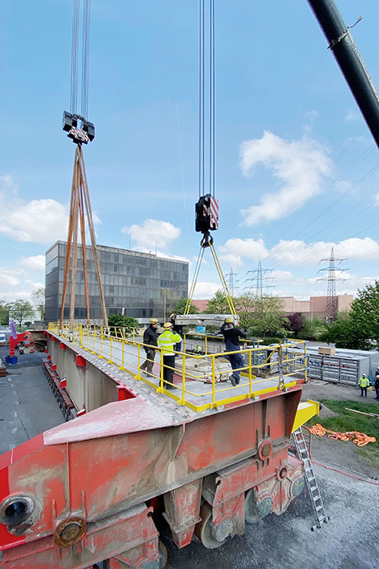

liebherr-lr11000-maxikraft-1.jpg
An SPMT manoeuvres the modified crane girder to the LR 11000. Counterweight plates move the colossal steel structure into a horizontal position during hosting.
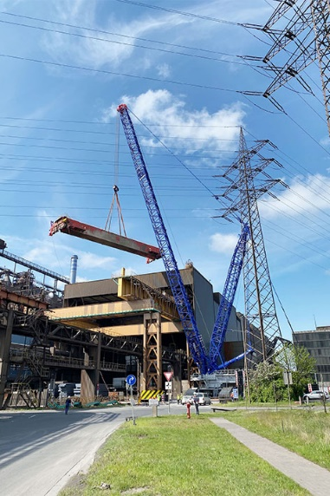

liebherr-lr11000-maxikraft-2.jpg
In constricted conditions, MaxiKraft’s LR 11000 installs the 200 tonne steel support in its new position.

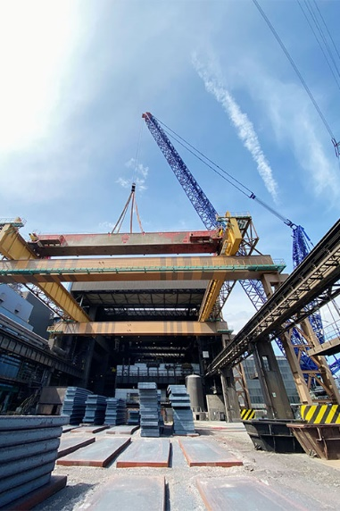

liebherr-lr11000-maxikraft-3.jpg
In the future, the crane girder will combine with a mobile safety wall to provide protection from the wind and weather for the extrusion casting system.
Contact
Wolfgang Beringer
Marketing and Communication
Phone: +49 7391/502 - 3663
Email: wolfgang.beringer@liebherr.com
Published by
Liebherr-Werk Ehingen GmbH
Ehingen (Donau) / Germany
www.liebherr.com

