Press release

Liebherr wins 2022 architectural digest design award

⸺
Liebherr presents line of groundbreaking refrigeration products
Design allows optimum versatility and functionality for households across North America

Liebherr’s french door monolith bottom freezer amoung Architectual Digest 2022 Great Design Award recipients highlighting distinctive new products in the kitchen and bath industry.
Miami, FL (USA) July 12, 2022 –– Liebherr USA, Co., Refrigerators and Freezers - An industry leader in state-of-the-art refrigeration for over 65 years, is proud to announce that it has won the prestigious Architectural Digest 2022 Great Design Award: Kitchen and Bath for the French Door Monolith Bottom Freezer. Presented by the leading global design authority, the AD Great Design Awards highlights the most distinctive new products in the kitchen and bath categories.
“It is truly an honor,” says Jon Barfell, Senior Marketing Manager, Liebherr USA, Co., Refrigerators and Freezers. “With every product we introduce to the market, we seek to provide the highest quality and aesthetic experience for our customers, and we appreciate that AD recognizes our commitment to design and excellence.”
Liebherr’s Monolith collection is a line of groundbreaking refrigeration products. With two doors that open independently of each other, the Monolith French Door Bottom Freezer provides extraordinary versatility to meet the function and design of well-appointed kitchens across the U.S.
Features
Like all the products in the Monolith line, the French-door Bottom Freezer offers luxury and performance as well as advanced technology, including such features as:
InfinitySwipe: Monolith’s intuitive electronic touch-control panel features a full-color 3.5-inch touch and swipe screen that’s bright, clean, and wonderfully user-friendly.
InfinityLight: Monolith’s seamlessly-integrated LED side-wall lighting casts a beautiful and even glow, offering a soft brightening effect upon opening the doors. InfinityLight doesn’t just add drama and flair, it also emits less heat, helping to preserve food quality.
BioFresh-Plus: The BioFresh-Plus technology stores fish and seafood at the perfect temperature, just like at the fish market. Featuring separate electronic controls, BioFresh-Plus offers precise temperature regulation that can easily separate the drawer into two compartments with independent temperatures for everyday use.
SmartDevice: Monolith comes with a SmartDeviceBox which allows for the option of Wi-Fi capability, allowing temperature changes and adjustments to be made via a smartphone or tablet remotely.
Monolith products are created to integrate seamlessly into all styles of American kitchens, with vast customization potential, advanced technology, and an elegant look with cutting-edge features.
Liebherr was previously recognized by Architectural Digest in 2017 for its WU4500 Built-In 24-Inch Wide 46 Bottle Cabinet. The brand’s reputation as a world leader in technology and design stems from listening to what matters most to customers, then meeting their needs with the most advanced technology, in the most attractive forms.
About Liebherr USA, Co.
Liebherr USA, Co. based in Newport News, VA provides sales and service on behalf of ten different Liebherr product segments: earthmoving, material handling, mining, mobile and crawler cranes, tower cranes, concrete technology, deep foundation machines, maritime cranes; components, and refrigeration and freezing.
About the Liebherr Group
The Liebherr Group is a family-run technology company with a highly diversified product portfolio. The company is one of the largest construction equipment manufacturers in the world. It also provides high-quality and user-oriented products and services in a wide range of other areas. The Liebherr Group includes over 140 companies across all continents. In 2021, it employed more than 49,000 staff and achieved combined revenues of over 11.6 billion euros. Liebherr was founded in Kirchdorf an der Iller in Southern Germany in 1949. Since then, the employees have been pursuing the goal of achieving continuous technological innovation, and bringing industry-leading solutions to its customers.

Images
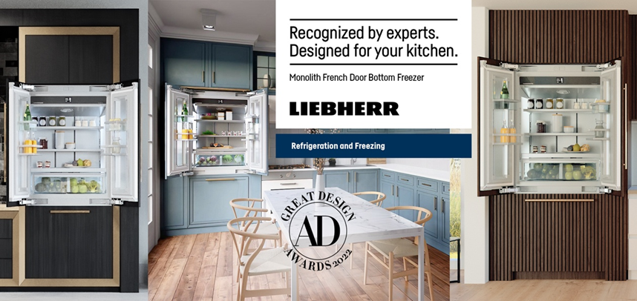
liebherr-AD Award.jpg
Liebherr Appliances Website announcing the 2022 award
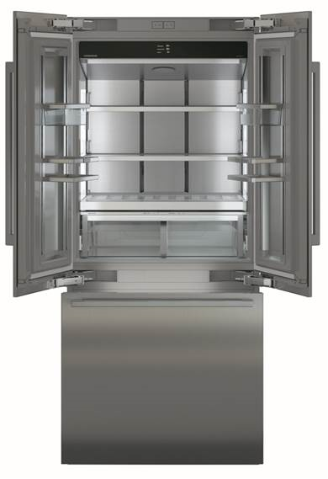
liebherr- MCB3652.jpg
Liebherr French door monolith bottom freezer
Contact
Ana Cabiedes
General Manager, Marketing, Liebherr USA, Co.
Phone: +1 757-240-4250
E-Mail: ana.cabiedes@liebherr.com
Jonathan Barfell
Senior Marketing Manager, Liebherr USA, Co., Refrigerators and Freezers
Phone: +1 305-817-7500
E-Mail: jonathan.barfell@liebherr.com
Published by
Liebherr USA, Co.
Newport News / USA
www.liebherr.com

