Press release

Taking off with Liebherr electronics: high-tech drones by Quantum-Systems

⸺
Drone manufacturer Quantum-Systems relies on Liebherr’s experience, when it comes to the manufacturing of electronics for the autopilot and motor controller
Liebherr’s Components product segment in Lindau carries out the procurement, manufacturing, testing and assembly of the electronic components
Quantum-Systems and Liebherr plan to further expand their cooperation
The Munich-based drone manufacturer Quantum-Systems relies on Liebherr’s Electronics Manufacturing Services (EMS). In future, Liebherr’s Components product segment will manufacture the Quantum-Skynode autopilot and the motor controller for the “Vector” and “Scorpion” unmanned aerial systems in Lindau (Germany). Quantum-Systems drones are used worldwide for mapping, surveying and reconnaissance applications.
Nussbaumen (Switzerland), 28 June 2022 – The EMS order by Quantum-Systems does not only include the procurement of components and production of electronics, but also the assembly of components for the autopilot. Comprehensive testing services accompany the manufacturing processes and ensure high product quality.
“In Liebherr we have found an ideal electronics partner for our drones. Liebherr’s decades of experience in the production of high-quality aerospace electronics flows directly into our products. This is an essential element for the performance of our drones, especially for operations in adverse environmental conditions with extreme temperatures,” says Florian Seibel, CEO and co-founder of Quantum-Systems.
Further expansion of cooperation
A tour of the Liebherr-Elektronik GmbH production site in Lindau at the beginning of June 2022 heralded further expansion of the cooperation beyond manufacturing services. In future, the focus will be on development and qualification in the field of electronics in particular. With its in-house test centre in Lindau, Liebherr can also carry out the qualification and verification of electronic components on-site.

Flexibility and wide range of applications for the drones
Quantum-Systems’ drones can be equipped with different sensors and cameras. The vertical take-off and landing capability provides additional flexibility in use. The autopilot manufactured by Liebherr also enables fully autonomous drone operations. Fields of application are, for example, health analysis of plants from the air, progress monitoring in opencast mines or real-time situational analyses in disaster areas.
Long-standing experience in electronics manufacturing
For over 40 years, Liebherr’s electronic components have proven their value daily all over the world in a wide variety of industries, such as aviation, construction or mining. When it comes to the electronics manufacturing processes, the company draws on its profound cross-industry experience in operation under the most demanding conditions. This, in turn, ensures high quality in component assembly and installation.

About Quantum-Systems GmbH
Quantum-Systems GmbH develops and deploys small Unmanned Aircraft Systems (sUAS) for the geospatial community (commercial product line) and the defence, security, and intelligence community (governmental product line), providing unprecedented data quality, efficiency, and operational usability.
The fully autonomous sUAS with AI edge computing capabilities enables its users to capitalize on the emerging megatrend of autonomous sUAS data acquisition solutions that will open entirely new markets and applications. All Quantum-Systems sUAS combine eVTOL (electrical vertical take-off and landing) capabilities with long-range utilizing electrical and aerodynamic efficiency.
The continuous integration of state-of-the-art sensors into the systems allows for increased aerial data intelligence. Quantum-Systems was founded in 2015 and is headquartered at Special Airport Oberpfaffenhofen, 20 km west of Munich.
About Liebherr-Components AG
In this segment, the Liebherr Group specialises in the development, design, manufacturing of high-performance components in the field of mechanical, hydraulic and electric drive and control technology. Liebherr-Component Technologies AG, based in Bulle (Switzerland), coordinates all activities in the Components product segment.
The extensive product range includes combustion engines, injection systems, engine control units, axial piston pumps and motors, hydraulic cylinders, slewing bearings, gearboxes and winches, switchgear, electronic and power electronics components, and software. The high-quality components are used in cranes and earthmoving machinery, in the mining industry, maritime applications, wind turbines, automotive engineering or in aviation and transport technology. Synergy effects in s other product segments of the Liebherr Group are used to drive continuous technological development.
About the Liebherr Group
The Liebherr Group is a family-run technology company with a highly diversified product portfolio. The company is one of the largest construction equipment manufacturers in the world. It also provides high-quality and user-oriented products and services in a wide range of other areas. The Liebherr Group includes over 140 companies across all continents. In 2021, it employed more than 49,000 staff and achieved combined revenues of over 11.6 billion euros. Liebherr was founded in Kirchdorf an der Iller in Southern Germany in 1949. Since then, the employees have been pursuing the goal of achieving continuous technological innovation, and bringing industry-leading solutions to its customers.
Images
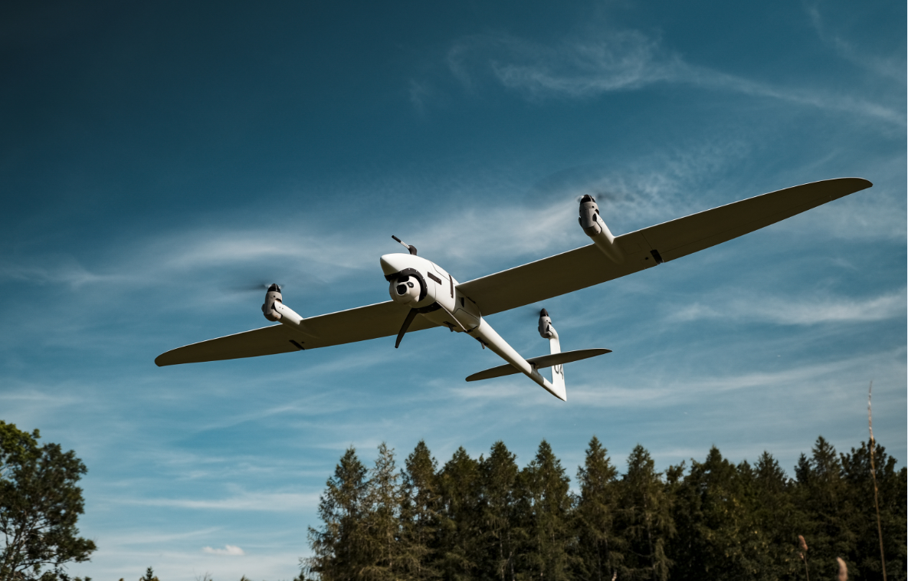
liebherr-quantum-systems-vector-drone.jpg
Liebherr electronics on board: The “Vector” drone by Quantum-Systems is optimised for autonomous missions in mapping, surveying and reconnaissance applications.

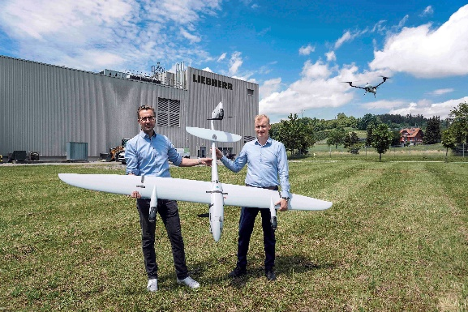
liebherr-quantum-systems-expand-cooperation.jpg
Florian Seibel, CEO and co-founder of Quantum-Systems, and Jan Uhlig, Managing Director at Liebherr-Elektronik GmbH, plan to further expand their cooperation in the field of electronics.

Contact
Alexandra Nolde
Senior Communication & Media Specialist
Phone: +41 56 296 4326
E-mail: alexandra.nolde@liebherr.com
Published by

Liebherr-Components AG

Nussbaumen / Switzerland
www.liebherr.com/ems

