Press release

Long boom and high lifting capacities convince –

LTM 1230-5.1 for Soliman

⸺⸺
- Versatile LTM 1230-5.1 with long boom for Soliman
- Ideal for working fully raised and at great hook heights
- Liebherr’s reliability and after-sales service as well as the high resale value of Liebherr cranes all played a part in the purchase decision
French crane contractor Soliman has taken delivery of a new Liebherr LTM 1230-5.1 mobile crane. The higher lifting capacities of the powerful, versatile 5-axle crane compared to other models in the same crane class, together with its particularly long boom, were just some of the criteria which made up the company’s mind to buy the new crane. Soliman is particularly pleased with the reliability of the products and Liebherr’s service. Another factor behind the decision was the high resale value of Liebherr cranes on the second hand market.
Ehingen (Donau) (Germany), 23 June 2022 – French crane contractor has taken delivery of a new LTM 1230-5.1. One of the factors which persuaded the company to buy the Liebherr 5-axle model was its high resale value on the second hand market. Soliman is also delighted with the reliability of Liebherr cranes: “We chose Liebherr when we decided to develop our fleet as a result of the reliability of Liebherr cranes and the fact that they often deliver higher lifting capacities compared to others in the same crane class”, explains Enzo Gigante, Commercial Manager at Soliman.
Powerful, versatile crane with a long boom
“We decided on the LTM 1230-5.1 from Liebherr because of its great boom length, versatility and high performance”, continues Gigante. The 230 tonne model features a very long 75 metre telescopic boom. This can also be combined with a 43 metre fixed jib. That makes high radii possible, for example for hoisting loads over buildings. Its maximum hoist height is 111 metres. In addition, there is a wide range of auxiliary boom systems available for this crane model, which can be adjusted hydraulically as an option.
Operating in constricted conditions possible thanks to VarioBase®
The LTM 1230-5.1 also sets new standards in terms of lifting capacity. Its VarioBase® and VarioBallast® features ensure that it is also ideal for working in constricted conditions. The LTM 1230-5.1 was the very first crane to feature an asymmetrical support system, known as VarioBase® Plus. This combines trapezoidal support with VarioBase® technology. It means that even higher lifting capacities are possible, particularly over the crane’s rear outriggers.
The Liebherr LTM 1230-5.1 is ideal for working fully raised and at great hook heights, for example for erecting tower cranes or maintenance work for wind turbines. The Soliman team is active both in industry and on construction sites. The new LTM 1230-5.1 joins the higher lifting capacity segment within the Soliman crane fleet. “The crane fits perfectly in the heavy load cranes within our fleet”, adds Gigante.
Soliman was founded in 1984 in the French city of Lille. Today, the company has two other outlets on the coast and in Picardie. That means that Soliman has a presence throughout the Hauts-de-France region. The company has a workforce of around 40 employees and now has a fleet of 26 cranes, over half of which have been supplied by Liebherr. “We work in every sector where a crane is required, such as construction and general industry. Our employees are passionate and each of them has their own strengths and specialities.”

About Liebherr-Werk Ehingen GmbH
Liebherr-Werk Ehingen GmbH is a leading manufacturer of mobile and crawler cranes. Its range of mobile cranes extends from 2-axle 35 tonne cranes to heavy duty cranes with a lifting capacity of 1200 tonnes and a 9-axle chassis. Its lattice boom cranes on mobile or crawler crane chassis deliver lifting capacities of up to 3000 tonnes. With universal boom systems and extensive additional equipment, they can be seen in action on construction sites throughout the world. The Ehingen site has a workforce of 3,800. Extensive, global service guarantees the high availability of Liebherr mobile and crawler cranes. In 2021, the Liebherr plant in Ehingen recorded a turnover of 2.33 billion euros.
About the Liebherr Group
The Liebherr Group is a family-run technology company with a highly diversified product portfolio. The company is one of the largest construction equipment manufacturers in the world. It also provides high-quality and user-oriented products and services in a wide range of other areas. The Liebherr Group includes over 140 companies across all continents. In 2021, it employed more than 49,000 staff and achieved combined revenues of over 11.6 billion euros. Liebherr was founded in Kirchdorf an der Iller in Southern Germany in 1949. Since then, the employees have been pursuing the goal of achieving continuous technological innovation, and bringing industry-leading solutions to its customers.

Image
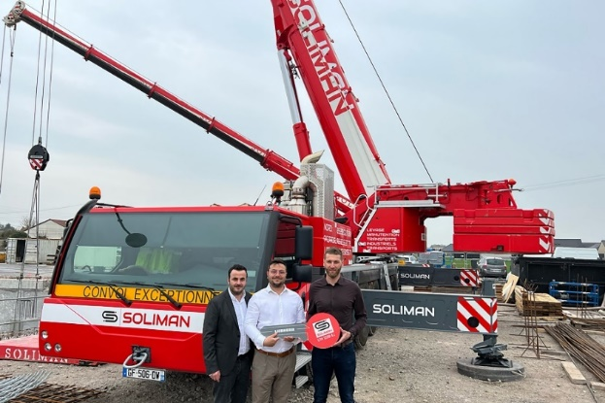
liebherr-ltm-1230-5-1-handover-soliman.jpg
Handover of the LTM 1230- 5.1 to Soliman (from left to right): Enzo Gigante, Giuseppe Gigante (both from Soliman) and Guillaume Gaeng (Liebherr Grues Mobiles).

Contact
Wolfgang Beringer
Marketing and Communication
Phone: +49 7391/502 - 3663
Email: wolfgang.beringer@liebherr.com
Published by
Liebherr-Werk Ehingen GmbH
Ehingen (Donau), Germany
www.liebherr.com

