Press release

Liebherr selected to supply valves for Pearl 10X engine

⸺
Liebherr-Aerospace was selected by Rolls-Royce to supply engine pneumatic valves and anti-ice valves for the Pearl® 10X engine, powering Dassault Aviation’s Falcon 10X business jet. This contract further solidifies Liebherr’s strategic relationship with Rolls-Royce in the field of pneumatics.
Toulouse (France), June 2022 – Liebherr-Aerospace will supply a pneumatic package (four valves) for the Rolls-Royce Pearl 10X engine. This agreement with Rolls-Royce marks another important step towards further strengthening Liebherr’s presence in the engine market.
“This contract enabling us to be part of Rolls-Royce’s Pearl 10X engine is a testament that deep collaboration and excellence pays off. We are very proud to work so closely with our customers in developing state of the art technology to fit their specific needs”, said Alex Vlielander, Chief Customer Officer, Liebherr-Aerospace & Transportation SAS.
The Pearl 10X - the most powerful version of the Pearl series - powers the Falcon 10X platform, which is expected to enter service as early as 2025.
Liebherr-Aerospace is also onboard the Falcon’s 10X airframe as the provider of integrated air management system, landing gear actuation and steering components.

About Liebherr-Aerospace & Transportation
Liebherr-Aerospace & Transportation SAS, Toulouse (France), is one of eleven divisional control companies within the Liebherr Group and coordinates all activities in the aerospace and transportation systems sectors.
Liebherr-Aerospace is a leading supplier of systems for the aviation industry and has more than six decades of experience in this field. The range of aviation equipment produced by Liebherr for the civil and defense sectors includes flight control and actuation systems, gears and gearboxes, landing gear and air management systems as well as electronics. These systems are deployed in wide-bodied aircraft, single aisle and regional aircraft, business jets, defense aircraft, defense transporters, defense training aircraft and civil and defense helicopters.
Liebherr’s aerospace and transportation systems division employs around 6,000 people. It has four aviation equipment production plants at Lindenberg (Germany), Toulouse (France), Nizhny Novgorod (Russia) and Guaratinguetá (Brazil). These production sites offer a worldwide service with additional customer service centers in – amongst others - Saline (Michigan/USA), Seattle (Washington/USA), Montreal (Canada), Hamburg (Germany), Dubai (UAE), Bangalore (India), Singapore and Shanghai (People’s Republic of China).

About the Liebherr Group
The Liebherr Group is a family-run technology company with a highly diversified product portfolio. The company is one of the largest construction equipment manufacturers in the world. It also provides high-quality and user-oriented products and services in a wide range of other areas. The Liebherr Group includes over 140 companies across all continents. In 2021, it employed more than 49,000 staff and achieved combined revenues of over 11.6 billion euros. Liebherr was founded in Kirchdorf an der Iller in Southern Germany in 1949. Since then, the employees have been pursuing the goal of achieving continuous technological innovation, and bringing industry-leading solutions to its customers.

Image
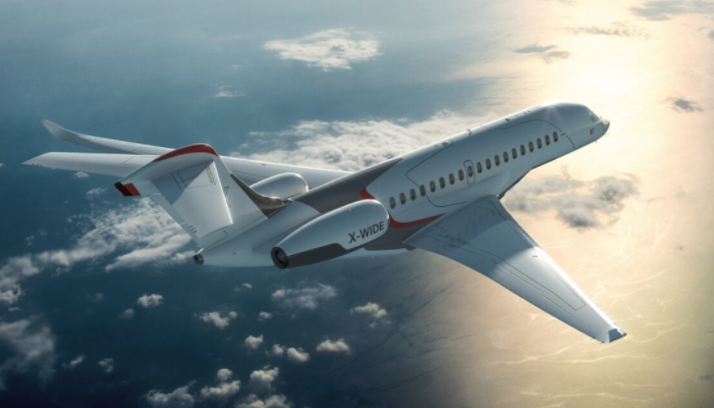
Dassault-Falcon10X-Copyright-Dassault-Aviation.jpg
The Falcon 10X is powered by two Rolls-Royce Pearl 10X engines with Liebherr components. - © Dassault Aviation

Contact person
Ute Braam
Corporate Communications
Phone: +49 8381 / 46 - 4403
E-mail: ute.braam@liebherr.com

Published by
Liebherr-Aerospace & Transportation SAS
Toulouse / France
www.liebherr.com

