Press release

Liebherr earthmoving and material handling machines at Svenska Maskinmässan 2022

⸺
Liebherr presents four wheel loaders including the new compact loader L 508
Liebherr also showcases its compact wheeled excavator A 913 Compact Litronic and A 916 Compact Litronic
Besides that, Liebherr is represented by its Generation 8 crawler excavators and dozers as well as telescopic handlers for heavy industrial applications and material handling machines for efficient recycling operations
Also presented to the Swedish trade audience: the TA 230 Litronic articulated dump truck
The Svenska Maskinmässan, a trade fair for construction machines, takes place in Stockholm (Sweden) from 2 to 4 June 2022. There, Liebherr presents an extensive range of earthmoving and material handling machines on an area of 2,000 m². Visitors to the exhibition find the Liebherr booth in the outdoor area V:09 Solvalla in the Stockholm district of Bromma. Besides a static machine exhibition, visitors to the fair can also look forward to a demonstration area where some of the machines can be seen live in action.
Solvalla, Stockholm (Sweden), 2 June 2022 – Liebherr is exhibiting numerous earthmoving and material handling machines for a wide range of applications at the Svenska Maskinmässan fair. With the L 508 Compact, the L 556 XPower®, the L 586 XPower® and the L 509 Tele, Liebherr is exhibiting four of its wheel loader models. Also on display are two representatives of the Liebherr compact wheeled excavators, the A 913 Compact and A 916 Compact, along with a number of Generation 8 crawler excavators. Furthermore, the TA 230 Litronic articulated dump truck is presented to the Swedish trade audience. Besides that, Liebherr is presenting two material handling machines for various operations in the field of recycling and waste management, the LH 18 M Industry Litronic and the LH 26 M Industry E. A telescopic handler and a dozer round off the range at the show.
Four wheel loaders at the Liebherr booth and trade fair premiere of model L 508 Compact
At Svenska Maskinmässan, Liebherr is presenting four wheel loaders with operating weights between 5,700 kg and 32,600 kg. The L 508 Compact, making its trade fair premiere, is the largest model in the new Liebherr compact loader series introduced this year. The most important innovations include the redesigned operator's cab, which provides the operator with excellent visibility thanks to its generous use of glass. The optimised visibility of the lift arms also ensures an unobstructed view of the working attachment and therefore maximum safety. For the first time ever, the L 506 and L 508 models are now available as speeder variants. In this version, they can reach a top speed of 30 km/h. In addition, Liebherr expands the compact loader series with the new L 504 model.
In addition, Liebherr is showing two models from its large wheel loader series, the L 556 XPower® and the L 586 XPower®. Liebherr fits a power-split driveline as standard for these wheel loaders. It combines hydrostatic drive, which is ideal for material uptake and travelling over short distances, with mechanical drive, the advantages of which come to the fore over long distances and when driving on gradients. The combination of these two drive types in a single wheel loader ensures maximum efficiency and outstanding fuel savings in every application. To further enhance performance, Liebherr has recently reinforced the lift arms and overhauled the working hydraulics of the L 556 XPower®. Innovations also include increased tip load, breakout force and engine power.
For its mid-sized and large wheel loaders, Liebherr offers various intelligent assistance systems to increase safety and comfort. An example is the active personnel detection with brake assistant. This optional assistance system, which is installed at the rear of the wheel loader, warns the machine operator visually on the display and with acoustic signals of dangers in the rear area of the wheel loader. In order to provide a specific warning of imminent injury to persons, the assistance system independently distinguishes between humans and objects using smart sensors. As soon as the active personnel detection emits a warning signal, the brake assistant automatically reduces the speed of the wheel loader to a standstill in order to avoid a potential accident.
Front area monitoring is another assistance system for wheel loaders. It is useful especially in industrial applications where wheel loaders often work with large attachments, high-dump buckets for example, for handling lighter goods such as wood chips, paper or waste. These large attachments inevitably obstruct the driver's field of vision. Hence, Liebherr offers a roof camera for front area monitoring to provide the operator with a view of the bucket in front of the machine from a significantly elevated perspective and transmits the image in the operator's cab. Front area monitoring is therefore used for seeing people or objects hidden by the attachment, which increases safety when accelerating, driving forward and loading with large buckets.
To complete the wheel loader line up, Liebherr is exhibiting the L 509 Tele telescopic wheel loader. This multifunctional machine combines the lift height and reach of a regular telescopic loader with the productive material handling capacity of a classic wheel loader. Instead of classic wheel loader lift arms, the L 509 Tele has an extendable telescopic lift arm which can lift to a height of 4.8 m with a fork attachment.
Two representatives of the Liebherr compact wheeled excavator range
Liebherr compact wheeled excavators are the perfect helpers on construction sites where space is restricted, for example in inner cities, in road construction or in classic earthmoving work. At the Svenska Maskinmässan, Liebherr is presenting two representatives: the A 913 Compact Litronic and the A 916 Compact Litronic, which are shown live in action on the demonstration area.
The A 913 Compact has an operating weight between 13,900 and 16,000 kg and meets the requirements of emission level V. The 95 kW / 129 hp engine gives the machine excellent working and road performance with high fuel efficiency at the same time. With the A 913 Compact, Liebherr has developed a machine with both high lift capacity and enormous manoeuvrability and flexibility. The compact wheeled excavator is equipped with an extremely flexible undercarriage with all-wheel steering and crab mode. With the all-wheel steering, the steering movements of the front and rear axles act in opposite directions so that only a very small radius is needed when turning. In crab mode the steering movements of the front and rear axles act in the same direction. This allows the machine to be moved sideways without the uppercarriage turning.
The A 916 Compact is one of the larger models in the Liebherr compact wheeled excavator range. Its operating weight is between 16,000 and 18,300 kg and it meets the requirements of emission level V. The machine concept of the A 916 Compact doesn't only impress with respect to performance; it also offers maximum flexibility. Its engine delivers a high output of 110 kW / 150 hp and thus fast acceleration, high terminal speeds and maximum handling volume. Fast and flowing working movements are possible thanks to the optimally tuned hydraulic system. The tight tail swing radius of just 1.80 m makes the machine ideal for extended operations, even in the confined space of construction site work.
Liebherr Generation 8 crawler excavators: highlights of the Svenska Maskinmässan trade fair
Among the products on display is also the tracked excavator R 920 Compact phase IV with its 110 kW / 150 hp engine. With its innovative maintenance concept, the Liebherr R 920 Compact combines the properties of a standard crawler excavator with the advantages of a compact machine, especially with its compact swing of only 1850 mm. This makes it the ideal tool for working efficiently on construction sites where space is limited.
Liebherr is also exhibiting its Generation 8 crawler excavators: the R 924 and R 926. With higher digging forces and greater undercarriage traction, these two new models combine performance and comfort with a heavier counterweight and minimal fuel consumption. For the launch of this new generation of excavators, Liebherr has completely revised the basic concept of its machines in order to offer its customers even more user-friendly and efficient products. In particular, access to the upper carriage has been extended and the maintenance platform now has handrails to increase safety during operation.
With a power output of 150 kW / 204 hp and an operating weight of 28 tonnes, the R 926 G8 model combines ease of operation and ergonomics without compromise. In order to offer improved performance, the architecture of the R 926 has been completely redesigned and updated. On demonstration at the exhibition, visitors have the opportunity to observe it in action. The R 924 G8 crawler excavator, developed and manufactured at Liebherr-France SAS in Colmar (France), is capable of handling work requiring regular tool changes, increased stability and high breaking forces. In short, the new R 924 excavator is an all-rounder.
Generation 8 dozers give customers new perspectives
The diesel-hydraulic dozers of the new Generation 8 – a Liebherr PR 736 G8 is shown at the fair – feature powerful common rail engines from Liebherr's own production. Compliance with emissions level V is ensured across the fleet by the SCR filter, a combination element comprising diesel particulate filter and SCR catalytic converter. Electronically piloted, the response and the speed of the front and rear equipment can be flexibly adjusted to the operating conditions and requirements of the driver. The intelligent working hydraulics also feature assist functions such as blade emptying with vibration function, rear ripper park position and automatic blade lift when reversing, and they allow 2D and 3D machine controls to be integrated.
The new assist systems of the Generation 8 dozers make several levels of driver support available: Free Grade for active blade stabilisation during fine levelling and Definition Grade for automatic blade positioning when creating 2D areas. Two independent, permanently integrated sensor circuits (gyro and inertia sensors) are used to stabilise all blade axes. In conjunction with the hydrostatic drive and optimised centre of gravity, this allows particularly high levelling speeds and extremely precise results. Furthermore, the option 3D Grade provides a factory-fitted GPS machine control from Topcon – fully integrated and calibrated at the factory. Alongside this, Ready Kits allow the simple retrofitting of the latest 2D and 3D control systems from Trimble and Leica.
Impressive in every dimension – telescopic handlers for heavy industrial operations
Liebherr is exhibiting the T 60-9s at the trade fair. Besides the freely regulated hydrostatic travel drive and high-performance working hydraulics, Liebherr telescopic handlers score with productivity-boosting assist systems such as Auto Power, Load Moment Plus and programmable bucket return, plus intelligent safety functions such as Auto Hill Assist and the intervening overload warning system. The particularly efficient hydrostatic travel drive allows an actual maximum speed of 40 km/h. Alternatively, the machines are available as 20 km/h and 30 km/h speed variants.
The travel speed is freely regulated and with the optional Auto Power function, independent of the power currently required in the working hydraulics. The engine speed is automatically increased according to requirements (joystick deflection), regardless of the travel speed. The standard Hill Assist system, which automatically activates the parking brake, ensures maximum driving comfort and safety when driving over uneven ground. The installed high-performance working hydraulics are electronically piloted and the load-independent flow distribution allows powerful simultaneous work movements with sufficient power reserves.
Developed for the toughest off-road operations: the TA 230 Litronic articulated dump truck
Following its successful digital product launch at the end of 2020, the articulated dump truck is presented to the Swedish trade audience at the Svenska Maskinmässan. With the TA 230, Liebherr has developed a dump truck in the 30-tonnes category for the toughest off-road operations. The robust and powerful all-terrain machine is primarily designed for transporting excavated materials and for the mining industry. The machines are also useful helpers in major infrastructure projects. Thanks to their optimal clearance profile, they can also be used for special applications such as tunnel construction.
New designs in the front end area ensure maximum ground clearance and thus superb off-road performance. The powershift transmission is located under the cab and the exhaust gas treatment is positioned compactly and securely behind the operator's cab, allowing a large slope angle. The solid rotary articulated joint also provides for optimum off-road capability. It allows independent movements of the front and rear end to ensure maximum manoeuvrability. The robust and positive-locking swivel joint with tapered roller bearing is perfect for the shear loads arising during use, withstands maximum loads and provides optimal force distribution.
A powerful 6-cylinder construction machinery engine with 12 l displacement and 265 kW / 360 hp is installed in the TA 230 Litronic, which complies with the requirements of exhaust emissions standard V. A robust and efficient drivetrain with automatic 8-speed powershift transmission ensures optimal force distribution. Automatic traction control is also available for the machine in the form of actively controlled longitudinal differential locks. As soon as slip occurs at an axle, the torque is cleverly transferred to the axle or axles with traction.
The large and robust trough is designed for the effective transport of a payload weighing up to 28 tonnes. Numerous improvements have been made for quick and efficient loading and unloading, as well as safe transport of the material. The front of the trough is straight and the sills are low so that loading with a wheel loader, for example, is easily possible across the entire length. During the loading process, an innovative weighing system, which comes as standard, shows the current payload on the display in the operator's cab. An optional loading light on both sides at the back of the operator's cab shows the loading level outdoors.
The newly developed, spacious operator's cab provides ideal conditions for comfortable and safe working. The excellent panoramic windows without any annoying struts and the short, inclined bonnet give the driver an optimum view of the driving, working and articulating area of the machine. In the soundproof cab, ergonomically arranged control elements facilitate intuitive operation of the machine. Various trays and storage spaces greatly expand the spatial offering. A new lighting concept with LED headlights also ensures improved visibility and safety – both for the machine operator and everyone in the outdoor area.
Specially designed for recycling operations: the LH 18 M Industry Litronic and the LH 26 M Industry E
With the two material handling machines, the LH 18 M Industry and the LH 26 M Industry E, at the Svenska Maskinmässan, Liebherr is presenting two models especially for recycling operations. The LH 18 M Industry is the most compact representative of the range of Liebherr material handling machines. Liebherr is presenting the LH 26 M Industry E as an example of its electric material handling machines. Visitors to the fair are able to admire the electric material handling machine live in action at the demonstration area.
Examples of its possible applications in the field of recycling are the handling, unloading and sorting of waste paper, waste wood and waste materials. The focus is on a high level of machine availability. Both machines are equipped with a reversible, fold-down fan drive and a close-mesh protective grille for quick and simple cleaning. The fan's direction of rotation can be reversed to blow the radiator and protective grille free, increasing the productive working time. Furthermore, the LH 26 M Industry E features an external air conditioning compressor. This maximises the air stream in the radiator and fan unit to guarantee a high level of reliability even in very dusty conditions.
The LH 18 M Industry material handling machine has an operating weight between 17,000 and 18,000 kg, engine power of 105 kW / 143 hp and it meets the requirements of emissions level V. The machine is also available with approval for on-road use, allowing flexible changes of location.
The ergonomic, clearly arranged and generously dimensioned operator's cab provides a high level of working quality and booths for maximum driver comfort. Moreover, ergonomically arranged control elements and touchscreen displays make it easy to operate the machine. The LH 18 M Industry impresses with a high degree of sensitivity thanks to the optimum tuning between the engine, control valves and proportional controls. In addition, the standard proportional controls allow the steering, cab height and support to be conveniently and safety actuated using joysticks. The service-orientated machine design also allows short maintenance times and reduces unproductive downtimes. All day-to-day service points are accessed quickly, safely and easily from the ground.
The Liebherr LH 26 M Industry E electric material handling machine impresses as a concept that is well thought out down to the last detail. The innovative drive concept includes the 90 kW Liebherr electric motor, which guarantees powerful and dynamic working movements while keeping maintenance costs and noise emissions low. Moreover, the drive concept includes an additional electric motor for auxiliary consumers, guaranteeing purposeful power distribution and maximum energy efficiency. Sophisticated frequency converter technology allows the engine speed to be individually adjusted to the respective use of the machine. Besides the simple adjustment to all common power supply networks worldwide, the frequency converter is also characterised by a substantial reduction in operation costs. This is achieved by preventing switch-on current peaks with a gentle ramp-up when starting and the related conservation of the hydraulic drive components. The cable feed operates with a cable winding system that allows the machine to move safely within a working radius of 40 m, or more on request.
About the Liebherr Group
The Liebherr Group is a family-run technology company with a highly diversified product portfolio. The company is one of the largest construction equipment manufacturers in the world. It also provides high-quality and user-oriented products and services in a wide range of other areas. The Liebherr Group includes over 140 companies across all continents. In 2021, it employed more than 49,000 staff and achieved combined revenues of over 11.6 billion euros. Liebherr was founded in Kirchdorf an der Iller in Southern Germany in 1949. Since then, the employees have been pursuing the goal of achieving continuous technological innovation, and bringing industry-leading solutions to its customers.

Images
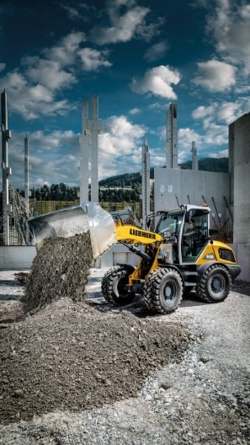
liebherr-compact-loader-l508.jpg
The new Liebherr L 508 compact loader celebrates its trade fair premiere at Svenska Maskinmässan.

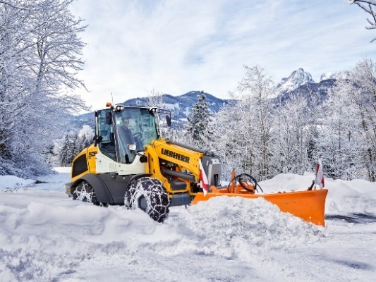
liebherr-new-telescopic-wheel-loader-l509-winter-service.jpg
The L 509 Tele is a powerful machine, also for winter service.

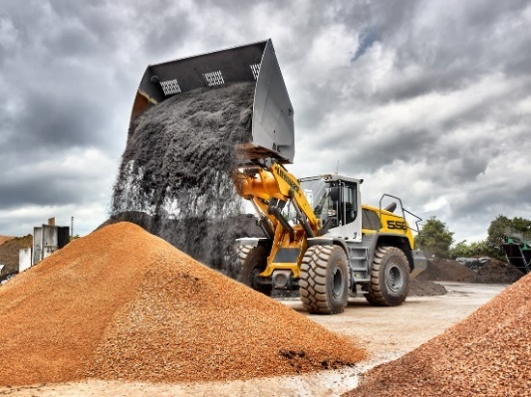
liebherr-wheel-loader-l556-xpower-high-dump-bucket.jpg
Liebherr shows its wheel loader L 556 XPower® at Svenska Maskinmässan.

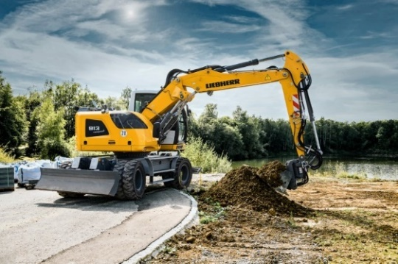
liebherr-a913-compact-litronic.jpg
Liebherr is presenting the A 913 Compact Litronic at the Svenska Maskinmässan, one of the latest representatives of the compact wheeled excavators.

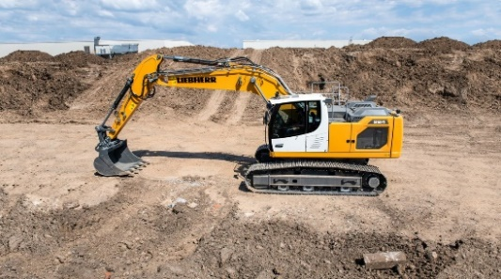
liebherr-r924.jpg
The new Liebherr R 924 excavator is an all-rounder.

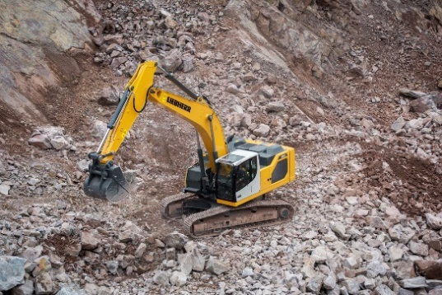
liebherr-r926.jpg
The Liebherr R 926 G8 model combines ease of operation and ergonomics without compromise.

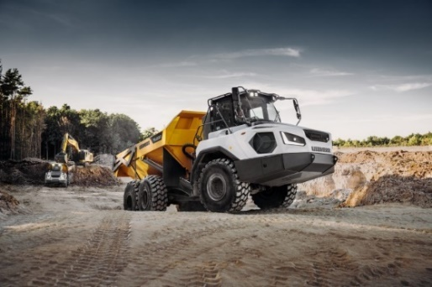
liebherr-ta230-litronic.jpg
The Liebherr TA 230 Litronic articulated dump truck has been designed for the toughest off-road operations.

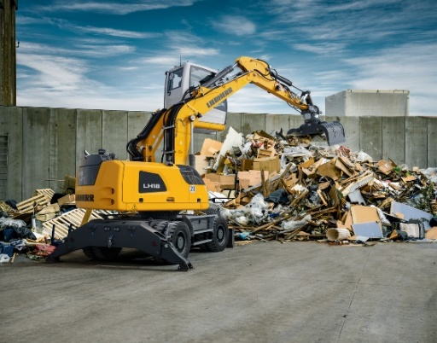
liebherr-lh18m-litronic.jpg
The LH 18 M Industry Litronic is the most compact representative of the range of Liebherr material handling machines and is predestined for efficient operations in the field of recycling and waste management.

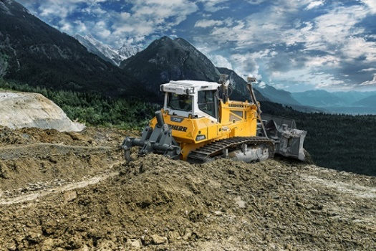
liebherr-pr736.jpg
With Generation 8, Liebherr customers work relaxed, safely and productively.

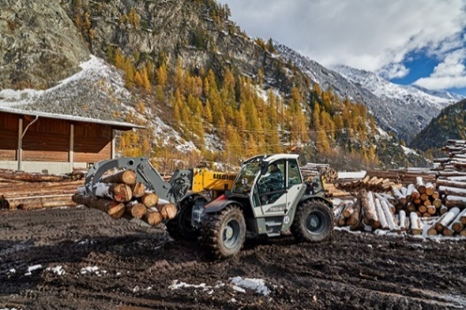
liebherr-t60-9s.jpg
The entire portfolio includes three telescopic handler models for industrial material handling – here model T 60-9s in a sawmill.

Contact
Nadine Willburger
Marketing
Phone: +49 7354 / 80 - 7332
email: nadine.willburger@liebherr.com
Published by
Liebherr-Hydraulikbagger GmbH
Kirchdorf an der Iller / Deutschland
www.liebherr.com

