Press release

Skyscraper construction in Singapore: World first for Liebherr luffing jib cranes

⸺
Two Liebherr 710 HC-L 32/64 Litronic cranes are working on the construction of the Central Boulevard Towers in Singapore
Liebherr’s largest luffing jib cranes are, for the first time ever, using a 24 HC 1000 tower system to climb within the structure as conditions are tight
The two cranes will reach their maximum tower height of 245 metres in just ten climbing stages
Local regulations and the layout of the site presented considerable challenges for the developers of a skyscraper project in Singapore. The solution involves two new Liebherr 710 HC-L luffing jib cranes, which are able to climb inside the building with the help of a 24 HC 1000 tower system. This is the first time the climbing system has been used worldwide; it requires less effort, which reduces crane downtimes.
Singapore, 1 June 2022 – Limited space, lifts weighing several tonnes and a world first: Two new Liebherr luffing jib cranes are currently raising a 48-storey office building in the centre of Singapore. Internal climbing systems have been a successful part of high-rise building construction for a number of years now. What makes the Singapore project a world first is that the two 710 HC-L cranes are using a 24 HC 1000 tower system to climb up on the inside.
The cranes started work in November 2020. Back then, the cranes belonging to the fleet of the Kim Soon Lee company were assembled freestanding at a tower height of around 40 metres. The Central Boulevard Towers are being built right next to the historic “Lau Pa Sat” building, also known as “Telok Ayer Market”. One of the two new towers will be approx. 241 metres in height. It’s for this part of the project that the two 710 HC-Ls, with jib lengths of 40 and 45 metres, are being used.
Fewer climbing stages, less downtime
The two cranes will reach their maximum tower height of 245 metres in just ten climbing stages. This is made possible by a 57 metre-high tower. “The number of times a crane has to climb impacts how long the downtime is for customers,” says Liebherr Tower Cranes project manager Eric Konijn, stressing the advantages of this solution. “We were able to offer our customer a solution with ten climbing stages, which saves them valuable time and consequently money.” One climbing stage takes about two hours, so the cranes stand still for as short a time as possible. In addition, there are significantly fewer storeys to reinforce, which also has a positive impact on cost efficiency.
Due to the amount of guying that is legally required, and the resulting significantly increased costs, having the cranes climb completely on the outside of the building wasn’t a viable option. Plus, there isn’t enough space on site to use exterior climbing cranes.
Lifts of up to 30 tonnes
The high-performance Liebherr 710 HC-L model was chosen because of the tight conditions on site, and the project’s heavy load and handling capacity requirements. The 710 HC-L has a maximum lifting capacity of 64 tonnes and is the largest luffing jib crane Liebherr offers. It can easily lift and precisely position the pre-cast concrete parts, weighing up to 30 tonnes, which are needed for the skyscraper’s construction.
When completed, the 48-storey tower will accommodate office and retail space. The Central Boulevard Towers project also includes a second tower, which is 16 storeys high. One of the highlights is an urban “sky park” with green spaces. Small recesses are to be incorporated into the greenery as meeting areas, and the park will also include a jogging track for employees to do their laps on.
The two luffing jib cranes will be working on this site, which borders on high-traffic roads, for several more months. They will continue climbing skywards section by section, watched over by the city’s skyscrapers. When they reach their maximum height, they will tower over the surrounding high-rises.
About the Liebherr Tower Cranes Division
More than seven decades of experience have made Liebherr a recognised specialist for lifting technology on all types of construction sites. The range of Liebherr Tower Cranes encompasses an extensive selection of high-quality tower cranes that are used worldwide. This includes fast-erecting, top-slewing, luffing jib and special-purpose cranes as well as mobile construction cranes. In addition to these products, Liebherr also offers a wide range of services that complete the company’s portfolio: Tower Crane Solutions, Tower Crane Customer Service and the Tower Crane Center.
About the Liebherr Group
The Liebherr Group is a family-run technology company with a highly diversified product portfolio. The company is one of the largest construction equipment manufacturers in the world. It also provides high-quality and user-oriented products and services in a wide range of other areas. The Liebherr Group includes over 140 companies across all continents. In 2021, it employed more than 49,000 staff and achieved combined revenues of over 11.6 billion euros. Liebherr was founded in Kirchdorf an der Iller in Southern Germany in 1949. Since then, the employees have been pursuing the goal of achieving continuous technological innovation, and bringing industry-leading solutions to its customers.

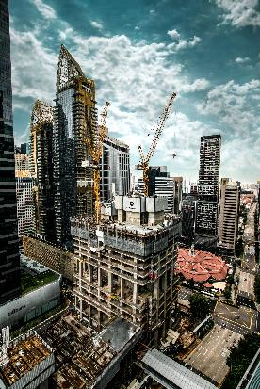
Images

liebherr-710-hcl-singapore-01.jpg
Two Liebherr luffing jib cranes are currently working on the construction of one of the two towers of the Central Boulevard Towers in Singapore.

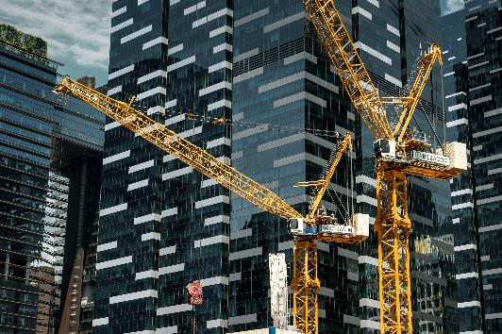
liebherr-710-hcl-singapore-02.jpg
For the first time, the 710 HC-L cranes climb on a 24 HC 1000 tower system to save space.

Contact person
Daniel Haefele
Global Communication
Telephone: +49 7351/41 - 2330
Email: daniel.haefele@liebherr.com
Published by
Liebherr-Werk Biberach GmbH
Biberach / Germany
www.liebherr.com

