Press release

Liebherr at the 28th International Exhibition for Track Technology in Münster

⸺
Liebherr rail-road excavators at booth B-420/B-421: A 922 Rail Litronic and A 924 Rail Litronic
Numerous Liebherr attachments and quick coupling systems as supplement to the multifunctional machine
ECM certification for Liebherr rail-road excavators
At the 28th International Exhibition for Track Technology in Münster Liebherr presents its latest generation of its rail-road excavators in the shape of the A 922 Rail Litronic and the A 924 Rail Litronic, both of which can be used on rail and on road. Also being showcased are various attachments and quick coupling systems to further enhance the versatility of these machines. Trade fair visitors will also have the opportunity to obtain comprehensive information about the ECM certification for Liebherr rail-road excavators.
Münster (Germany), 31 May 2022 – Liebherr-Hydraulikbagger GmbH has been developing and producing powerful Liebherr rail-road excavators in Kirchdorf an der Iller for more than five decades. The extensive experience, continual development of the product portfolio, as well as the effort to constantly provide maximum efficiency and performance, make Liebherr the global leader in this market today.
This is Liebherr’s sixth participation in this exhibition. The A 922 Rail Litronic and A 924 Rail Litronic rail-road excavators are on display in the outdoor area (booth no. B-420/B-421). Various Liebherr attachments and quick coupling systems are also on show, both static and on demo. Trade fair visitors can also obtain information about the ECM certification for Liebherr rail-road excavators. The directive requires vehicle owners to ensure the safe operation of their machines in the future.
Presentation of the latest Liebherr rail-road excavator generation: The A 922 Rail Litronic and A 924 Rail Litronic excavators
The A 922 Rail has an operating weight between 20,400 and 23,400 kg. The rail travel drive is mounted on either side of the undercarriage. During the re-railing the rail travel drive brings the tyres to rail level, whereby the inner wheels of the dual tyres assume the travel drive on rail. In addition to the standard counterweight, a revised, heavy counterweight with a reduced tail swing of 2,000 mm is now also available for the A 922 Rail. The maximum lift capacities can also be increased via a Power Lift mode as well as an optional 4-point support jib.
The A 924 Rail has an operating weight between 21,800 and 25,000 kg. The rail travel drive is also mounted on either side of the undercarriage. During unloading the rail guide is lowered in axle pairs until the inner wheels of the dual tyres are at the track wheel and ensure a frictional connection of the travel drive.
A 120 kW / 163 hp powerful and robust engine is installed in both machines. In combination with the optimally coordinated hydraulic system, the machines reach constantly high work speeds with the usual fluid working movements. For exhaust emission stage V Liebherr uses a newly developed SCRT system comprising a SCR catalytic converter and a standard particulate filter. The innovative hydraulic concept consists of a Liebherr variable displacement double pump with independent control circuits. High-performance, hydraulic attachments can thus be operated independently of the working and travel movements of the machines.
The service-orientated layout of the machine guarantees short maintenance periods and minimises the associated costs thanks to the time savings. All maintenance points are easily accessed from the ground.
The spacious two-person cabs featuring standard rollover protection (ROPS) and a modern interior design offer the best conditions for comfortable, focused and productive work. The usual generous use of glass and standard rear and side cameras provide an exceptional view of the working area and swing range.
As occupational safety plays an important role in track construction, Liebherr offers safety systems specially developed in-house for rail applications. Numerous equipment features such as the pipe break protection on the lifting and stick cylinders, electronic height and turning radius limitation, load moment limitation i.a.w. EN 15746-2, impact-resistant roof panel made of laminated safety glass, rollover protection system (ROPS) and an emergency exit through the rear window provide maximum safety in all operations.
Rail machine attachments and quick coupling systems
In order to meet the various construction site requirements efficiently and reliably, Liebherr offers a comprehensive portfolio of attachments to further enhance the versatility of its rail machines. With the fully hydraulic Liebherr quick coupling system LIKUFIX® both mechanical and hydraulic tools can be changed quickly and safely from the operator's cab. Both rail-road excavators presented at IAF are equipped with LIKUFIX®.
One of the various attachments on show is the Liebherr tilt unit LiTiU which increases the productivity of the machines by giving an additional swing angle of up to 2 x 50°. This is a huge advantage especially in track construction where there are generally more restrictions due to the rail infrastructure. By extending the working envelope of the machines LiTiU enables them to access areas otherwise difficult to reach. At the trade fair LiTiU 33 is showcased as a sandwich attachment, i.e. the connection between the end of the stick and LiTiU, and the connection between the bottom of the LiTiU and the tool are made via LIKUFIX®. This means the entire unit can be set down quickly and a different tool, such as the Liebherr stick extension, attached and operational within seconds. The 2.25 metre Liebherr LS 12 stick extension on display can increase the reach to over 10 metres (depending on the stick length) to give an increased working radius.
The Liebherr GMZ 22 clamshell buckets are also designed for track construction. They can be individually configured depending on customer requirements. The new generation with numerous new technical features is presented at IAF. Closely fitted and protected hydraulic lines ensure a reduced risk of damage. The new lean design of the ejectors with improved linkage for the grapples, combination and track construction buckets as well as the tilted side plates, lead to more efficient and less resistant grabbing as well as optimised loading and unloading operations. Top quality steel makes the clamshell buckets a robust and durable tool. Three different combinations are on show: The GMZ 22 with track construction buckets has a cutting width of 300 mm and capacity of up to 0.08 m³, whereas the GMZ 22 with combination buckets and grapples, each with a cutting width of 600 mm, have capacity of 0.20 m³ or 0.30 m³.
Pivot rotators have also become indispensable in track construction work and the Liebherr TR 20 pivot rotator on show offers maximum flexibility specially when digging with its infinite 360° rotation, patented swivel mechanism and swing angle of 2 x 50°.
ECM certification for Liebherr rail-road excavators
In order to be able to operate in rail transport, compliance with strict rules and regulations is required in addition to the comprehensive machine safety systems. In 2019, the EU Commission initiated a new directive intended to further enhance safety in railway traffic and to improve interoperability. The new EU ECM directive (Entity in Charge of Maintenance) now places responsibility on the owners of rail-road excavators.
The new DVO (EU) 2019/779, also called the ECM directive, applies to railway vehicles, which operate on the higher-level network. Liebherr rail-road excavators will also fall under this new certification requirement in the future. An ECM entity must be assigned to every machine in the vehicle register. ECM designates the authority responsible for the maintenance of the respective machine. From June this year, Liebherr-Mietpartner GmbH and Carl Beutlhauser Baumaschinen GmbH are officially certified as such ECM entities. The maintenance operations of Liebherr-Hydraulikbagger GmbH and Liebherr sales and service partners in Germany and Austria are certified. The Liebherr sales and service partner in the Czech Republic, Liebherr-Stavební stroje CZ s.r.o., was certified at the end of last year.
Successful ECM certification will enable Liebherr-Hydraulikbagger GmbH to continue giving customers competent consultation and support. Successful certification also means that Liebherr sales and service partners will remain authorised and trained to perform repairs, annual inspections and revisions on Liebherr rail-road excavators. Liebherr-Mietpartner GmbH and Carl Beutlhauser Baumaschinen GmbH are also certified as official ECM entities. This will ensure that Liebherr rail-road excavators also remain available to customers for rental.

About the Liebherr Group
The Liebherr Group is a family-run technology company with a highly diversified product range. The company is one of the largest construction equipment manufacturers in the world. It also provides high-quality, user-oriented products and services in many other areas. Today the Liebherr Group has over 140 companies spread across all continents. In 2021, the Liebherr Group employed 49,000 staff and achieved a consolidated total turnover of over 11.6 billion euros. Liebherr was founded in 1949 in Kirchdorf an der Iller in southern Germany. Since then the employees have pursued the aim to convince their customers with sophisticated solutions and contribute to technological progress.

Pictures
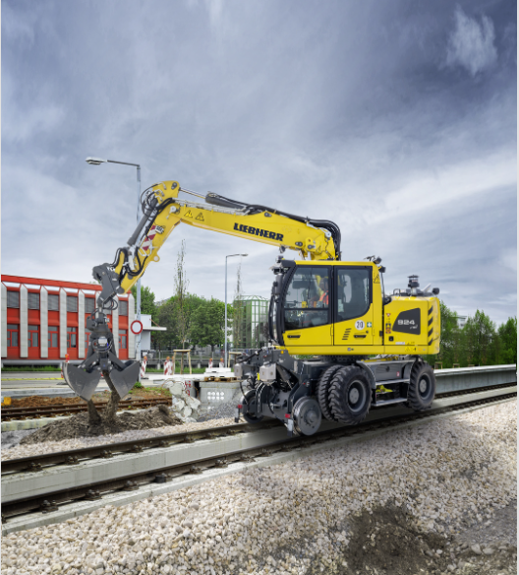
liebherr-iaf-1.jpg
At the 28th International Exhibition for Track Technology in Münster Liebherr presents a representative of its successful rail-road excavator with the A 924 Rail Litronic.

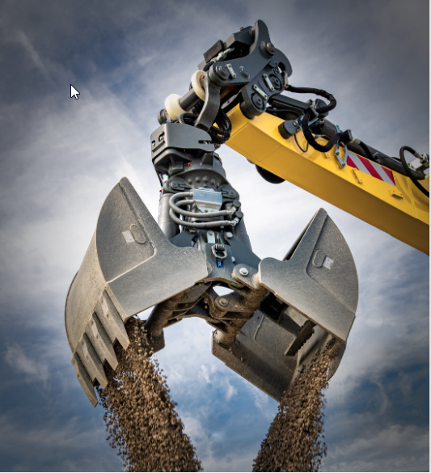
liebherr-iaf-2.jpg
The Liebherr GMZ 22 clamshell buckets are designed for track construction.
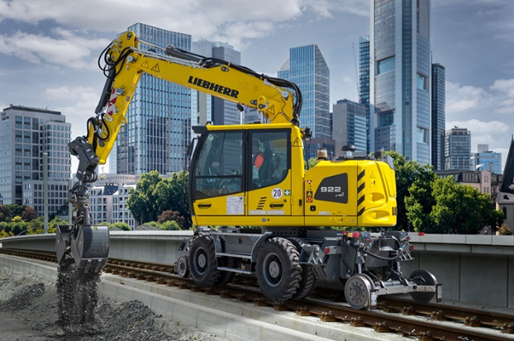
liebherr-iaf-3.jpg
ECM certification is mandatory for owners of rail-road excavators. Liebherr-Hydraulikbagger GmbH and Liebherr sales, rental and service partners in Germany, Austria and the Czech Republic are now officially certified in accordance with the ECM directive.

Contact
Nadine Willburger
Marketing
Telefon: +49 7354 / 80 - 7332
E-Mail: nadine.willburger@liebherr.com
Published by
Liebherr-Hydraulikbagger GmbH
Kirchdorf an der Iller / Deutschland
www.liebherr.com

