Press release

Liebherr introducing ECM certification for rail-road excavators

⸺
ECM as a mandatory certification system for organisations working on the maintenance of railway vehicles
Certification now includes Liebherr rail-road excavators
Liebherr-Hydraulikbagger GmbH and Liebherr sales, rental and service partners in Germany, Austria and the Czech Republic are now officially ECM-certified
Liebherr has been developing and producing rail-road excavators at its plant in Kirchdorf an der Iller since 1967 and is global market leader in this segment. Liebherr rail-road excavators can be used both on rail and on the road. Strict regulations have to be observed when operating in road traffic. In 2019, the EU Commission initiated a new directive intended to further enhance safety in railway traffic and to improve interoperability. The new EU ECM directive (Entity in Charge of Maintenance) now places responsibility on the holders of rail-road excavators.
Kirchdorf an der Iller (Germany), 31 May 2022 – The new (EU) Directive 2019/779, also known as the ECM directive, is applicable for railway vehicles operating in the higher-level network. Liebherr rail-road excavators will also be subject by this new certification requirement in the future.
An ECM entity is to be assigned to every machine in the vehicle register so that this vehicle can be operated in the rail network. ECM, i.e. "Entity in Charge of Maintenance", denotes the entity responsible for the maintenance of the machine concerned. From June this year, Liebherr-Mietpartner GmbH and Carl Beutlhauser Baumaschinen GmbH are officially certified as such ECM points. The maintenance operations of Liebherr-Hydraulikbagger GmbH and Liebherr sales and service partners in Germany and Austria are certified. The Liebherr sales and service partner in the Czech Republic, Liebherr-Stavební stroje CZ s.r.o., was certified at the end of last year.
New implementation regulation demands certification
Following a serious railway accident in Italy in 2009 caused by a crack in a track wheel, directive (EU) 445/2011 was introduced to implement ECM as a system for the certification of "entities in charge of maintenance of freight wagons ". Until now, this directive, which requires a comprehensive maintenance management system, has only been valid for goods trains. To enhance safety in railway traffic, the old directive has been revised and expanded.
The new directive (EU) 2019/779, which came into effect in 2019, expands the application to all rail cars that operate on the public rail network. This also includes Liebherr rail-road excavators operating in various European countries such as Germany, Austria and in the Czech Republic. Non-EU countries such as Switzerland also base their requirements on this regulation.
The revised directive also includes a mandatory certification system for all ECM entities in which the maintenance processes are audited. Vehicles that are not assigned to an ECM entity may no longer be used in railway traffic.
Customer benefits thanks to ECM certification
Liebherr-Hydraulikbagger GmbH and the Liebherr sales, rental and service partners in Germany, Austria and the Czech Republic have implemented a maintenance management system that is compliant with directive (EU) 2019/779. From June this year, these divisions will be officially ECM-certified.
Successful ECM certification will enable Liebherr-Hydraulikbagger GmbH to continue giving customers competent consultation and support. Moreover, the company also upholds the customary high-quality processes in the production of rail-road excavators – and ensures ECM-compliant procedures.
Successful certification also means that Liebherr sales and service partners will remain authorised and trained to perform repairs, annual inspections and revisions on Liebherr rail-road excavators. Liebherr-Mietpartner GmbH and Carl Beutlhauser Baumaschinen GmbH are also certified as official ECM entities. This will ensure that Liebherr rail-road excavators remain available to customers for rental in the familiar manner.
About the Liebherr Group
The Liebherr Group is a family-run technology company with a highly diversified product portfolio. The company is one of the largest construction equipment manufacturers in the world. It also provides high-quality and user-oriented products and services in a wide range of other areas. The Liebherr Group includes over 140 companies across all continents. In 2021, it employed more than 49,000 staff and achieved combined revenues of over 11.6 billion euros. Liebherr was founded in Kirchdorf an der Iller in Southern Germany in 1949. Since then, the employees have been pursuing the goal of achieving continuous technological innovation, and bringing industry-leading solutions to its customers.

Images
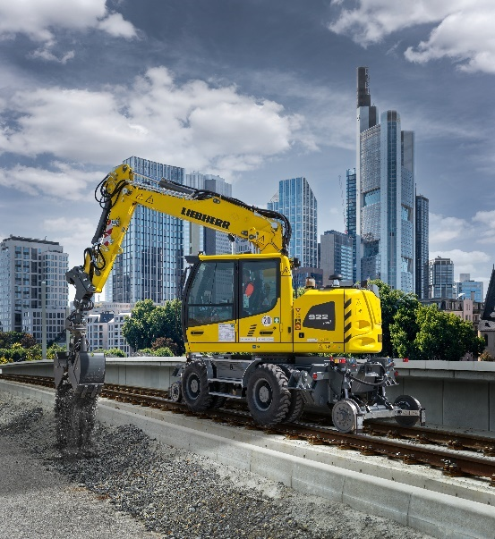
liebherr-zweiwegebagger-ecm.jpg
ECM certification is mandatory for holders of rail-road excavators. Liebherr-Hydraulikbagger GmbH and Liebherr sales, rental and service partners in Germany, Austria and the Czech Republic are now officially certified in accordance with the ECM directive.
Contact
Nadine Willburger
Marketing
Phone: +49 7354 / 80 - 7332
E-mail: nadine.willburger@liebherr.com
Published by
Liebherr-Hydraulikbagger GmbH
Kirchdorf an der Iller / Deutschland
www.liebherr.com

