Press release

Future-oriented – Lelieur takes delivery of Liebherr LTM 1230-5.1 mobile crane

⸺⸺
- Lelieur continues its 30-year partnership with Liebherr
- LTM 1230-5.1 to refresh Lelieur’s fleet ready for the future
- Powerful Liebherr crane with a long boom
- ECOdrive and ECOmode reduce fuel consumption and noise emissions
As part of the renewal of Lelieur Levage's fleet, the French company has continued its partnership with Liebherr, which has been ongoing for more than 30 years. Sustainability and the well-being of personnel on and around the site are major criteria for Lelieur and were factors in the decision to purchase a new LTM 1230-5.1 mobile crane. The technical aspects of the powerful Liebherr mobile crane with its long boom also scored heavily in favour of the 5-axle model.
Ehingen (Donau) (Germany), 25 May 2022 – Lelieur Levage has taken delivery of an LTM 1230-5.1 as part of its plans to update its fleet with around 30 cranes. The new, more powerful 230 tonne crane will replace an LTM 1220-5.1 and take its place in the fleet between a 130 and a 300-tonne-crane. “The Liebherr cranes that we invest in are always state of the art and enable us to minimise our fuel consumption and reduce noise emissions”, says Eric Lelieur, owner of Lelieur Levage. “That means that they help to make work on sites as green as possible and ensure the well-being of the site workers and local residents.”
Low noise and exhaust emissions
Its ECOdrive technology enables the LTM 1230-5.1 to reduce its fuel consumption by adjusting its ZF TraXon gearbox to the perfect travel setting and also reduces noise emissions. Furthermore, ECOmode in the superstructure also minimises fuel consumption and noise emissions. “We choose Liebherr for mobile cranes because the brand enables us to demonstrate our commitment for limiting our CO₂ footprint and therefore satisfy the energy policy challenges of the world of tomorrow”, continues Lelieur.
Long, powerful and versatile – high lifting capacity for great hoist heights
Other major criteria behind the purchase included the high capacity and boom length of the LTM 1230-5.1. At 75 metres, this crane features one of the longest telescopic booms in this crane class. It can also be combined with a 43 metre fixed jib. As a result of its long boom system and high lifting capacity, this 5-axle model is an ideal crane for working fully raised at great hook heights, for example for assembling tower cranes or maintenance work for wind turbines. The main areas of work for the Lelieur’s new crane will be maintenance work in industry.
In addition, Liebherr’s VarioBase® and VarioBallast® innovations played a major role in choosing to buy the LTM 1230-5.1. They enable work to be carried out safely, particularly in constricted conditions. “Liebherr machines deliver excellent comfort and safety”, adds Lelieur. “The fact that all the models and different machines have the same controls is a major benefit.”
Partnership with Liebherr dates back over 30 years
“Liebherr is a committed, reliable supplier with whom we have built up a relationship of trust”, explains the company owner. There has been a partnership between Lelieur and Liebherr for more than 30 years. Lelieur Levage is based in Dunkirk and Calais on the coast of the Hauts-de-France region. The French family-run company, founded in 1970, is active throughout the region at the heart of its industrial centres where there is a large number of construction projects. The company owns a fleet of around 50 machines with which Lelieur provides its customers with hoisting, haulage and storage services.
About Liebherr-Werk Ehingen GmbH
Liebherr-Werk Ehingen GmbH is a leading manufacturer of mobile and crawler cranes. Its range of mobile cranes extends from 2-axle 35 tonne cranes to heavy duty cranes with a lifting capacity of 1200 tonnes and a 9-axle chassis. Its lattice boom cranes on mobile or crawler crane chassis deliver lifting capacities of up to 3000 tonnes. With universal boom systems and extensive additional equipment, they can be seen in action on construction sites throughout the world. The Ehingen site has a workforce of 3,800. Extensive, global service guarantees the high availability of Liebherr mobile and crawler cranes. In 2021, the Liebherr plant in Ehingen recorded a turnover of 2.33 billion euros.
About the Liebherr Group
The Liebherr Group is a family-run technology company with a highly diversified product portfolio. The company is one of the largest construction equipment manufacturers in the world. It also provides high-quality and user-oriented products and services in a wide range of other areas. The Liebherr Group includes over 140 companies across all continents. In 2021, it employed more than 49,000 staff and achieved combined revenues of over 11.6 billion euros. Liebherr was founded in Kirchdorf an der Iller in Southern Germany in 1949. Since then, the employees have been pursuing the goal of achieving continuous technological innovation, and bringing industry-leading solutions to its customers.

Images
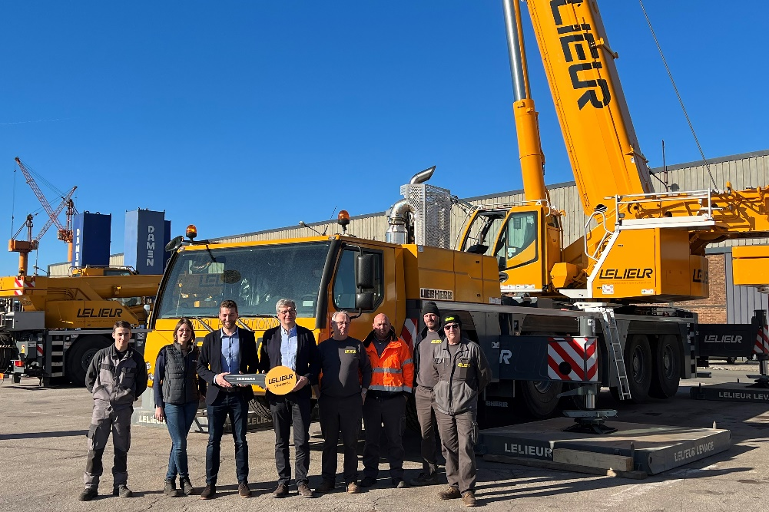
liebherr-ltm-1230-5-1-handover-lelieur.jpg
Handover of the LTM 1230-5.1 to Lelieur Levage (From left to right): Théophile (Liebherr Grues Mobiles), Elise (Lelieur), Guillaume Gaeng (Liebherr Grues Mobiles), Eric Lelieur (owner of Lelieur), Xavier, Jérémy, François and Stéphane (all from Lelieur).

Contact
Wolfgang Beringer
Marketing and Communication
Phone: +49 7391/502 - 3663
Email: wolfgang.beringer@liebherr.com
Published by
Liebherr-Werk Ehingen GmbH
Ehingen (Donau), Germany
www.liebherr.com

