Press Information

Smart equipment solutions: Liebherr presents new multi-tine grab

⸺
The new Liebherr five-tine grab GMM 50-5: Clever design for machine classes from 35 to 55 tonnes
Impresses with exceptional load-bearing capacity, resistance and durability
Designed for tough applications in the area of recycling and scrap handling
Liebherr presents its newly developed multi-tine grab GMM 50-5. The intelligently designed five-tine grab was not only developed for customers, but also developed together with them. The new grab combines decades of Liebherr expertise in the area of the development and manufacture of high-performance, robust attachments with a valuable wealth of experience from the users themselves. The multi-tine grab excels in terms of exceptional load-bearing capacity, resistance and durability.
Kirchdorf an der Iller (Germany), 24 May 2022 – Recycling and scrap handling are some of the toughest applications in industrial goods handling. Robustness, reliability and efficiency are required therefore, choosing the right attachment for the job is key for efficient and economical goods handling.
With the five-tine grab GMM 50-5 Liebherr has developed a new attachment that fully meets these special operational requirements. A comprehensive portfolio of buckets as well as a wide selection of optional equipment means that diverse materials can be handled efficiently and economically in recycling and scrap handling. Only top-quality materials are used for the manufacture of the new grab. The GMM 50-5 is available for material handlers with an operating weight from 35 to 55 tonnes.
Extremely robust and resistant
The components of the new GMM 50-5 are made of sturdy cast steel as well as low-wear, high-strength steel sheets. The consistent use of the high-quality materials guarantees extreme stability and resistance for the toughest applications and material handling scenarios. The special shape of the tine support and the buckets was developed based on state-of-the-art calculation and simulation software. Thanks to this modern development process, the new grab is extremely robust and resistant despite its low dead weight.

Focus on maximum service life and performance
In the design phase special attention was paid to maximum service life: In order to split the high torque, the slewing drive, for example, was equipped as standard with two motors. This increases the service life and minimises wear considerably. Both rotary transmission and the reinforced slewing drive are sealed multiple times to give maximum protected against external factors such as dust and water.
Large and flow-optimised oil ducts not only ensure fast work speeds, but also efficient machine operation. The sealed, anti-twist piston rod protection for hydraulic cylinders is also included with the grab as standard. The latter come with new cylinder kinematics, which also guarantee a long-lasting and good closing mechanism also when the tines becomes worn.
A newly designed wear back on the tines also extends the service life immensely. Long-lasting good and precise penetration in diverse scrap and recycling materials is due to the special shape and alignment of the tine tips. They are made from a new type of material for a long service life.
Easy servicing and numerous options
As the lubrication points are arranged ergonomically and logically, the GMM 50-5 is supplied with the necessary lubrication in a very short space of time. Perfect tolerances and generously dimensioned bearing surfaces lead to gentle interplay of the individual components.
Thanks to the optional motor and hose protection damage to rotary motors and hydraulic lines is minimised. An optional central lubrication system assumes regular, automatic lubrication of all central points. The GMM 50-5 can be equipped with shackles to protect magnetic plates. In order to protect the edges of the often highly stressed internal sheet of the grab against wear and tear, the tines can be equipped with a reinforcement set of wear-resistant sheets.
Three different tines shapes
The GMM 50-5 is designed specially for optimal grabbing of mixed and shredder waste as well as chippings or shavings with content of up to 1.10 m³. The arrangement and shape of the tines are optimised for perfect penetration and holding of bulky and at the same time loose material. There is a choice of three different tines for handling diverse materials: The version with open tines is perfect for handling large-size and bulky scrap objects. The version with semi-closed tines is ideal for medium-sized, mixed materials and shredding waste. Small, fine materials and chippings or shavings can be handled most effectively with the closed, heart-shaped tines.

About the Liebherr Group
The Liebherr Group is a family-run technology company with a highly diversified product portfolio. The company is one of the largest construction equipment manufacturers in the world. It also provides high-quality and user-oriented products and services in a wide range of other areas. The Liebherr Group includes over 140 companies across all continents. In 2021, it employed more than 49,000 staff and achieved combined revenues of over 11.6 billion euros. Liebherr was founded in Kirchdorf an der Iller in Southern Germany in 1949. Since then, the employees have been pursuing the goal of achieving continuous technological innovation, and bringing industry-leading solutions to its customers.
Pictures
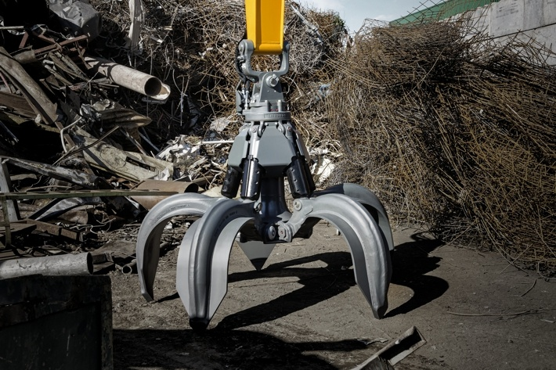
liebherr-gmm50-5-1.jpg
The Liebherr multi-tine grab GMM 50-5 was completely redeveloped with a smart design.
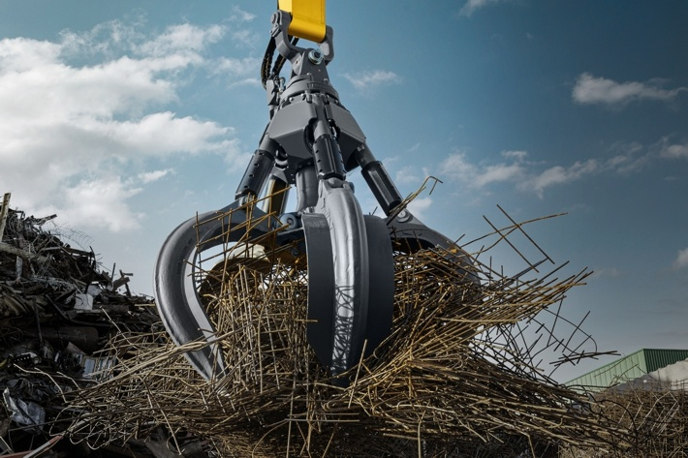
liebherr-gmm50-5-2.jpg
The new GMM 50-5 is designed for tough applications in the area of recycling and scrap handling. There is a choice of three perfectly designed tines for different materials.
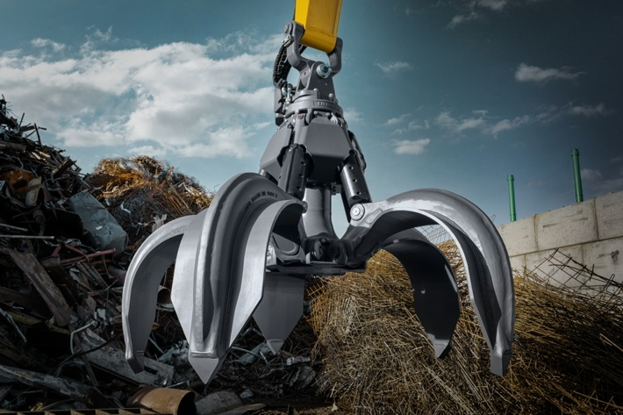
liebher-gmm50-5-3.jpg
Extremely robust and resistant: The components of the new GMM 50-5 are made of sturdy cast steel as well as low-wear, high-strength steel sheets. The consistent use of high-quality materials guarantees extreme stability and resistance.

Contact
Nadine Willburger
Marketing
Tel.: +49 7354 / 80 - 7332
E-mail: nadine.willburger@liebherr.com
Published by
Liebherr-Hydraulikbagger GmbH
Kirchdorf an der Iller / Germany
www.liebherr.com

