Press release

Customer Day at Liebherr: Expanded Operations, Expanded Solutions

⸺
First event hosted at newly expanded facility
Presentation of products and the new campus
Over thirty exhibits of ten product segments featured
Newport News, VA (USA), May 12, 2022 – Liebherr USA, Co. hosted visitors from across the globe at their first Customer Day on May 12. The company highlighted and demonstrated a diverse range of products across all ten segments including earthmoving, material handling technology, deep foundation machines, tower cranes, mining, mobile and crawler cranes, maritime cranes, concrete technology, components as well as refrigerators and freezers.
New products for the US market
Liebherr USA, Co. unveiled various new products to the US market including the TA230 articulated dump truck, LTM 1110-5.2 all-terrain crane, LTM 1300-6.3 all-terrain crane, LR 1700 crawler crane, LR 1400 SX crawler crane, LR 1250.1 unplugged crawler crane, LRB 23 piling & drilling rig, 36 XXT truck mounted concrete pump, 80-LP line pump, and PR 776 dozer.
Having formally moved in to the expanded campus in April 2020, Customer Day also provided the opportunity to reveal the $60 million enhancement to the facilities: They are comprised of a 60,000 ft2 administrative building, an 82,000 ft2 workshop and training facility, a 92,000 ft2 parts distribution warehouse including retail operations, a one-story 7,500 ft2 wash bay building, and a guard house.
The new campus will help Liebherr serve customers across various product segments. It significantly increases production operations for concrete pumps and repair capacity for mobile and crawler cranes, as well as for construction equipment. The new shop is also equipped to handle the growing numbers of Liebherr earthmoving equipment.
“The investment in our new Liebherr USA headquarters and facilities represents our strong commitment to the US market. The new state of the art repair and training facilities as well as the new central warehouse are, in terms of size and technical standards, advanced and comply with current and future requirements of our customers, covering all ten product segments. This in combination with our highly qualified and motivated workforce perfectly serves and supports our customers in the USA,” stated Managing Director Kai Friedrich.
Event for customers, partners and families
The event launch allowed Liebherr customers to join in facility tours and experience product presentations, including a live application show of various new machines. Over thirty exhibits throughout the facility grounds were on display, and product experts were on hand to explain special features of the new machines and give insights on using established machines.
As the first of three events taking course over the weekend, the Customer Day preceded Liebherr’s Recruiter and Counselor Open House on Friday the 13th and Family Day on Saturday the 14th.
“After two years of anticipation, we are honored to present our newly expanded facilities and products on such a momentous day,” noted Managing Director, Dr. Tim Gerhardt. “This opportunity allows us to showcase Liebherr’s growth and dedication to our US partners and customers.”
About Liebherr USA, Co.
Liebherr USA, Co. based in Newport News, VA provides sales and service on behalf of ten different Liebherr product segments: earthmoving, material handling machines, mining, mobile and crawler cranes, tower cranes, concrete technology, deep foundation machines, maritime cranes; components, and refrigeration and freezing.
About the Liebherr Group
The Liebherr Group is a family-run technology company with a highly diversified product portfolio. The company is one of the largest construction equipment manufacturers in the world. It also provides high-quality and user-oriented products and services in a wide range of other areas. The Liebherr Group includes over 140 companies across all continents. In 2021, it employed more than 49,000 staff and achieved combined revenues of over 11.6 billion euros. Liebherr was founded in Kirchdorf an der Iller in Southern Germany in 1949. Since then, the employees have been pursuing the goal of achieving continuous technological innovation, and bringing industry-leading solutions to its customers.

Images
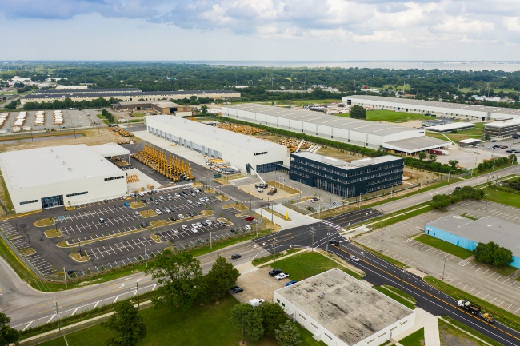
Liebherr_USA_Newport_News.jpg
Liebherr USA Co.’s new expanded facilities including the admin building, training facility/workshop, and warehouse.
Contact
Ana Cabiedes
General Manager, Marketing
Phone: +1 757-240-4250
E-Mail: ana.cabiedes@liebherr.com
Published by
Liebherr USA, Co.
Newport News / USA
www.liebherr.com

