Press release

STRABAG relies on LIKUFIX® from Liebherr

⸺
STRABAG has been using the fully hydraulic quick coupling system LIKUFIX® for several years
Increased efficiency and safety in construction site operation

One of Europe's largest construction service providers, STRABAG SE from Austria, has been successfully using the fully hydraulic quick coupling system LIKUFIX® from Liebherr for several years now in addition to several Liebherr construction machines and attachments.
STRABAG uses the fully hydraulic Liebherr quick coupling system LIKUFIX® for all existing and new Liebherr machines, as well as for most machines from other manufacturers.

Kirchdorf an der Iller (Germany), 16 May 2022 – Apart from its comprehensive portfolio of earthmoving machines and material handlers, Liebherr-Hydraulikbagger GmbH also provides numerous attachments appropriate for the respective application, as well as different configuration levels of quick coupling systems.
STRABAG SE is an international European group, whose comprehensive range of services includes structural and civil engineering as well as road construction. In addition to deep foundation machines and tower cranes, the company also uses various machines from the earthmoving division. Due to the complex and versatile range of services at STRABAG, a frequent change of attachment is generally unavoidable especially with hydraulic excavators. Machine operators regularly change the attachment in day-to-day site work. Therefore, for productive, efficient and safe construction site operation the fully hydraulic quick coupling system LIKUFIX® from Liebherr has been used successfully for several years at STRABAG.
LIKUFIX®: Integral component of future machine equipment
The use of a hydraulic excavator together with a quick coupling system is a basic prerequisite for economical, efficient and competitive use, says Rudolf Arnold, Managing Director Sales at Liebherr-Hydraulikbagger GmbH. Liebherr offers three different configuration levels of quick coupling systems: Apart from mechanical quick coupling systems for infrequent changes of attachments, the hydraulic quick coupling system is perfect for frequent changes. The quick coupler can be operated at the touch of a button; however, the hydraulic lines must be manually connected and separated. With the fully hydraulic quick coupling system LIKUFIX® the attachment change can be conveniently realised from the operator's cab. Thanks to the combination of hydraulic quick coupler and LIKUFIX® coupling block, both mechanical and hydraulic attachments are quickly combined with the machine to create a powerful and high-performance unit.
According to Martin Philipp, Head of Investment and Procurement at STRABAG BMTI
GmbH & Co. KG, the majority of the wheeled and crawler excavators in new investments are equipped with the fully hydraulic quick coupling system LIKUFIX®. This concerns both Liebherr machines and machines from other manufacturers as the quick coupling systems from Liebherr can be used with machines from all manufacturers. For STRABAG it is a worthwhile additional investment as the efficiency of hydraulic excavators is boosted significantly thanks to the quick change of attachment.

Positive experiences with LIKUFIX®
LIKUFIX® has already been used successfully at STRABAG since 2007. The fully hydraulic quick coupling system from Liebherr mainly impresses in terms of high product quality as well as easy servicing and maintenance. Liebherr continuously optimises these aspects in the course of further product development. For instance, with the new HD generation of quick coupling systems the steel structure was optimised compared to the predecessor series, whereby the life could once again be significantly increased. The new generation was also designed in view of optimised maintenance so that maintenance work can now be carried out even more simply, for shorter downtimes sometimes even directly on the construction site.
LIKUFIX® not only increases the efficiency, but also safety in day-to-day construction site operation. An important factor for the company because huge importance is attached to safety in the STRABAG Group. The attachment is changed from the operator's cab at the touch of a button. This ensures that nobody is in the danger zone during the change of attachment. A unique advantage of the quick coupling system from Liebherr is exhibited here: Instead of the pressure control of the locking cylinder, each hydraulic Liebherr quick coupler has electronic position sensors as standard which monitor the position of the locking bolt. An optical and acoustic warning informs the machine operator when the quick coupler is opened. In addition, the machine operator can confirm whether the quick coupler is safely connected to the attachment thanks to good visibility of the left locking bolt. Another proximity sensor monitors the correct position of the attachment in the locking position, thus ensuring enhanced safety in further construction site operation.
LIKUFIX® is fully hydraulic
The fully hydraulic quick coupling system LIKUFIX® is a hydraulic quick coupler combined with the hydraulic block LIKUFIX®, which was developed by Liebherr in 2000, highlights Frederik Kössinger, Sales Manager of Attachments and Quick coupling Systems at Liebherr-Hydraulikbagger GmbH. LIKUFIX ® has hydro-mechanical bearings, meaning the system can be perfectly balanced on all axles and at all degrees of freedom, he adds. Furthermore, the quick coupling system is easy to clean and dirt can be easily detected. A solid metal plate and sunken hydraulic couplings prevent damage during the coupling process. An optional bracket at the coupling block also protects the hydraulic lines against damage. Depending on the tonnage class, Liebherr has four different LIKUFIX® variants in the portfolio in the area of hydraulic excavators. Liebherr also has two fully hydraulic quick coupling systems for material handlers.

About STRABAG SE
STRABAG SE is a European-based technology partner for construction services, a leader in innovation and financial strength. The company creates added value for customers by integrating diverse services in specialised business units and assuming responsibility. STRABAG brings people, construction materials and machines to the right place at the right time and also realises complex construction projects. Thanks to the commitment of more than 74,000 employees, STRABAG generates an annual revenue of around 16 billion euros. An extensive network of several subsidiaries in many European countries and also on other continents expands the catchment area beyond Austria and Germany.

About the Liebherr Group
The Liebherr Group is a family-run technology company with a highly diversified product portfolio. The company is one of the largest construction equipment manufacturers in the world. It also provides high-quality and user-oriented products and services in a wide range of other areas. The Liebherr Group includes over 140 companies across all continents. In 2021, it employed more than 49,000 staff and achieved combined revenues of over 11.6 billion euros. Liebherr was founded in Kirchdorf an der Iller in Southern Germany in 1949. Since then, the employees have been pursuing the goal of achieving continuous technological innovation, and bringing industry-leading solutions to its customers.
Images
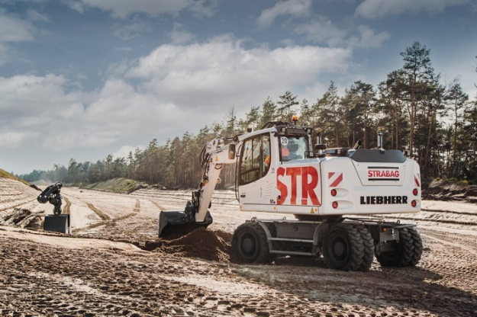
liebherr-likufix-strabag-1.jpg
STRABAG uses the fully hydraulic Liebherr quick coupling system LIKUFIX® for all existing and new Liebherr machines, as well as for most machines from other manufacturers.
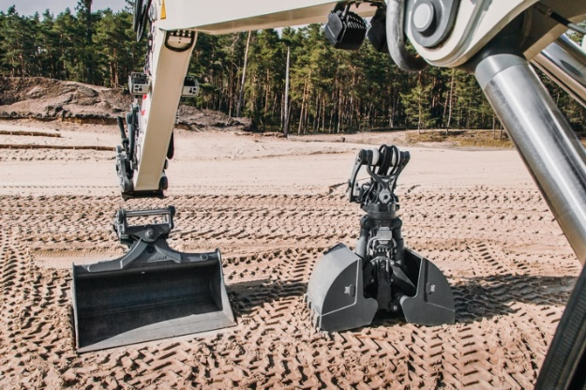
liebherr-likufix-strabag-2.jpg
LIKUFIX® enables a quick and safe change of the attachment from the operator's cab.
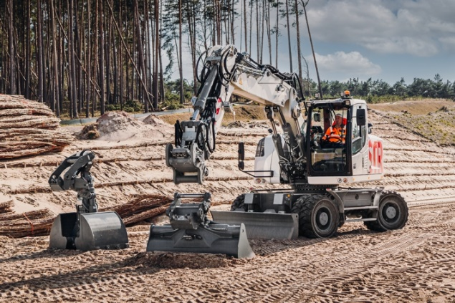
liebherr-likufix-strabag-3.jpg
LIKUFIX® is a hydraulic quick coupler combined with an automatic hydraulic coupling system specially developed by Liebherr already in 2000.
Contact
Nadine Willburger
Marketing
Phone: +49 7354 / 80 - 7332
E-mail: nadine.willburger@liebherr.com
Published by
Liebherr-Hydraulikbagger GmbH
Kirchdorf an der Iller / Deutschland
www.liebherr.com

