Press Information

MyLiebherr homepage: new design and features enhance user experience
The homepage of the MyLiebherr online portal has a new look. Thanks to the modern design users benefit from a clearly structured, intuitive user interface and a clearly arranged homepage. Optimised and additional features round off the design update.
Biberach an der Riss (Germany), 10 May 2022 – Finding a spare part with a click of the mouse or quickly accessing documentation for a machine: with the MyLiebherr online portal Liebherr customers have access to information and services at any time of the day. It is available for products ranging from construction machines, mining equipment, mobile and crawler cranes, material handling technology, components to maritime cranes. The redesign of the MyLiebherr homepage marks the start of a new phase in the further development of the portal. In addition, major parts of now have a mobile version.
Focus on user-friendliness
In the course of the development of the new design special attention was paid to the user-friendliness of the MyLiebherr homepage. The key areas are now combined and clearly structured. This means that users see all their products at a glance and can skip directly to the areas “Personal data” and “Business relationships”. In addition, all licence managers and administrators of a company are now displayed to the user with their respective contact details. The previous navigation was replaced with the “Apps” area and offers easy and quick access to the key portal applications. Whether they need the shop, the spare parts catalogue or product documents – users can now enter applications by clicking on the new large tiles. With the new pop-up windows users also receive feedback on error messages or information about the status of requests.
New features in profile management
The profile management was optimised and even better tailored to the needs of users. In the “Address Book” section company administrators can now create and manage addresses that are available either to themselves or all users of their company. For orders, the appropriate delivery address can be selected directly without having to enter it again each time. In the “Products” section company administrators or product managers have the option to store keywords for each machine. Products can thus be assigned to corresponding topic clusters, enabling them to be found more quickly. These keywords are then visible to all users of a company.
More new features planned
The changeover to the new user interface is automatic. When visiting the website www.myliebherr.com the MyLiebherr portal automatically appears in the new design without users having to make any additional settings. The login data also have unlimited validity.
In the coming months, numerous new features for MyLiebherr will be gradually rolled out.

About the Liebherr Group
The Liebherr Group is a family-run technology company with a highly diversified product portfolio. The company is one of the largest construction equipment manufacturers in the world. It also provides high-quality and user-oriented products and services in a wide range of other areas. The Liebherr Group includes over 140 companies across all continents. In 2021, it employed more than 49,000 staff and achieved combined revenues of over 11.6 billion euros. Liebherr was founded in Kirchdorf an der Iller in Southern Germany in 1949. Since then, the employees have been pursuing the goal of achieving continuous technological innovation, and bringing industry-leading solutions to its customers.
Pictures
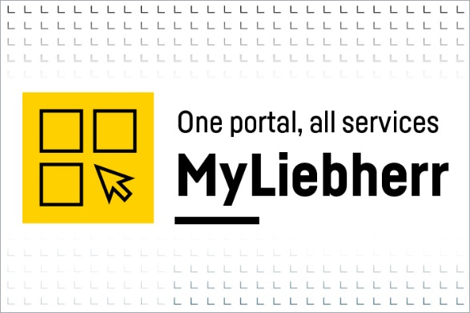
liebherr-myliebherr-design-mark-EN.jpg
Large parts of MyLiebherr now have a mobile version.

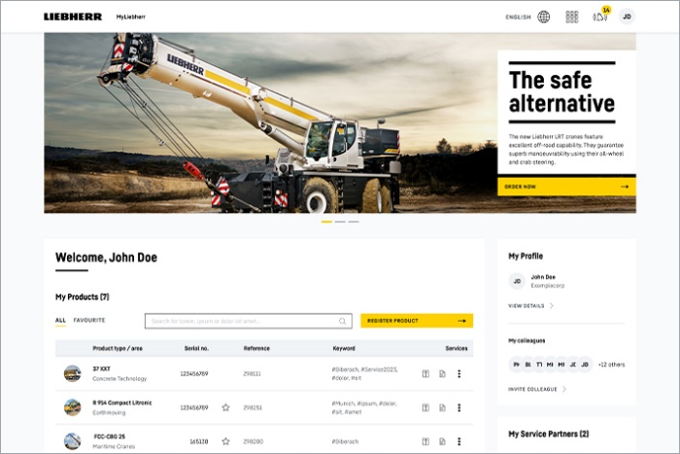
liebherr-myliebherr-homepage.jpg
The new MyLiebherr homepage has a clearly structured, intuitive user interface.

Contact
Philipp Hirth
Head of Public Relations
Phone: +49 7351 41-4445
Email: philipp.hirth@liebherr.com
Liebherr-International Deutschland GmbH
Biberach an der Riss/Germany
www.liebherr.com

