Press release

Liebherr-Mischtechnik GmbH and FBR cooperate to commercialise bricklaying robot

⸺
Liebherr-Mischtechnik and the Australian manufacturer FBR cooperate in the development of a mobile bricklaying robot. The robot, named Hadrian, masons buildings quickly and efficiently.
Bad Schussenried (Germany), 6th May 2022 – The technology company FBR Ltd. and Liebherr-Mischtechnik GmbH have signed a contract for cooperation in the further development of a bricklaying robot.
The robot, named Hadrian, is considered one of the most advanced construction robots. As the world's first mobile robot, it can take on the complete bricklaying work of an entire building outdoors. The robot works very precisely and at a high speed. The robot has already built its first buildings in Australia, and further pilot programs with customers in various countries are planned within the next months.
The cooperation is comprised of two phases. The first phase is focused on ensuring that the next generation of Hadrian is suitable for scalable industrialisation and commercialisation. With its many years of experience in the industrialization of construction machinery, Liebherr-Mischtechnik GmbH will support the development.
As soon as the product is ready for series production and economic profitability has been achieved in operation, a long-term Manufacturing and Commercialisation Agreement can be signed by both parties. With this transition to the second phase of the agreement, the focus shifts to serial producing the robot and preparing for market entry. The MOU continues for a period of at least two years or until the execution of a Manufacturing and Commercialisation Agreement.
FBR’s Managing Director & Chief Executive Officer, Mike Pivac: “We are pleased to be working with Liebherr-Mischtechnik GmbH on the industrialisation and global commercialisation of the Hadrian X®. Liebherr and FBR share a vision of significantly increasing the safety, sustainability, and efficiency of the construction industry. Both companies recognise that the digitalisation and automation of processes on the job site are the key enablers for realising this vision. FBR and Liebherr complement each other in terms of experience and technologies to bring a product like the Hadrian X® to series production readiness.”
Liebherr-Mischtechnik GmbH’s Head of R&D for concrete pumps Dr. Karl Westermann: “This cooperation with one of the most advanced pioneers in robotic construction demonstrates that the Liebherr Group is continuously investigating new and innovative technologies to ensure its customers’ success on the job-site now and in the future.”
FBR Ltd. is an Australian company focused on developing automation solutions in the construction industry. The company develops dynamically stabilised robots designed for outdoor work.

About Liebherr-Mischtechnik GmbH
Liebherr-Mischtechnik GmbH is a worldwide manufacturer and supplier of high-quality concrete mixing plants, concrete pumps and ready-mix concrete truck mixers. The company belongs to the Liebherr Group and is based in Bad Schussenried, Germany.
About the Liebherr Group
The Liebherr Group is a family-run technology company with a highly diversified product portfolio. The company is one of the largest construction equipment manufacturers in the world. It also provides high-quality and user-oriented products and services in a wide range of other areas. The Liebherr Group includes over 140 companies across all continents. In 2021, it employed more than 49,000 staff and achieved combined revenues of over 11.6 billion euros. Liebherr was founded in Kirchdorf an der Iller in Southern Germany in 1949. Since then, the employees have been pursuing the goal of achieving continuous technological innovation, and bringing industry-leading solutions to its customers.

Images
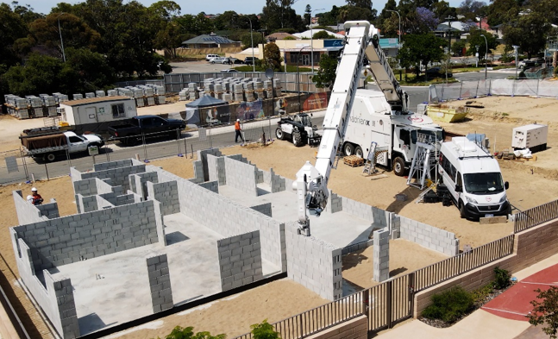
liebherr-bricklaying-robot.jpg
The bricklaying robot Hadrian lays bricks in buildings quickly and efficiently.

Contact
Klaus Eckert
Head of Sales Promotion
Telefone: +49 7583 949-328
E-Mail: klaus.eckert@liebherr.com
Published by
Liebherr-Mischtechnik GmbH
Bad Schussenried / Germany
www.liebherr.com

