Press release

In a double pack: Clausen Kran AG procures Liebherr mobile cranes

⸺
First rough terrain crane LRT 1090-2.1 in Switzerland
High performance, compactness and variability of Liebherr machines are decisive factors
Clausen Kran AG has been a reliable partner for crane work and special transports for 50 years
The Valais-based company Clausen Kran AG rounds off its crane fleet with a Liebherr LTM 1150-5.3 mobile crane and an LRT 1090-2.1 rough terrain crane. The Brig-based company is an expert in crane operations in the mountains and relies 100 percent on Liebherr mobile and crawler cranes.
Reiden (Switzerland), 3 May 2022 – Company owner Geri Clausen explains: “The LTM 1150-5.3 is a powerful all-rounder allowing flexible use thanks to its variable driving conditions. Its five axles make it very compact and manoeuvrable. With the detachable boom, it also offers a great advantage for a variety of operations in our mountainous region.” Cornelia Clausen-Ogi, company owner, adds: “The LRT 1090-2.1 rough terrain crane is an ideal addition to our crane fleet, enabling us to offer our customers customised solutions for their projects.”
Flexible all-rounder with 66 metre telescopic boom
Clausen is planning the new LTM 1150-5.3 for assembly and disassembly of construction cranes as well as for operations in chemical plants where large lifting heights are required. For power stations and cable car projects with weight-limited access, the Liebherr 150-tonne crane is ideal as it weighs 31 tonnes with the boom dismantled. All mobile and crawler cranes in the Clausen Kran AG fleet are made by Liebherr. “We enjoy a long-standing and trusting partnership with Liebherr. I have a high regard for Liebherr's modern crane technology, as I myself use the vehicles nearly every day”, declares Geri Clausen.
Clausen also cites Liebherr’s famously good service as an important decision criterion: “Standing for quality and service, Liebherr has been providing us with state-of-the-art crane and drive technology for years. We receive excellent support and Liebherr-Baumaschinen AG in Reiden is there for us around the clock”.
The LTM 1150-5.3 has a 66-metre telescopic boom, putting it on a par with crane types in the 200-tonne capacity class. It scores with outstanding lifting capacities in a steep position as well as with a large radius. And it is ready for immediate use on the construction site: With a total weight of 60 tonnes and an axle load of 12 tonnes, the new 150-tonne truck already carries nine tonnes of ballast. This means it can do many jobs without the need for extra ballast transport. That saves time and money. It also has an optional detachable boom and removable sliding beams. When both components are removed, the LTM 1150-5.3 weighs around 31 tonnes. This makes it much easier to obtain special permits for the routes to be travelled.
“Safety first”
The Liebherr LRT 1090-2.1 rough terrain crane – sold for the first time in Switzerland – was designed above all with a high degree of safety in mind. Standard equipment includes sliding beam monitoring. This automatically detects the support status – on tyres or supports – and transfers it to the crane control. The LRT also comes with the variable supporting base VarioBase® as standard. This boosts flexibility on the construction site, while at the same time increasing the crane’s lifting capacity. With a maximum lifting capacity of 90 tonnes and a maximum lifting height of 66 metres, the 2-axle crane is ideally suited for off-road use.
Clausen Kran AG was founded in 1972. The fleet is distinguished by its diversity and currently consists of seven mobile and crawler cranes with lifting capacities of up to 250 tonnes as well as three heavy-duty tractors. Thanks to innovative ideas, the company is one of the leading providers of crane work and special transports in the Valais and Switzerland.
About the Liebherr Group
The Liebherr Group is a family-run technology company with a highly diversified product portfolio. The company is one of the largest construction equipment manufacturers in the world. It also provides high-quality and user-oriented products and services in a wide range of other areas. The Liebherr Group includes over 140 companies across all continents. In 2021, it employed more than 49,000 staff and achieved combined revenues of over 11.6 billion euros. Liebherr was founded in Kirchdorf an der Iller in Southern Germany in 1949. Since then, the employees have been pursuing the goal of achieving continuous technological innovation, and bringing industry-leading solutions to its customers.

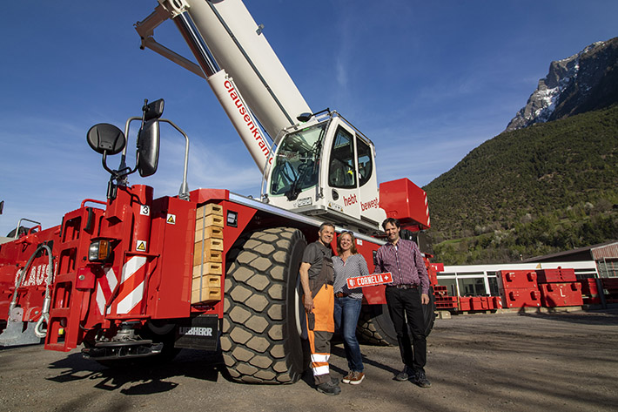
Photos
liebherr-lrt1090-2.1-clausen.jpg
Crane handover in Brig: from left to right: Geri Clausen, Cornelia Clausen-Ogi (both Clausen Kran AG), Reto Studer (Liebherr-Baumaschinen AG).

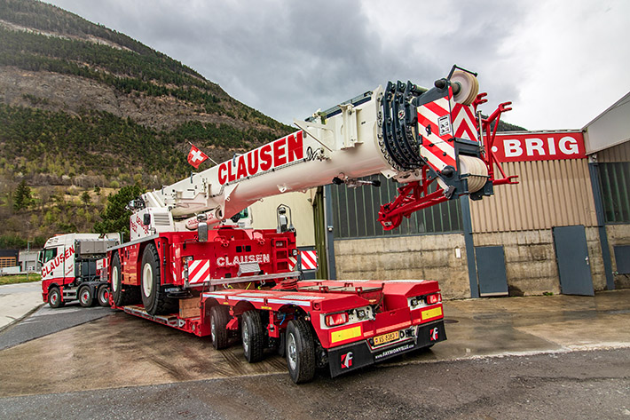
liebherr-lrt1090-2.1.jpg
The LRT 1090-2.1 all-terrain crane is transported by low-loader on public roads.

Contact
Reto Studer
Head of Marketing
Phone: +41 62 785 81 20
Email: reto.studer@liebherr.com
Published by
Liebherr-Baumaschinen AG
Reiden/Switzerland
www.liebherr.com

