Press release

HLC 295000 ready to work

⸺
Naming ceremony of Vessel “Orion I” with Heavy Lift Crane 295000 in Vlissingen (NL)
Crane successfully passed all tests
Variety of functions and features of the HLC-Series unique in the market
The HLC (Heavy Lift Crane) 295000 is on board the “Orion”, the next generation offshore installation vessel by DEME. Being the largest crane Liebherr has ever built, it has a maximum lifting capacity of 5,000 Tonnes. Its working field will be the offshore industry, in which it will help installing wind farms and decommissioning “old” energy platforms.
Rostock (Germany), 2nd May 2022 – After the vessel had left the port of Rostock on 27 March, the ship had its name-giving ceremony in Vlissingen in the Netherlands at the end of last week. It was Mrs.Amélie Michel, spouse of Mr. Charles Michel, President of the European Council, who did “the honours”. Among the several hundred spectators in attendance, DEME CEO Luc Vandenbulcke as well as DEME chairman Luc Bertrand were present. Patricia Rüf, Member of the administrative board of Liebherr-International AG and joint management of the maritime cranes company area of the Liebherr Group as well as Leopold Berthold, Managing Director of Liebherr-MCCtec Rostock GmbH came from Liebherr’s side.
In discussions and gestures, the event was widely regarded as a symbol of partnership and ongoing cooperation between the two companies. In the next weeks, the vessel will be headed towards Rügen. Roughly 20 kilometres northeast from the island, the offshore wind farm “Arcadis Ost I” in the Baltic Sea will be constructed.
“What we are witnessing here, is indeed a very memorable event. Fundamentally, it demonstrates what is achieved, when people are closely working together, especially alongside with a competent and reliable partner. Today, we are proud. In an extraordinary effort, our team at Liebherr brought this heavy lift crane up on this ship so now everyone can see what has been accomplished,” so Robert Pitschmann, Global Application Manager Heavy Lift Offshore at Liebherr.
Basically, by the help of the compact design, the crane is destined to serve in the offshore market. For example the base column, being only 16.8 metres diameter, is unique in the market. The HLC 295000 requires little space on deck and offers more storage space for transportation. It is ready to take up its work in the ample field of the offshore industry. With its maximum capacity of 5,000 tons and an outreach of up to 151 metres, the HLC can manage large components, for example, during the decommissioning of offshore platforms.
The well-paved road towards the new job
After the vessel left Rostock, it was at sea and took a series of offshore testing, incl. several overload tests. Additional works took place for adjustments and final inspections. All tests were executed and passed successfully. Hence, the vessel could be handed to DEME in Bremerhaven soon after. DEME, a Belgian company acting globally, which is active in the various fields of the marine engineering, including solutions for the offshore energy market. For Liebherr, DEME is a strong affiliate and both have been working together cooperatively during recent years. Eventually, it departed to Vlissingen in April, where today’s naming ceremony was held. Its final departure to “Arcadis Ost I” will be in the next weeks.

“‘Orion’ heralds a new era in the offshore energy industry – one which will be dominated by multi-megawatt turbines, jackets and components. The combination of load capacity and superior lifting heights of ‘Orion’ will enable DEME to play an important role in helping the industry successfully navigate the energy transition,” so Luc Vandenbulcke, CEO DEME Group.
Shaping tomorrow’s energy
This heavy lift crane will gain a decisive impact in the energy transformation since it will support the construction of windfarms, on the one hand. On the other hand, it will be used for the decommissioning of “old” platforms, a development pushed forward by offshore wind. Essentially, this conveys a reduction in offshore oil and gas installations. It will carry with it, hence, a focus of dismantling parts as large as possible in order to reduce resources on transport. Conclusively, the Liebherr crane could enhance working on the energy revolution because it is able to function on “both ends” of the contest for greener energy. Indeed, both fields of application can now be served by a single Liebherr product: the heavy lift crane.
Moreover, a maximum lifting height of 175 metres enables the HLC 295000 to operate in the required height right away without special efforts. All this demonstrates that the heavy lift crane in general can be regarded as the ideal instrument for the challenges ahead within the changing field of energy production as well as in all related working areas closely related to it. The extraordinary efficiency, swift- and readiness when it comes to transporting, accuracy but also power give this Liebherr heavy lift crane and the HLC-Series an advancement due to its smart versatility.
About DEME
DEME is a world leader in the highly specialised fields of dredging and land reclamation, solutions for the offshore energy market, environmental and infra marine works. With more than 140 years of experience and 5,200 highly skilled professionals, DEME has built up a vast bank of knowledge and expertise, which has allowed them to foster a pioneering approach throughout their history. This enables DEME to bring tailor-made solutions, innovation and new technologies to customers’ projects, ensuring that they are performed safely, efficiently and cost-effectively.

About the Liebherr Group
The Liebherr Group is a family-run technology company with a highly diversified product portfolio. The company is one of the largest construction equipment manufacturers in the world. It also provides high-quality and user-oriented products and services in a wide range of other areas. The Liebherr Group includes over 140 companies across all continents.
In 2021, it employed more than 49,000 staff and achieved combined revenues of over 11.6 billion euros. Liebherr was founded in Kirchdorf an der Iller in Southern Germany in 1949. Since then, the employees have been pursuing the goal of achieving continuous technological innovation, and bringing industry-leading solutions to its customers.
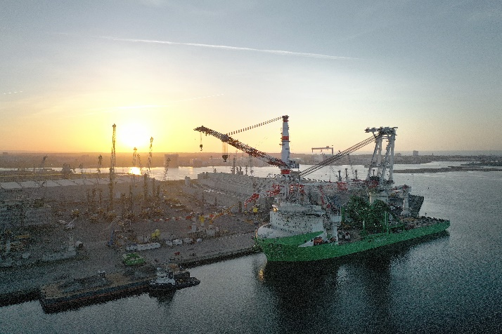
Images

Liebherr_HLC295000_Orion_PortRostock
The HLC 295000 on board the “Orion I” at the Port of Rostock.
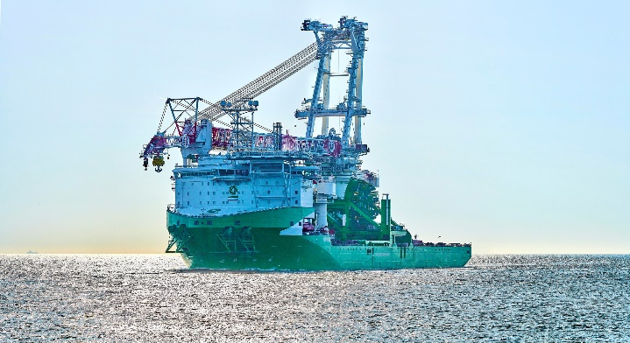

Liebherr_HLC295000_Orion_Offshore
The HLC successfully passed all tests.

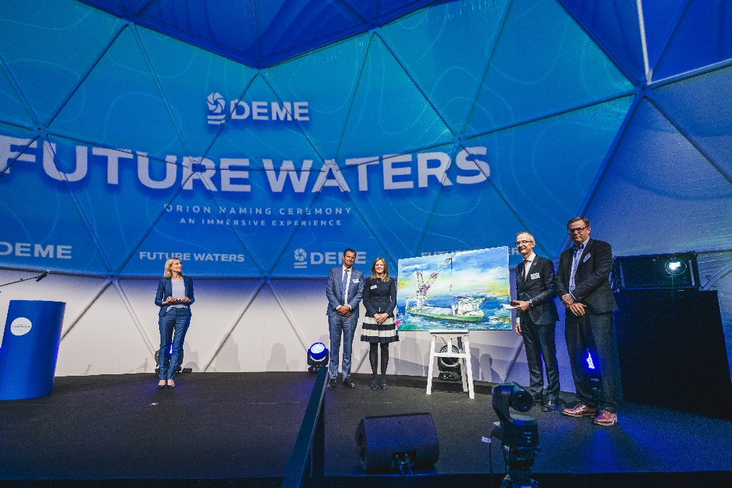

Liebherr_Naming_Ceremony_Orion
Representatives of Liebherr and DEME during ceremony.

Contact

Olaf Seidenfaden
Marketing Manager Offshore Cranes
Tel.: + 49 381 6006 5028
email: olaf.seidenfaden@liebherr.com

Published by

Liebherr-MCCtec Rostock GmbH

Rostock / Germany

www.liebherr.com

