Press release

New LTM 1750-9.1 becomes the most powerful crane in the Magis fleet

⸺⸺
- Magis buys all its new mobile cranes from Liebherr
- High standards in crane technology, safety and sustainability are important corporate principles at Magis and were factors behind the purchase decision
- The LTM 1750-9.1 is now the most powerful mobile crane in the company’s fleet
Italian company Magis S.r.l. has taken delivery of a new LTM 1750-9.1 mobile crane from Liebherr-Werk Ehingen GmbH. It will strengthen the crane fleet at the crane and heavy haulage contractor based in Taranto. Magis buys all its new mobile cranes from Liebherr, as its fundamental corporate principles include keeping up with current developments in safety and sustainability and ensuring reliability and competitiveness.
Ehingen (Donau) (Germany), 29 April 2022 – Andrea Caroppi, Technical and Commercial Director and Member of the Board of Directors at Magis S.r.l. comments: “The reasons for the investment in such an important vehicle are very wide-ranging and varied. The new crane expands the capacity of our portfolio. As for all the other new machines in our fleet, the decision was made to purchase from Liebherr because the company stands for technical reliability, performance, innovation and an eye for detail.” Before buying the LTM 1750-9.1, Magis looked very closely at the alternatives to the machine. Over the last four years the crane and heavy haulage contractor has been renewing its fleet in stages. The important feature in this process was that the new machines must include the latest developments in safety and sustainability and also be able to meet current reliability and competitiveness standards. “At the end of all our deliberations, we decided on a Liebherr telescopic mobile crane, which delivers a high level of mobility as well as short set-up times whilst also being powerful in its various configurations”, adds Andrea Caroppi. Another criterion in deciding on the LTM 1750-9.1 was its great flexibility for operating in all sectors.
Wide range of uses with powerful boom systems
The 9-axle LTM 1750-9.1 can carry its complete telescopic boom when driving on public roads. Due to its high lifting capacities and variable boom system, it can cover a wide range of jobs in industry, infrastructure and the energy sector. Its Y-telescopic boom guying enables the crane to achieve enormous lifting capacities. The all-terrain crane is designed to ensure particularly short set-up times and great mobility. The extensive comfort and safety equipment, such as load charts for various wind speeds, round off the concept for the LTM 1750-9.1. An 800 tonne upgrade has been available since 2020, making this mobile crane significantly more powerful.
Most powerful crane in the Magis fleet
The LTM 1750-9.1 is now the flagship in the Magis fleet. It is now the most powerful crane operated by the company and will replace an LTM 1500-8.1. The planned range of uses for the new LTM 1750-9.1 at Magis is extremely varied. The potential areas of work include both the new construction and demolition of plant and structures in the industrial sector, for example steelworks, chemical and petrochemical plants and prefabricated components, as well as the erection and maintenance of wind farms. “We believe that a crane of this type and capacity will enable us to complete hoisting work which has previously been beyond us, for example for the erection of wind turbines”, continues Andrea Caroppi.
Magis S.r.l. based in Taranto in southern Italy, has 18 employees. The ISO-certified company has been active with mobile cranes and many other industrial sectors for almost 40 years. Its work includes the installation and maintenance of wind farms, the erection and removal of metal structures, bridges, road and railway viaducts. Its portfolio also includes the assembly of prefabricated houses and the demolition and renovation of steel plants as well as work on cement plants, chemical and petrochemical plants and refineries. Magis’ core national and international business is the completion of large hoists, crane and lifting platform rental as well as special and heavy haulage services. Over the last four years, Magis S.r.l. has pursued the objective of completely updating and expanding its crane fleet. Today its fleet comprises almost exclusively new Liebherr mobile cranes, from the LTM 1100-4.2 to the LTM 1750-9.1. The company already has plans to buy an LTM 1650-8.1.
About Liebherr-Werk Ehingen GmbH
Liebherr-Werk Ehingen GmbH is a leading manufacturer of mobile and crawler cranes. Its range of mobile cranes extends from 2-axle 35 tonne cranes to heavy duty cranes with a lifting capacity of 1200 tonnes and a 9-axle chassis. Its lattice boom cranes on mobile or crawler crane chassis deliver lifting capacities of up to 3000 tonnes. With universal boom systems and extensive additional equipment, they can be seen in action on construction sites throughout the world. The Ehingen site has a workforce of 3,800. Extensive, global service guarantees the high availability of Liebherr mobile and crawler cranes. In 2021, the Liebherr plant in Ehingen recorded a turnover of 2.33 billion euros.
About the Liebherr Group
The Liebherr Group is a family-run technology company with a highly diversified product portfolio. The company is one of the largest construction equipment manufacturers in the world. It also provides high-quality and user-oriented products and services in a wide range of other areas. The Liebherr Group includes over 140 companies across all continents. In 2021, it employed more than 49,000 staff and achieved combined revenues of over 11.6 billion euros. Liebherr was founded in Kirchdorf an der Iller in Southern Germany in 1949. Since then, the employees have been pursuing the goal of achieving continuous technological innovation, and bringing industry-leading solutions to its customers.

Images
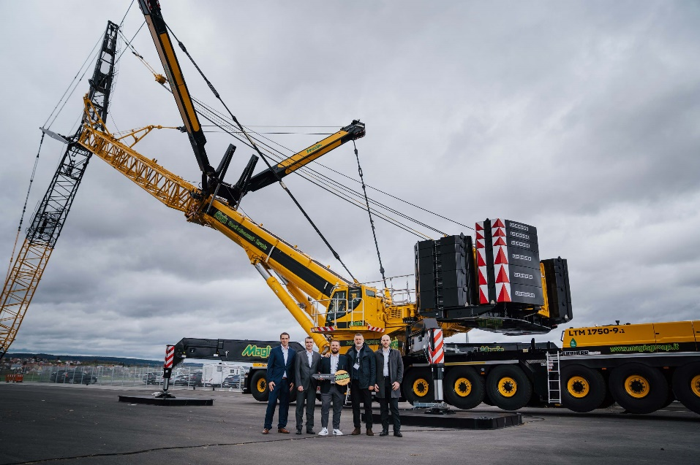
liebherr-ltm-1750-9-1-handover-magis.jpg
Handover of the LTM 1750-9.1 to Magis S.r.l. in Ehingen-Berg (from left to right) Florian Maier (Liebherr-Werk Ehingen GmbH), Fabio Fenzi (Liebherr-Italia S.p.A.), Andrea Caroppi (Magis S.r.l.), Roberto Fazzini and Emanuele Perrone (Liebherr-Italia S.p.A.).

Contact
Wolfgang Beringer
Marketing and Communication
Phone: +49 7391/502 - 3663
Email: wolfgang.beringer@liebherr.com
Published by
Liebherr-Werk Ehingen GmbH
Ehingen (Donau), Germany
www.liebherr.com

