Press release

Liebherr earns spot in Boeing Premier Bidder Program

⸺
Lindenberg (Germany), April 2022 – Liebherr-Aerospace announced it earned a spot in the Boeing Premier Bidder Program.
The program recognizes and rewards consistently high-performing Boeing Commercial
Airplanes and Boeing Global Services suppliers, strengthening Boeing’s collective performance and commitment to safety, quality and integrity.

The program provides Premier Bidder members with an opportunity to increase their business with Boeing, including visibility of upcoming bids and an invitation to program conferences with key Supply Chain leadership.

Liebherr-Aerospace Lindenberg GmbH makes the main gear steering system for the Boeing 777 and Boeing 777X, the folding wing tip actuation, high-lift actuators, the power drive unit and the hydraulic motor for the leading edge actuation system for the 777X as well as the nose wheel steering remote electronic unit for the Boeing 787 Dreamliner.

Liebherr-Aerospace Lindenberg GmbH joins approximately 140 suppliers that have met and sustained the high quality, delivery and performance criteria required for inclusion in the Premier Bidder Program.

About Liebherr-Aerospace & Transportation
Liebherr-Aerospace & Transportation SAS, Toulouse (France), is one of eleven divisional control companies within the Liebherr Group and coordinates all activities in the aerospace and transportation systems sectors.
Liebherr-Aerospace is a leading supplier of systems for the aviation industry and has more than six decades of experience in this field. The range of aviation equipment produced by Liebherr for the civil and defense sectors includes flight control and actuation systems, gears and gearboxes, landing gear and air management systems as well as electronics. These systems are deployed in wide-bodied aircraft, single aisle and regional aircraft, business jets, defense aircraft, defense transporters, defense training aircraft and civil and defense helicopters.
Liebherr’s aerospace and transportation systems division employs around 6,000 people. It has four aviation equipment production plants at Lindenberg (Germany), Toulouse (France), Guaratinguetá (Brazil) and Nizhny Novgorod (Russia). These production sites offer a worldwide service with additional customer service centers in Saline (Michigan/USA), Seattle (Washington/USA), Montreal (Canada), Hamburg (Germany), Moscow (Russia), Dubai (UAE), Bangalore (India), Singapore and Shanghai (People’s Republic of China).

About the Liebherr Group
The Liebherr Group is a family-run technology company with a highly diversified product portfolio. The company is one of the largest construction equipment manufacturers in the world. It also provides high-quality and user-oriented products and services in a wide range of other areas. The Liebherr Group includes over 140 companies across all continents. In 2021, it employed more than 49,000 staff and achieved combined revenues of over 11.6 billion euros. Liebherr was founded in Kirchdorf an der Iller in Southern Germany in 1949. Since then, the employees have been pursuing the goal of achieving continuous technological innovation, and bringing industry-leading solutions to its customers.

Image
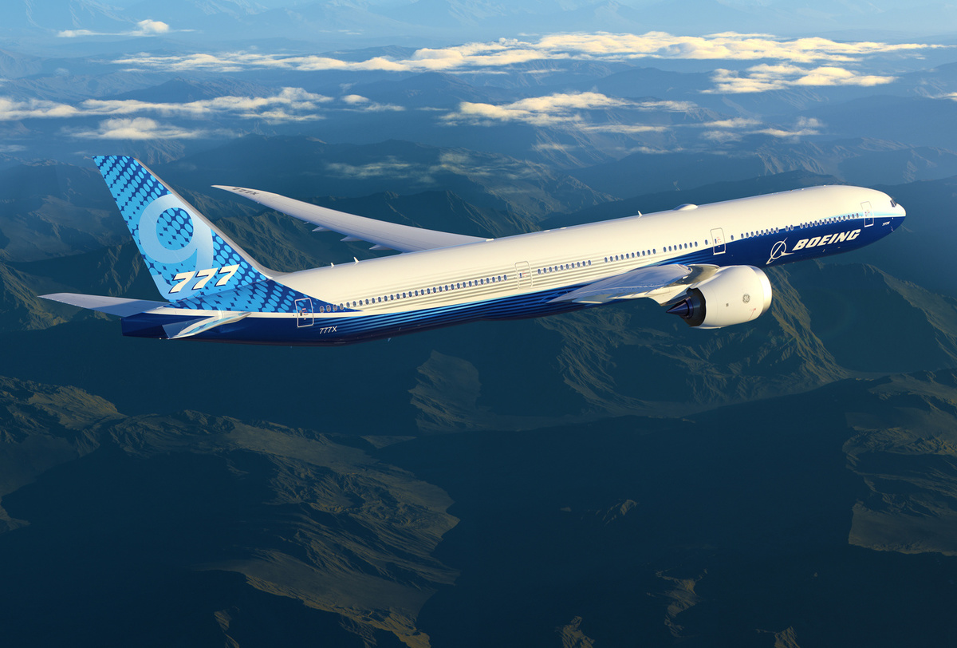
Boeing 777-9-r7bdyp_exp_777-9_side_above_clouds_02b_Post-Print.jpg
The Boeing 777X is equipped with Liebherr-Aerospace technology. – © Boeing

Contact person
Ute Braam
Corporate Communications
Phone: +49 8381 / 46 - 4403
E-mail: ute.braam@liebherr.com

Published by
Liebherr-Aerospace & Transportation SAS
Toulouse / France
www.liebherr.com

