Press release

100 percent Liebherr – Klüttgens expands crane fleet with LTM 1060-3.1

⸺
Klüttgens adds to fleet between 50 and 90 tonne lifting capacity
Klüttgens’ fleet is made up in full of Liebherr cranes
Main criteria behind the decision – compact, manoeuvrable crane with 48 metre telescopic boom
Klüttgens’ fleet is made up in full of Liebherr cranes. It has now added another one in the form of a new LTM 1060-3.1. This will add to the fleet between the 50 and 90 tonne lifting capacity. The compact, manoeuvrable 3-axle crane does not require transport escort on public roads and has a very long telescopic boom at 48 metres.
Ehingen (Donau) (Germany), 22 April 2022 – Klüttgens Autokrane + Schwertransporte GmbH based in Stolberg, near the German border with Belgium and the Netherlands, has purchased a new Liebherr LTM 1060-3.1. The crane is the company’s third 3-axle mobile crane from Liebherr and was purchased to expand Klüttgen’s fleet.
Perfectly packed for any road
Company owner Jens Petry says: “Our 50 tonner is sometimes too small and our 90 tonner too large. What is more, as it is a 3-axle model, this 60 tonner does not need a transport escort.” Special attention was given to the clever arrangement of the ballast slabs on the LTM 1060-3.1. This means that a wide range of driving configurations can be achieved quickly and easily. Its compact dimensions and time-tested ECOmode and ECOdrive make the LTM 1060-3.1 economical to use. In addition to its compact size, the crane features a long telescopic boom and impressive lifting capacities. “With a boom length of 48 metres, this mobile crane is relatively compact but at the same time is manoeuvrable due to its active rear axle steering”, says Petry. This means that all the axles on the vehicle can be steered. The front axles are steered mechanically using the steering wheel. The rear axles are actively steered by an electro-hydraulic system depending on the steering angle and speed. Even at high speed, this ensures very good lane stability and significantly reduced tyre wear.
The main work for the new LTM 1060-3.1 at Klüttgens will be unloading and installing prefabricated concrete components and loading machines, for example for machine relocation jobs. In addition, the mobile crane will also be used for the company’s customers in the chemical industry.

100 percent Liebherr
Klüttgens only uses Liebherr mobile cranes. “The customer service and availability of spare parts were important criteria behind the purchase decision as well as the features of the actual crane. We have grown used to this from Liebherr over several decades”, says Petry.
Klüttgens Autokrane + Schwertransporte GmbH based in Stolberg has 20 employees. The family-run company is mainly active in the mobile crane rental and heavy haulage sectors. In addition, Klüttgens also carries out machine and company relocations and operates a container service as well as a scrap and metal dealership. With decades of experience, the company provides its services both in Germany and in neighbouring Belgium and the Netherlands.
About Liebherr-Werk Ehingen GmbH
Liebherr-Werk Ehingen GmbH is a leading manufacturer of mobile and crawler cranes. Its range of mobile cranes extends from 2-axle 35 tonne cranes to heavy duty cranes with a lifting capacity of 1200 tonnes and a 9-axle chassis. Its lattice boom cranes on mobile or crawler crane chassis deliver lifting capacities of up to 3000 tonnes. With universal boom systems and extensive additional equipment, they can be seen in action on construction sites throughout the world. The Ehingen site has a workforce of 3,800. Extensive, global service guarantees the high availability of Liebherr mobile and crawler cranes. In 2021, the Liebherr plant in Ehingen recorded a turnover of 2.33 billion euros.
About the Liebherr Group
The Liebherr Group is a family-run technology company with a highly diversified product portfolio. The company is one of the largest construction equipment manufacturers in the world. It also provides high-quality and user-oriented products and services in a wide range of other areas. The Liebherr Group includes over 140 companies across all continents. In 2021, it employed more than 49,000 staff and achieved combined revenues of over 11.6 billion euros. Liebherr was founded in Kirchdorf an der Iller in Southern Germany in 1949. Since then, the employees have been pursuing the goal of achieving continuous technological innovation, and bringing industry-leading solutions to its customers.
Images
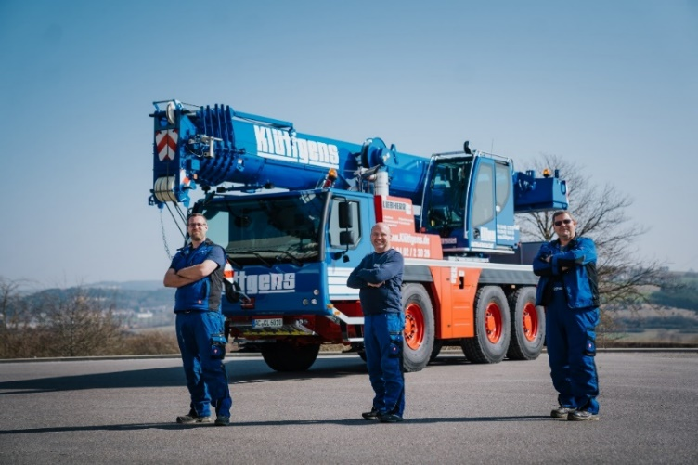
liebherr-ltm-1060-3-1-kluettgens-01.jpg
Handover of the LTM 1060-3.1 to Klüttgens (from left to right): Thomas Kapitzke (Crane Operator), Jens Petry (Company Owner) and Rainer Esser (Crane Operator).
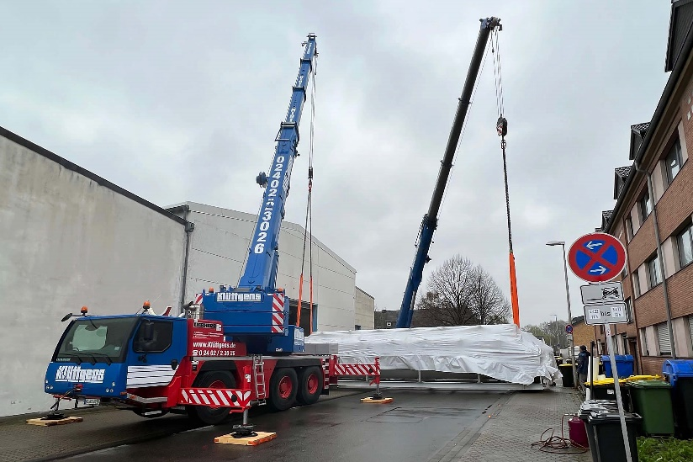
liebherr-ltm-1060-3-1-kluettgens-02.jpg
First job for the new LTM 1060-3.1 – tandem hoist with an LTM 1090-4.2 for loading a 30 tonne furnace system.

Contact
Wolfgang Beringer
Marketing and Communication
Phone: +49 7391/502 - 3663
Email: wolfgang.beringer@liebherr.com
Published by
Liebherr-Werk Ehingen GmbH
Ehingen (Donau) / Germany
www.liebherr.com

