Press release

“The crane always has another ace up its sleeve”

⸺
Liebherr LTM 1650-8.1 from Riga Mainz positions 70 tonne pontoon in flooded gravel pit
VarioBase® mode enables the crane to deliver large lifting capacities when working over the rear of the vehicle
Complex calculation of the fastening equipment due to the extreme asymmetry of the load
A large pontoon was positioned on a flooded gravel pit as part of the process of expanding a gravel plant in Babenhausen in the German state of Hesse. Crane and heavy haulage contractor Riga Mainz had been awarded this order. The Mainz-based crane experts sent what is currently their largest mobile crane, a Liebherr LTM 1650-8.1, to carry out the job around 30 kilometres south-east of Frankfurt am Main.
Ehingen (Donau) (Germany), 19 April 2022 – To access a new extraction area for gravel and sand, a pontoon measuring over 20 metres in length had to be positioned in a newly flooded gravel pit. The powerful LTM 1650-8.1 mobile crane had already had the floating pontoon on its hook once before in December last year. At that time, it had been removed from a lake several kilometres away from the current location, whose mineral contents had been removed in full.
For positioning the pontoon at the end of March, crane operator Werner Gebel had set up his modern 8-axle machine parallel to the massive load with the lake at its rear. “The crane naturally delivers very high lifting capacity values at the rear. That is particularly the case if I extend the outriggers fully using the VarioBase® program”, explained Gebel. In this mode, the LICCON crane control system calculates the maximum lifting capacity for every boom position. The maximum values are achieved when the crane is operated over its rear outriggers.
In Babenhausen, the challenge for the mobile was to position a gross load of around 70 tonnes into the water at a radius of 25 metres. To achieve this hoist, the LTM 1650-8.1 had been set up with its full slewing platform ballast of 155 tonnes. To enable the pontoon to be hoisted fully over the surface of the water, the hydraulically adjustable ballast radius was increased from 7.40 metres when it picked up the load to the maximum distance of 8.40 metres. Over the next few weeks, a large gravel excavator will be installed on the steel platform.
“The LTM 1650-8.1 demonstrate what is currently feasible”
“To attach the large load, we had to work with rope pulleys and fastening equipment of different lengths due to the fact that the centre of gravity was far from central”, explains Riga Mainz Managing Director Uwe Langer, who planned the crane job at the flooded gravel pit in minute detail. “First of all, however, we had to calculate the load case for the hoists using the material thicknesses of the floating section as there were no precise data available about the weight of the pontoon. That then enabled us to develop our hoisting concept. In addition, as a result of how close the crane set-up area was to the edge of the embankment, we had to carry out geological studies of the subsoil. We had to ensure that the ground pressure under the load distribution mats would not cause the soil to collapse.”
His company working out of Mainz has a 120-strong workforce running 40 mobile and crawler cranes and, in addition to crane work, also tackles heavy haulage, special transport and industrial installation work throughout Germany. The LTM 1650-8.1 has been the powerful flagship of Langer’s fleet for the last year. “This crane enables Liebherr to show what is technical feasible today and with the LICCON work planner, the company also provides a tool to make these possibilities into reality”, continues the expert. “The crane continually proves to us that it always has another ace up its sleeve.”

About Liebherr-Werk Ehingen GmbH
Liebherr-Werk Ehingen GmbH is a leading manufacturer of mobile and crawler cranes. Its range of mobile cranes extends from 2-axle 35 tonne cranes to heavy duty cranes with a lifting capacity of 1200 tonnes and a 9-axle chassis. Its lattice boom cranes on mobile or crawler crane chassis deliver lifting capacities of up to 3000 tonnes. With universal boom systems and extensive additional equipment, they can be seen in action on construction sites throughout the world. The Ehingen site has a workforce of 3,800. Extensive, global service guarantees the high availability of Liebherr mobile and crawler cranes. In 2021, the Liebherr plant in Ehingen recorded a turnover of 2.33 billion euros.

About the Liebherr Group

The Liebherr Group is a family-run technology company with a highly diversified product portfolio. The company is one of the largest construction equipment manufacturers in the world. It also provides high-quality and user-oriented products and services in a wide range of other areas. The Liebherr Group includes over 140 companies across all continents. In 2021, it employed around 49,000 staff and achieved combined revenues of over 11.6 billion euros. Liebherr was founded in Kirchdorf an der Iller in Southern Germany in 1949. Since then, the employees have been pursuing the goal of achieving continuous technological innovation, and bringing industry-leading solutions to its customers.

Photographs
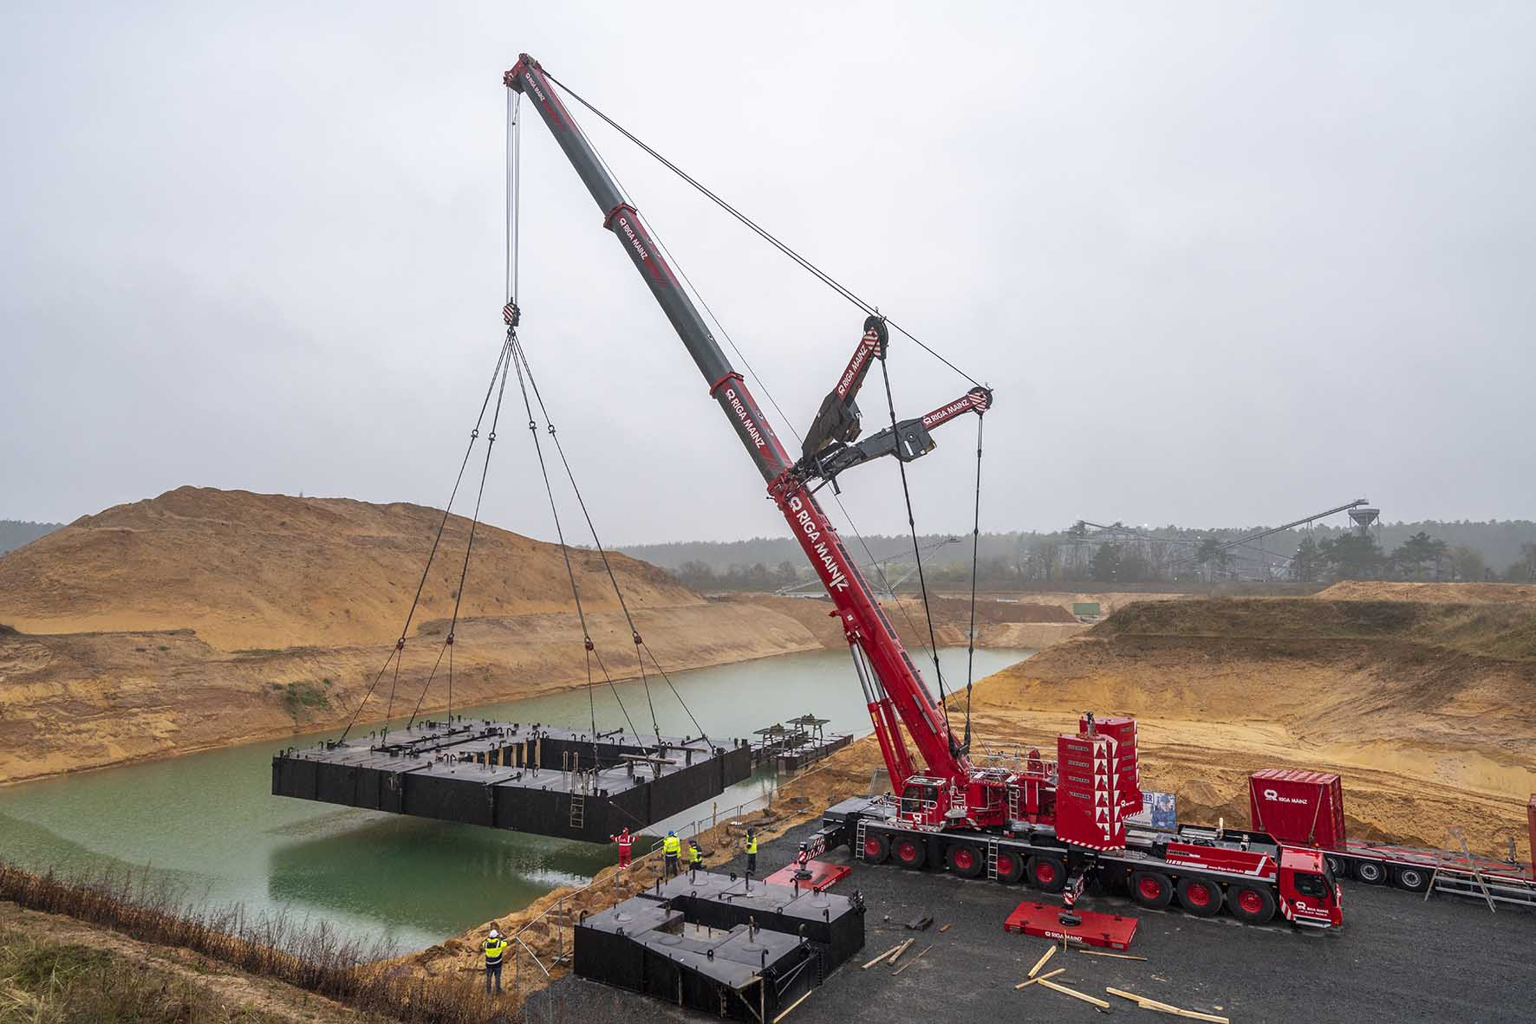
liebherr-ltm1650-8-1-riga-mainz-babenhausen-01.jpg
VarioBase® and VarioBallast® – with a radius of 25 metres, the large mobile crane places the 70 tonne floating structure onto the surface of the water. The radius of the slewing platform ballast has been extended to its maximum for this purpose.

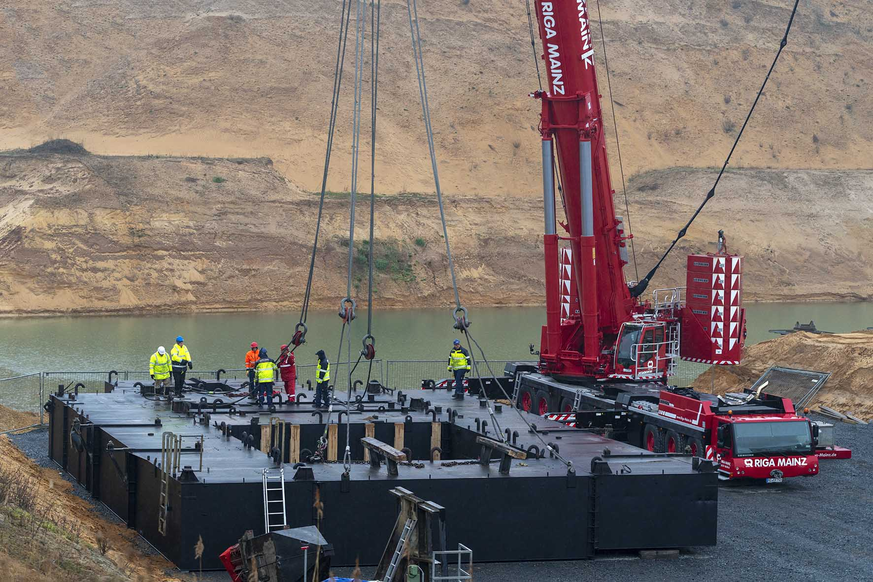
liebherr-ltm1650-8-1-riga-mainz-babenhausen-02.jpg
Not balanced – the asymmetric weight distribution of the load is counteracted using rope pulleys and fastening equipment of different lengths. Complicated calculations were required in advance for this purpose.

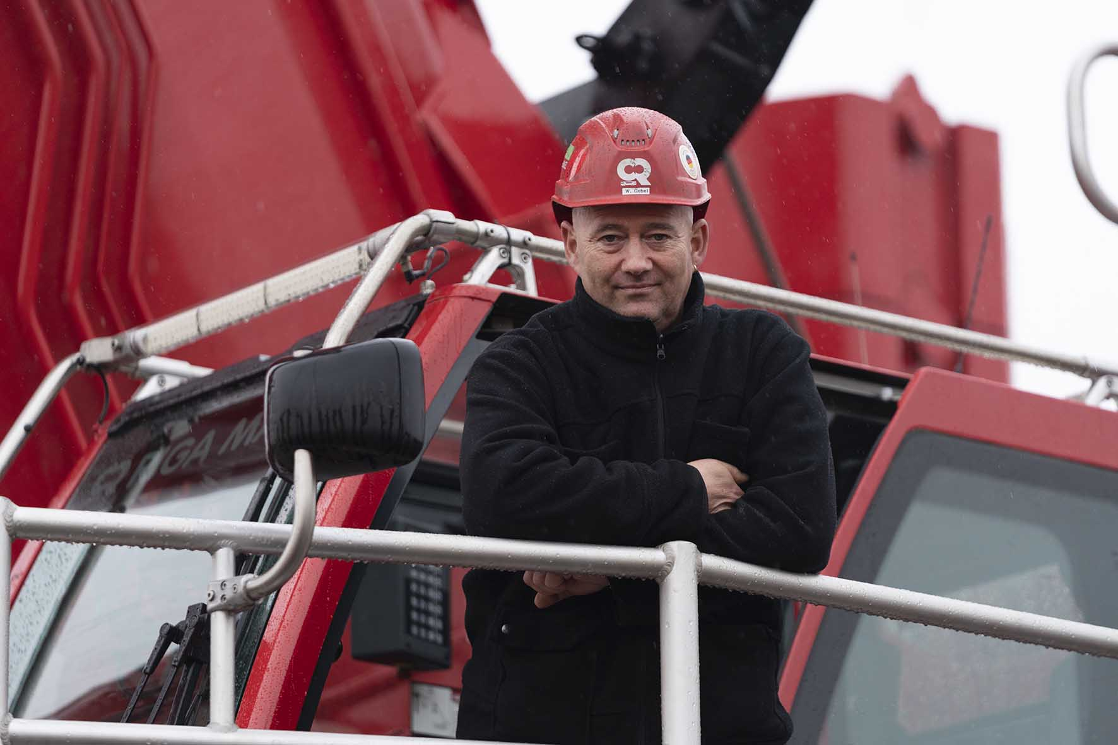
liebherr-ltm1650-8-1-riga-mainz-babenhausen-03.jpg
Crane operator Werner Gebel: “The crane delivers extremely high lifting capacity values for hoists over the rear.”

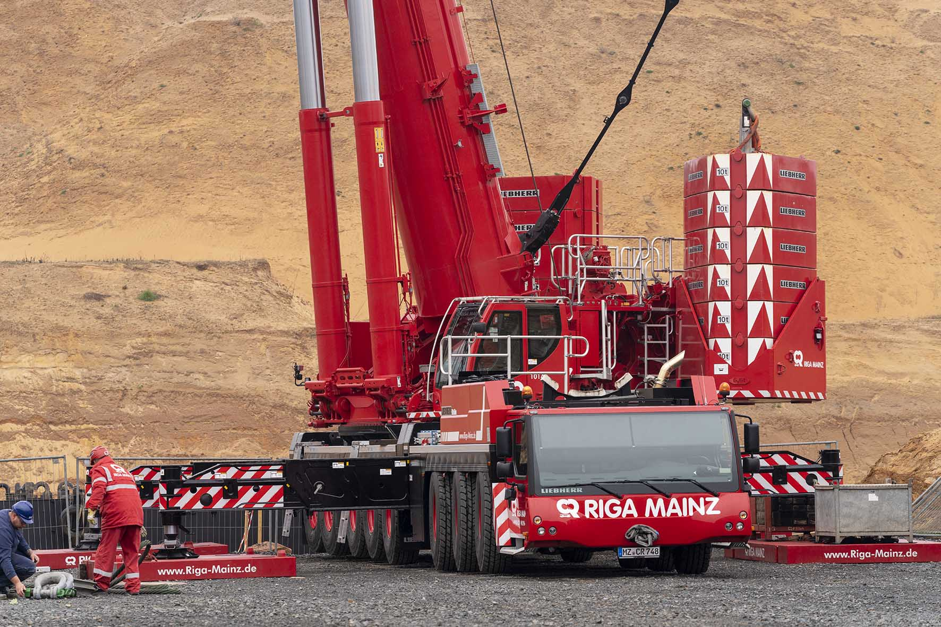
liebherr-ltm1650-8-1-riga-mainz-babenhausen-04.jpg
Modern power pack – the 155 tonne slewing platform ballast on the LTM 1650-8.1 can be adjusted hydraulically up to a distance of 8.40 metres.

Contacts
Wolfgang Beringer
Marketing and Communication
Phone: +49 7391/502 - 3663
Email: wolfgang.beringer@liebherr.com
Published by
Liebherr-Werk Ehingen GmbH
Ehingen (Donau) / Germany
www.liebherr.com

