Press release

The first Liebherr LR 12500-1.0 crawler crane goes to Sarens

⸺
Sarens convinced by the concept and performance of the new crawler crane
To be used primarily for renewables
LR 12500-1.0 delivers power reserves for future increased requirements
Crane and heavy haulage contractor Sarens has ordered the very first model of the new Liebherr LR 12500-1.0 crawler crane. The Belgian global contractor is convinced by the concept and performance of the new 2500 tonne crawler crane and will primarily be using it in the renewables industry, for example for handling offshore wind turbines. The new LR 12500-1.0 has plenty of power in reserve for potentially increased future requirements.
Ehingen (Donau) (Germany), 7 April 2022 – Liebherr consulted closely with its customers in the heavy load sector in its efforts to develop a concept for a new crawler crane between the LR 11350 with a lifting capacity of 1350 tonnes and the 3000 tonne LR 13000. The result is the new LR 12500-1.0 with a maximum lifting capacity of 2,500 tonnes. Liebherr and its customers believe there is a great deal of potential in this class and a growing market for large crawler cranes.
The new LR 12500-1.0 also marks Liebherr’s response to increasing market requirements for large crawler cranes for the petrochemicals industry and port handling. Handling enormous components for offshore wind turbines at ports, in particular, has become an important area of work for large crawler cranes. With its lifting capacity, the new 2,500 tonne crawler crane has also been designed to cover future requirements. Interest in the new LR 12500-1.0 is correspondingly high.
Sarens was quickly convinced by the concept and performance of the new 2,500-tonners and ordered the first unit. Managing Director Carl Sarens says: “The high lifting capacity of the LR 12500-1.0 is the outstanding feature for us. The new crane will enable us to close the gap between our crawler and ringer cranes. We are particularly focussing on jobs in renewables for the new 2,500 tonne crane. Handling offshore wind turbines at ports is also becoming a much more important business segment and the weights of components continues to rise.”
In developing the transport concept, Liebherr ensured that the new crawler crane can be used economically throughout the world. This is an important criterion for global operators like Sarens.

About Liebherr-Werk Ehingen GmbH
Liebherr-Werk Ehingen GmbH is a leading manufacturer of mobile and crawler cranes. Its range of mobile cranes extends from 2-axle 35 tonne cranes to heavy duty cranes with a lifting capacity of 1200 tonnes and a 9-axle chassis. Its lattice boom cranes on mobile or crawler crane chassis deliver lifting capacities of up to 3000 tonnes. With universal boom systems and extensive additional equipment, they can be seen in action on construction sites throughout the world. The Ehingen site has a workforce of 3,800. Extensive, global service guarantees the high availability of Liebherr mobile and crawler cranes. In 2021, the Liebherr plant in Ehingen recorded a turnover of 2.33 billion euros.
About the Liebherr Group
The Liebherr Group is a family-run technology company with a highly diversified product portfolio. The company is one of the largest construction equipment manufacturers in the world. It also provides high-quality and user-oriented products and services in a wide range of other areas. The Liebherr Group includes over 140 companies across all continents. In 2021, it employed more than 49,000 staff and achieved combined revenues of over 11.6 billion euros. Liebherr was founded in Kirchdorf an der Iller in Southern Germany in 1949. Since then, the employees have been pursuing the goal of achieving continuous technological innovation, and bringing industry-leading solutions to its customers.
Photograph
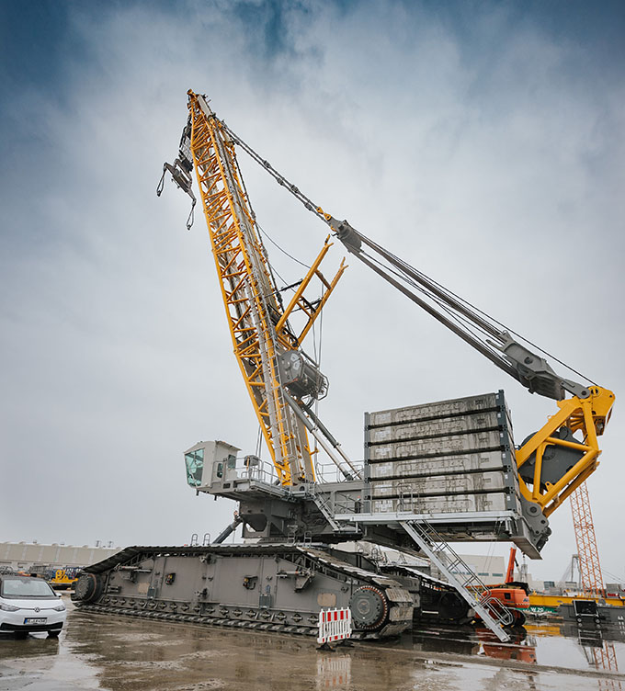
liebherr-crawler-crane-lr12500-1-0.jpg
Crane and heavy haulage contractor Sarens has ordered the very first model of the new Liebherr LR 12500-1.0 crawler crane.

Contacts
Wolfgang Beringer
Marketing and Communication
Phone: +49 7391/502 - 3663
Email: wolfgang.beringer@liebherr.com
Published by
Liebherr-Werk Ehingen GmbH
Ehingen (Donau) / Germany
www.liebherr.com

