Press release

Liebherr awarded engine contract with BHP

⸺
BHP will integrate Liebherr engines into their R 9600 excavator fleet at South Flank mine
Repowering the R 9600 fleet enables reduced maintenance and standardised parts capability
The six excavators will be repowered across 2023 to 2024
Liebherr has signed an agreement with BHP, a leading global resources company, to integrate Liebherr engines into BHP’s existing R 9600 600-tonne excavator fleet at South Flank mine in Western Australia. The integration will mark an important step in the partnership, while helping the customer to reduce maintenance and standardise parts capability.
Colmar (France), 6 April 2022 – Liebherr-Australia executive general manager customer service Tony Johnstone and BHP general manager South Flank Steve Campbell recently met in Perth to mark the signing of a deal to repower the South Flank R 9600 fleet with D9812 Liebherr engines and the strong ongoing partnership between the OEM and the miner. Repowering the R 9600 fleet enables reduced maintenance and standardised parts capability.
The integration follows intensive factory and field validations on the D98 engine series which includes a two-year validation study at BHP’s Jimblebar mine where the Liebherr D9812 has successfully powered an R 9400 for almost 20,000 hours.
Steve Campbell, BHP’s general manager for South Flank said, “BHP has a long-standing relationship with Liebherr across our Western Australian Iron Ore operations, and we have six of their largest machines in operation at South Flank. We’re looking forward to continuing with this collaboration which promises to bring performance and availability improvements to South Flank as we continue to ramp up production.”
Mark Pickett, vice president, Minerals Australia Supply continued, “We welcome the introduction of Liebherr engines into our equipment to deliver a more sustainable outcome and lower overall cost, as well as allowing Liebherr to have better control of product improvement. We look forward to continued partnership with Liebherr on these initiatives that make BHP’s operations more productive and improve sustainability.”
Liebherr also attaches great importance to this new step in the partnership and is looking forward to the continued collaboration. “We are pleased to be expanding our partnership with BHP through the integration of our engine technology,” said Dr Joerg Lukowski, Liebherr Mining executive vice president sales and marketing. “Our longstanding relationship and shared values of innovation make BHP an ideal partner. We look forward to seeing the tangible benefits of the D9812 engines within the R 9600s at South Flank mine, one of the most innovative mines in the world.”
Building on the Liebherr Group’s shared in-house competencies across different product segments, the D98 series completes the existing Liebherr engine portfolio for mining equipment by expanding into the upper power range. Designed specifically for the mining industry, the D98 series engine offers low fuel consumption and consequent emission reductions. The engine is also compatible for use with sustainably produced Hydrotreated Vegetable Oil (HVO) fuel which can significantly reduce CO₂ emissions.
The new engines will be supported locally by Liebherr-Australia. The first D9812 repowered R 9600 is scheduled to be operational by early quarter 1 2023, with repowers of the remaining R 9600 fleet to occur over 2023 and 2024.
About the Liebherr Group
The Liebherr Group is a family-run technology company with a highly diversified product portfolio. The company is one of the largest construction equipment manufacturers in the world. It also provides high-quality and user-oriented products and services in a wide range of other areas. The Liebherr Group includes over 140 companies across all continents. In 2020, it employed around 48,000 staff and achieved combined revenues of over 10.3 billion euros. Liebherr was founded in Kirchdorf an der Iller in Southern Germany in 1949. Since then, the employees have been pursuing the goal of achieving continuous technological innovation, and bringing industry-leading solutions to its customers.
Images
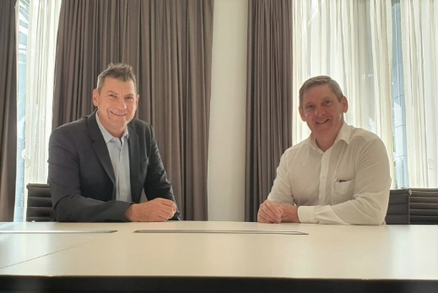
liebherr-signing-ceremony-BHP-engines.jpg
BHP’s Steve Campbell and Liebherr’s Tony Johnstone at the signing ceremony for the new engine deal.

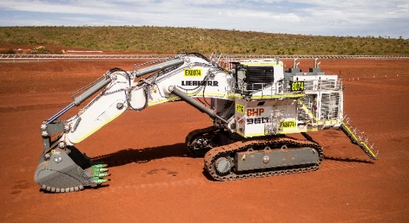
liebherr-bhp-r9600.jpg
One of BHP South Flank’s six R 9600 excavators.
Contact Liebherr
Grégory Schuh
Group Leader / Marketing Department
Telephone: +33 (0)3 69 49 21 99
E-Mail: Gregory.Schuh@liebherr.com
Published by
Liebherr Mining Equipment Colmar SAS
Colmar / France
www.liebherr.com

