Press release

Stevenson Crane, Rigging, and Heavy Haul adds Liebherr LR 1500 Crawler Crane to fleet in 2022

⸺
The crawler crane expands Stevenson fleet of over 35 Liebherr Cranes
Stevenson will use crane for heavy industrial work within multiple industries
LR 1500 provides high lift capacity and easy transport

The LR 1500 crawler crane delivers load capacity of a 500 metric tonne (550 USt) model with the dimensions and weights of a 400 metric tonne (440 USt) crane providing better capacity and easy transport for the midwest company.
Newport News, VA (USA), Liebherr USA, Co., March 30, 2022 – Founded in 1989, Stevenson Crane, Rigging, and Heavy Haul (Stevenson) will add Liebherr’s LR 1500 to its growing fleet in 2022. Stevenson mainly serves customers within the commercial, large residential, and heavy industrial markets. The company chose to acquire this crawler crane to better serve their diverse customer base and expand their overall crawler division.
The LR 1500 was designed with simplicity and economy in mind. With a maximum transport weight under 100,000 lbs and compact shipping dimensions, the crawler crane provides economical transport and easy set up for Stevenson jobsites in and around the Chicago area.
Stevenson relies on Liebherr’s state-of-the-art, innovative equipment for lifting needs within each industry they provide services. While remaining compact in size, the LR 1500 manages load capacity increase of approximately 28% on the 84 m (275 ft) main boom compared to its predecessor the LR 1400/2. A comparison of the configuration of the 84 m (275 ft) main boom with an 84 m (275 ft) luffing jib means the new crane actually manages an increase of 55% on average.
The “Powerful – Compact – Simple” crane is not only easy to set up and operate, but also features an adjustable derrick system ranging from 9 meters (30 ft) to 16 meters (52ft), allowing the crane to work in constricted spaces while maximizing lift capacity. The 30 m derrick boom (98ft) and 260 tonne derrick ballast (286 USt) provide ideal performance for Stevenson operators.
President of Stevenson, Donna Stevenson noted, “Stevenson Crane, Rigging, and Heavy Haul always provides the most innovative, safe, and cost-effective equipment to our customers. Liebherr’s commitment to the same goals helps Stevenson maintain its premier reputation as the leading crane and rigging company in the Midwest.”
About Stevenson Crane, Rigging, and Heavy Haul
Established in 1989, Stevenson Crane, Rigging, and Heavy Haul is a family owned and operated business based out of Bolingbrook, IL. The Midwest company provides services in commercial, large residential, and heavy industrial markets. With over 30 years of experience and 2500+ pieces of equipment, Stevenson Crane, Rigging, and Heavy Haul has grown into a comprehensive lifting firm offering an expansive selection of equipment as well as maintenance and planning, project management, and engineering services.
About Liebherr USA, Co.
Liebherr USA, Co. based in Newport News, VA provides sales and service on behalf of nine different Liebherr product segments: earthmoving, mining, mobile and crawler cranes, tower cranes, concrete technology, deep foundation machines, maritime cranes; components, and refrigeration and freezing.
About the Liebherr Group
The Liebherr Group is a family-run technology company with a highly diversified product portfolio. The company is one of the largest construction equipment manufacturers in the world. It also provides high-quality and user-oriented products and services in a wide range of other areas. The Liebherr Group includes over 140 companies across all continents. In 2020, it employed around 48,000 staff and achieved combined revenues of over 10.3 billion euros. Liebherr was founded in Kirchdorf an der Iller in Southern Germany in 1949. Since then, the employees have been pursuing the goal of achieving continuous technological innovation, and bringing industry-leading solutions to its customers.
Images
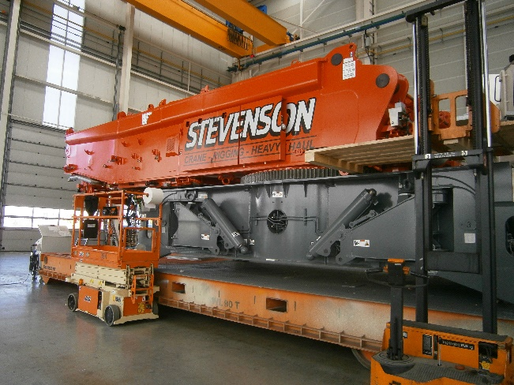
StevensonCrane_FactoryPhotoOne.jpg
LR 1500 crane superstructure is being painted, cleaned, and prepped before it is ready for transport.

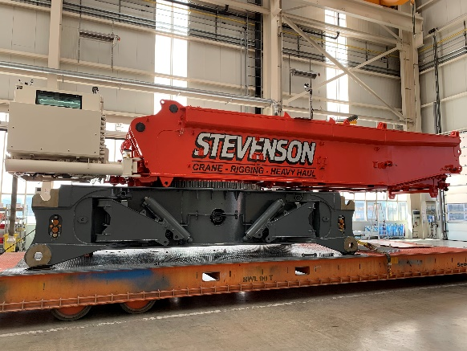
StevensonCrane_FactoryPhotoTwo.jpg
Stevenson LR 1500 Crane is labeled and waiting on mafi-trailer before final departure.

Contact
Ana Cabiedes Uranga
General Manager, Marketing
Phone: 757-240-4250
E-Mail: ana.cabiedes@liebherr.com
Published by
Liebherr USA, Co.
Newport News / USA
www.liebherr.com

