Press release

Liebherr Italia brings service even closer to its customers

⸺
Liebherr Service Technicians located throughout Italy
Seven-days-a-week on-call service
Training Courses for operators and maintenance technicians on offer
Digital services and traditional support available
Remanufacturing and used equipment

Liebherr Italia is offering a range of new services to mobile crane customers and operators. The new service developments show the Liebherr Group’s “passion” for its customers in Italy.
Monfalcone (Italy), 31. March 2022 - Liebherr Italia has placed a key focus on developing services for mobile crane customers over the past years. Customers who already value the Liebherr technical support’s reliable and straightforward solutions to their needs can now benefit from several improvements as well as new service offerings.
Closer to the customer
The response times as well as the distance between the technician and the customer have been reduced to a minimum. Liebherr customers can now count on the team of Liebherr technicians being close by, with offices located in the south, the islands, central and northern Italy. Thus, technicians can reach customers quickly with their well-equipped vans serving as mobile workshops. This helps customers save time and money by avoiding lengthy machine downtimes. The customer service is coordinated centrally by Liebherr Italia. It is also constantly improving the proximity to each and every customer thanks to a new collaboration with Liebherr-Utensili "LUT" based in Collegno (Torino).
One call every day
With its new seven-days-a-week on-call service, Liebherr Italia now also offers technical support on Saturdays and Sundays, since these are often workdays in the construction business. Besides telephone and remote support, Liebherr technicians are also available in person for urgent cases on weekends. The service hotline is manned by qualified Liebherr technicians.

Training courses for mobile crane operators
Liebherr also offers training courses aimed at young mobile crane operators, working for Liebherr customers. With the new Liebherr Mobile Crane Operator Training Course at the Liebherr Italia headquarters, new operators are able to acquire the knowledge they need to operate mobile cranes safely and effectively.
Digital services via MyLiebherr
The range of digital services available to Liebherr customers is constantly increasing. They allow for Liebherr to be by the customer’s side 24/7. In light of the impressive investments of Liebherr-Werk Ehingen, Germany, into the digital future, Liebherr Italia is aiming to become a pioneer and a provider of new technologies for the Italian market. With the online platform “MyLiebherr” customers in Italy already have a wide array of digital services at their disposal. These help customers to optimise and manage their costs of operating their mobile cranes fleets. Via the portal, customers can, amongst others, order spare parts at any time of the day, carry out functional diagnostics on mobile cranes remotely and run software simulations, digitally planning their crane fleets on site.
Remanufactoring and used equipment
In addition to the aforementioned services, Liebherr Italy is also an active player in the market for reman of used mobile cranes. A used vehicle offered by Liebherr is not simply a used vehicle. It retains a residual value above the market average. This is why Liebherr Italia provides its customers with a remanufacturing and repair centre. It is directly integrated in Liebherr-Werk Ehingen’s remanufactoring and repair centre in Germany and employs qualified technical staff for the inspection and repair of used mobile cranes.
About Liebherr-Werk Ehingen GmbH
Liebherr-Werk Ehingen GmbH is a leading manufacturer of mobile and crawler cranes. Its range of mobile cranes extends from 2-axle 35 tonne cranes to heavy duty cranes with a lifting capacity of 1200 tonnes and a 9-axle chassis. Its lattice boom cranes on mobile or crawler crane chassis deliver lifting capacities of up to 3000 tonnes. With universal boom systems and extensive additional equipment, they can be seen in action on construction sites throughout the world. The Ehingen site has a workforce of 3,600. Extensive, global service guarantees the high availability of Liebherr mobile and crawler cranes. In 2020, the Liebherr plant in Ehingen recorded a turnover of 2 billion euros.

About the Liebherr Group
The Liebherr Group is a family-run technology company with a widely diversified product range. The company is one of the largest manufacturers of construction machines in the world, but also supplies technically advanced, user-focused products and services in many other sectors. The group currently comprises more than 140 companies based in every continent of the world, has a workforce of around 48,000 and recorded a consolidated total turnover of more than 10.3 billion euros in 2020. Since it was founded in 1949 in Kirchdorf an der Iller in southern Germany, Liebherr’s aim has been to win customers by supplying high quality solutions and to contribute to technological progress.

Images:

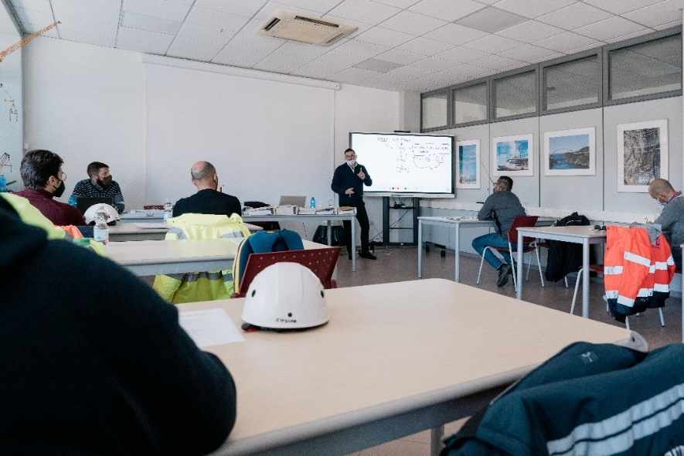
liebherr-mobile-crane-operator-training-theory.jpg
Training course for Liebherr mobile crane operators at the Liebherr Italia headquarters.

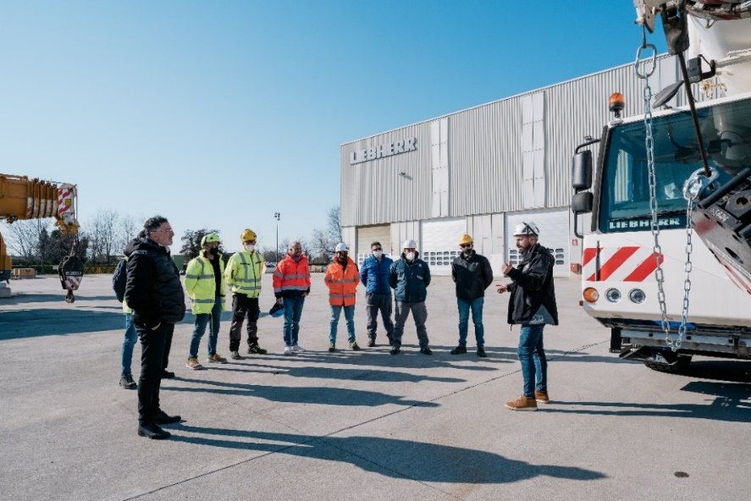
liebherr-mobile-crane-operator-training-practice.jpg
Practical training for mobile crane operators in Italy.

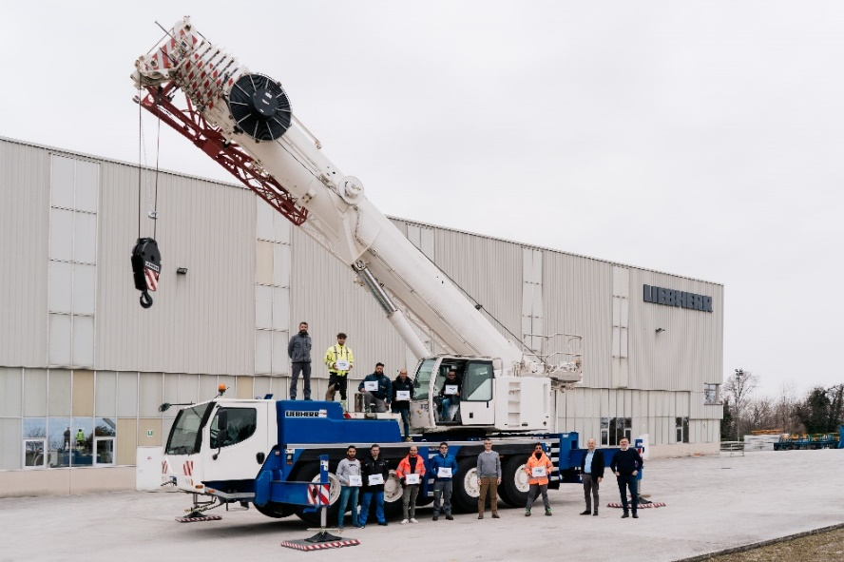
liebherr-mobile-crane-operator-certification.jpg
Training course for certified Liebherr mobile crane operators.

Contact
Marco Brambati
Tel.: +39 0481496929
E-mail: marco.brambati@liebherr.com
Published by
Liebherr-Werk Ehingen GmbH
Ehingen (Donau) / Germany
www.liebherr.com

